**Course Description**

As a data scientist, you will need to clean data, wrangle and munge it, visualize it, build predictive models, and interpret these models. Before you can do so, however, you will need to know how to get data into Python.

In this course, you'll learn the many ways to import data into Python: from flat files such as .txt and .csv; from files native to other software such as Excel spreadsheets, Stata, SAS, and MATLAB files; and from relational databases such as SQLite and PostgreSQL.

**1. Introduction and flat files**

In this chapter, you'll learn how to import data into Python from all types of flat files, which are a simple and prevalent form of data storage. You've previously learned how to use NumPy and pandas—you will learn how to use these packages to import flat files and customize your imports.



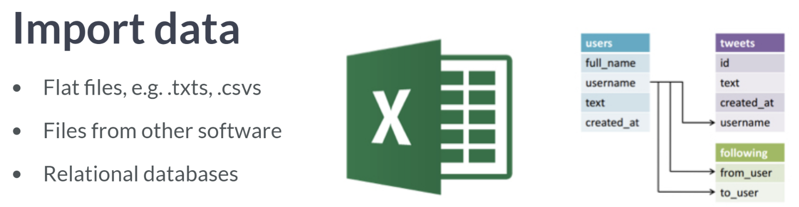  
Files from other software include excel spreadsheets, Stata, SAS, and MATLAB files.  
Relational databases such as SQLite & PostgreSQL.  
  
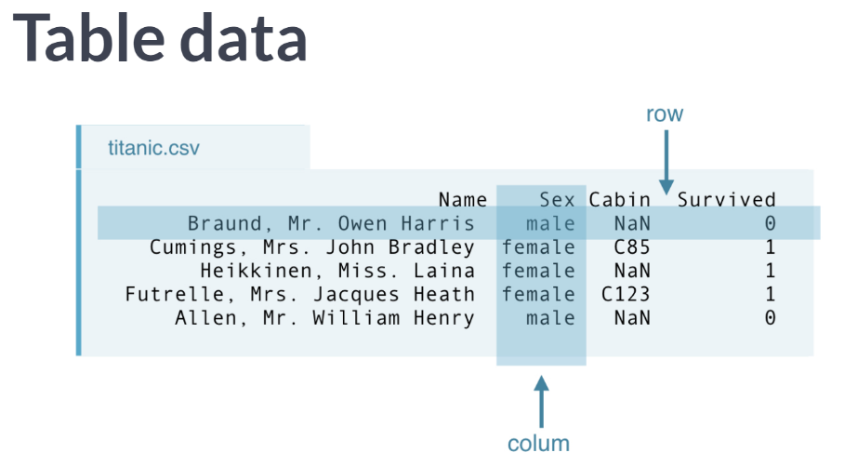  
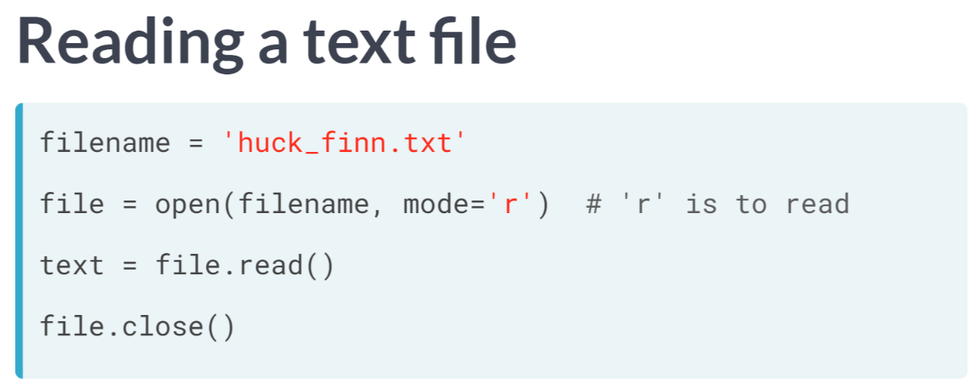  
  
  
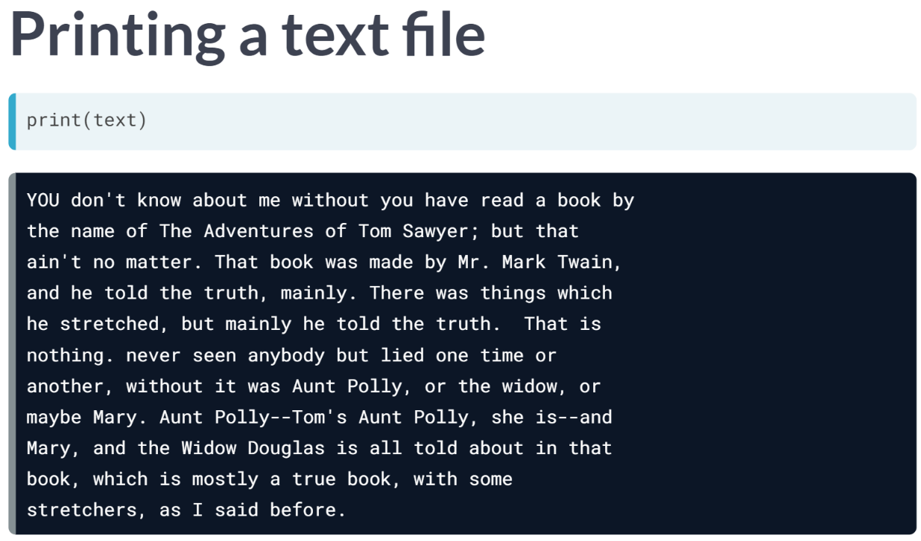  
  
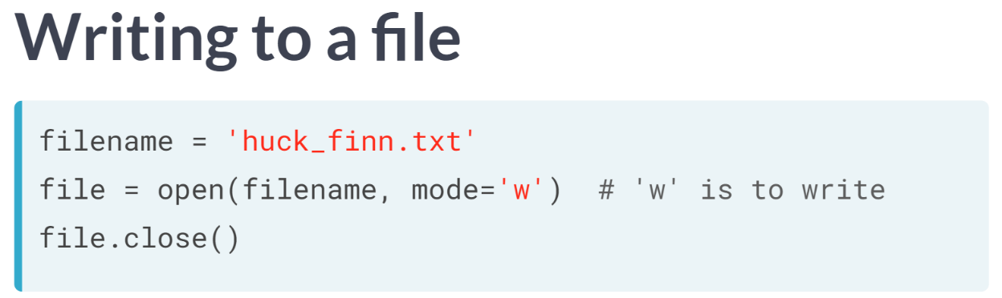

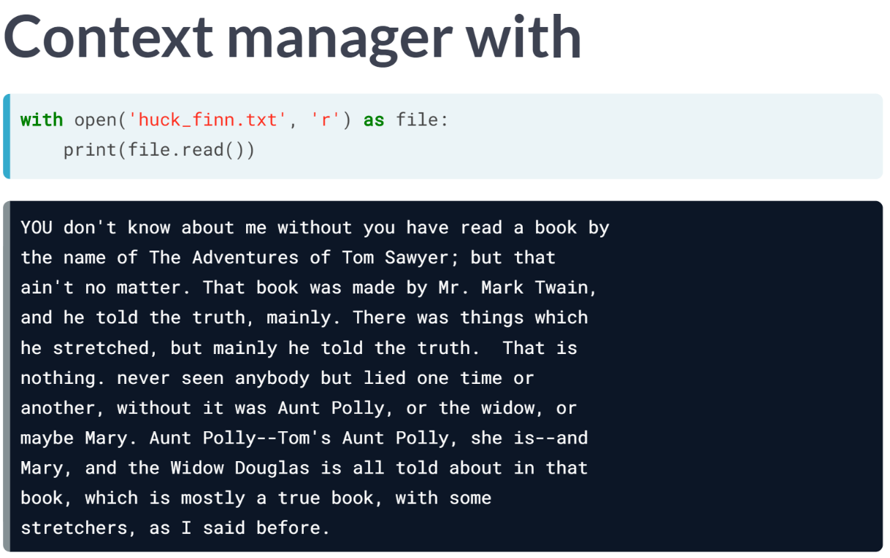  
You can avoid having to close the connection to the file by using a *with* statement. This allows you to create a context in which you can execute commands with the file open. Once out of this clause/context, the file is no longer open and, for this reason, is called a context manager.

What you are doing here is called 'binding' a variable in the context manager construct. While still within this construct, the variable file will be bound to open(filename, 'r'). It is thus the best practice to use the with statement as you **never have to concern yourself with closing files again**.

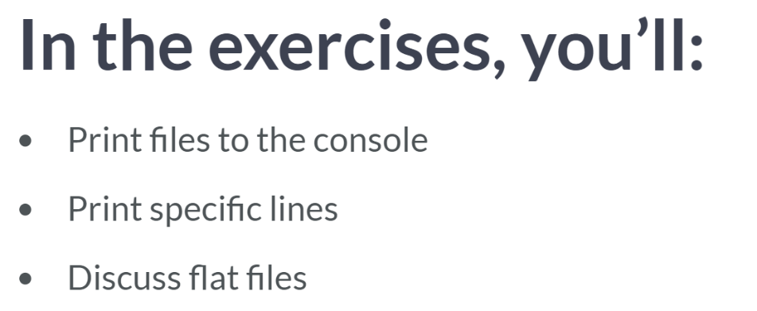

# Exploring your working directory

In order to import data into Python, you should first have an idea of what files are in your working directory.

IPython, which is running on DataCamp's servers, has a bunch of cool commands, including its [**magic commands**](http://ipython.readthedocs.io/en/stable/overview.html). For example, starting a line with ! gives you complete system shell access. This means that the IPython magic command ! ls will display the contents of your current directory. Your task is to use the IPython magic command ! ls to check out the contents of your current directory and answer the following question: which of the following files is in your working directory?

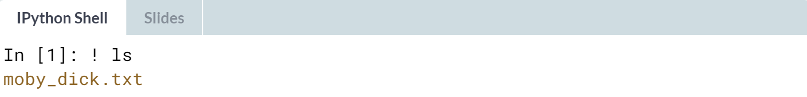  
  
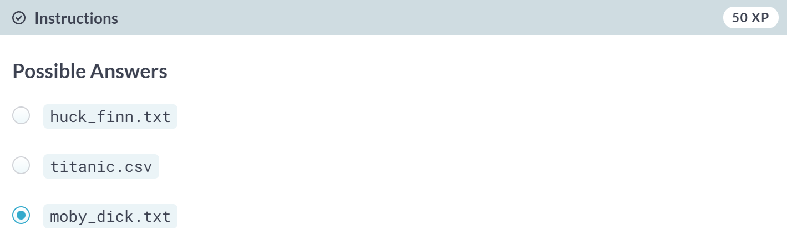

# Importing entire text files

In this exercise, you'll be working with the file moby_dick.txt. It is a text file that contains the opening sentences of Moby Dick, one of the great American novels! Here you'll get experience opening a text file, printing its contents to the shell and, finally, closing it.

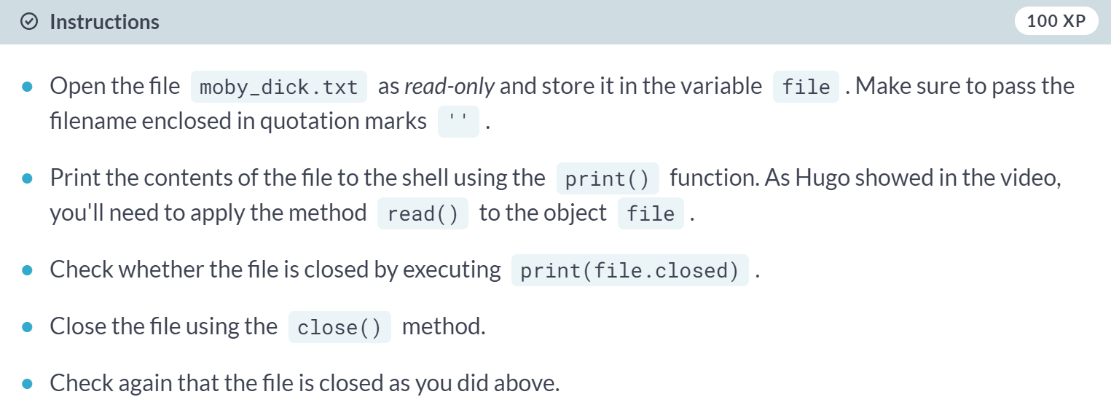  
  
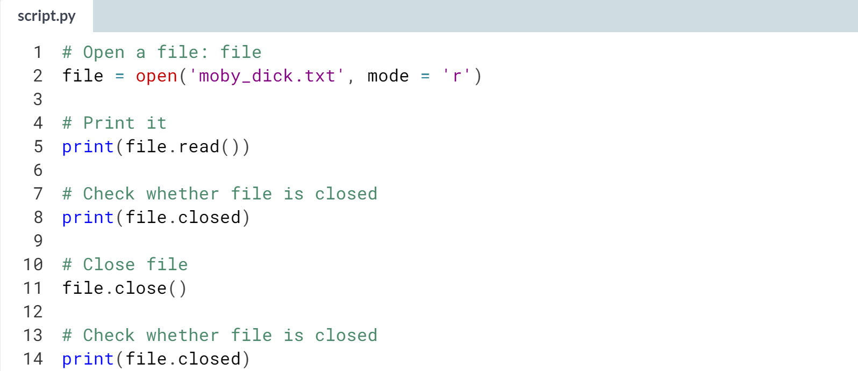  
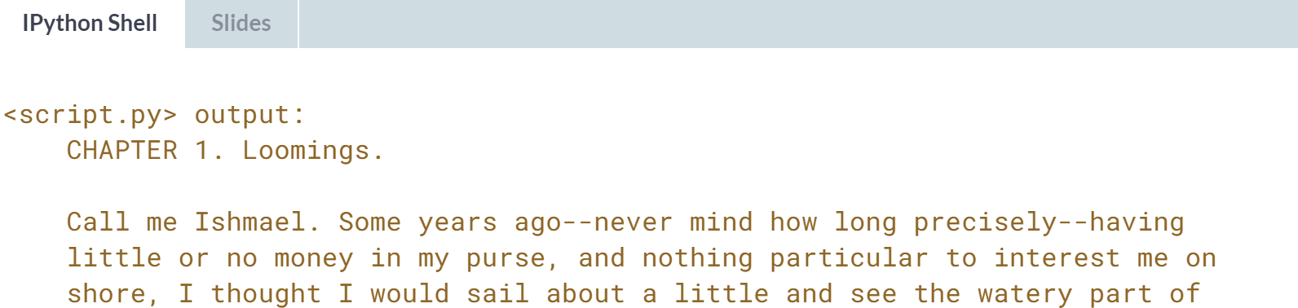

# Importing text files line by line

For large files, we may not want to print all of their content to the shell: you may wish to print only the first few lines. Enter the readline() method, which allows you to do this. When a file called file is open, you can print out the first line by executing file.readline(). If you execute the same command again, the second line will print, and so on.

In the introductory video, Hugo also introduced the concept of a **context manager**. He showed that you can bind a variable file by using a context manager construct:

with open('huck_finn.txt') as file:

While still within this construct, the variable file will be bound to open('huck_finn.txt'); thus, to print the file to the shell, all the code you need to execute is:

with open('huck_finn.txt') as file:

print(file.readline())

You'll now use these tools to print the first few lines of moby_dick.txt!

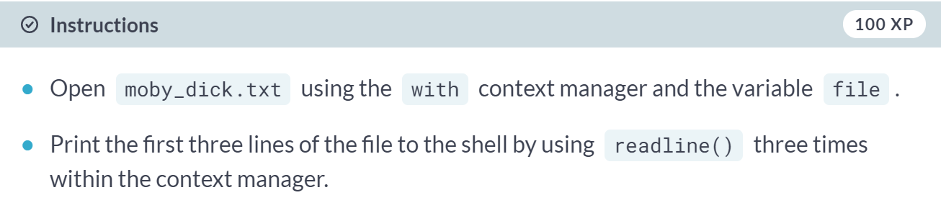  
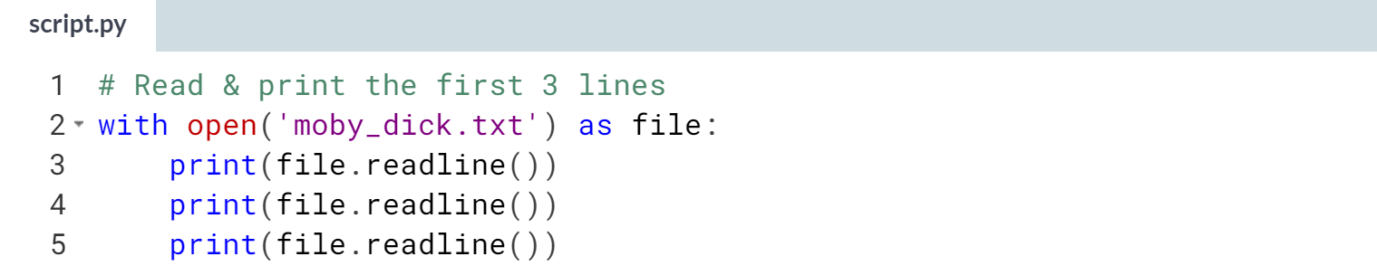  
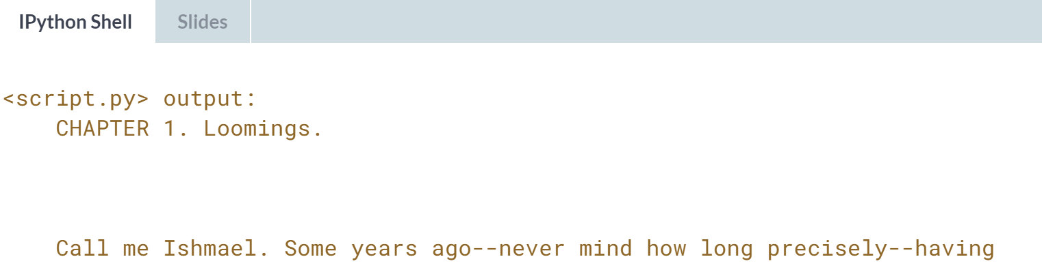



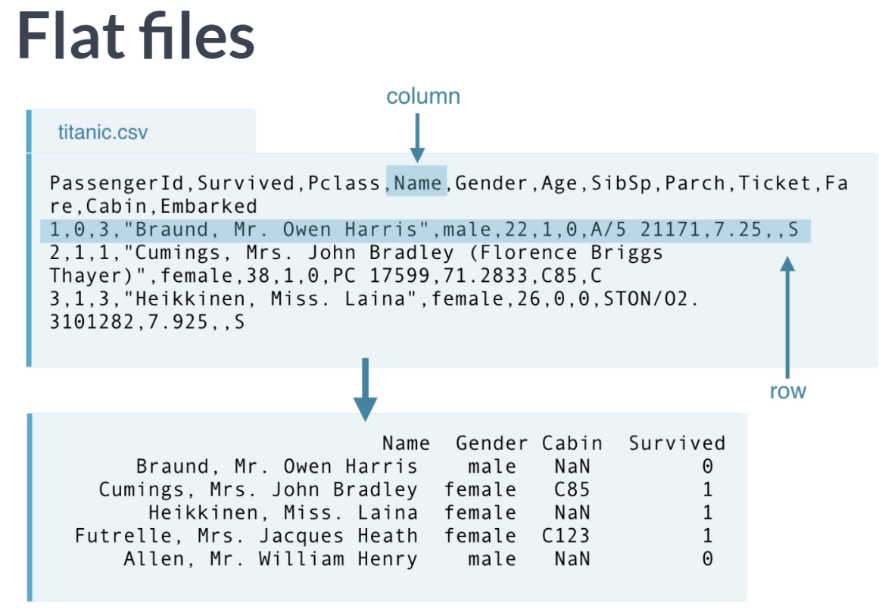  
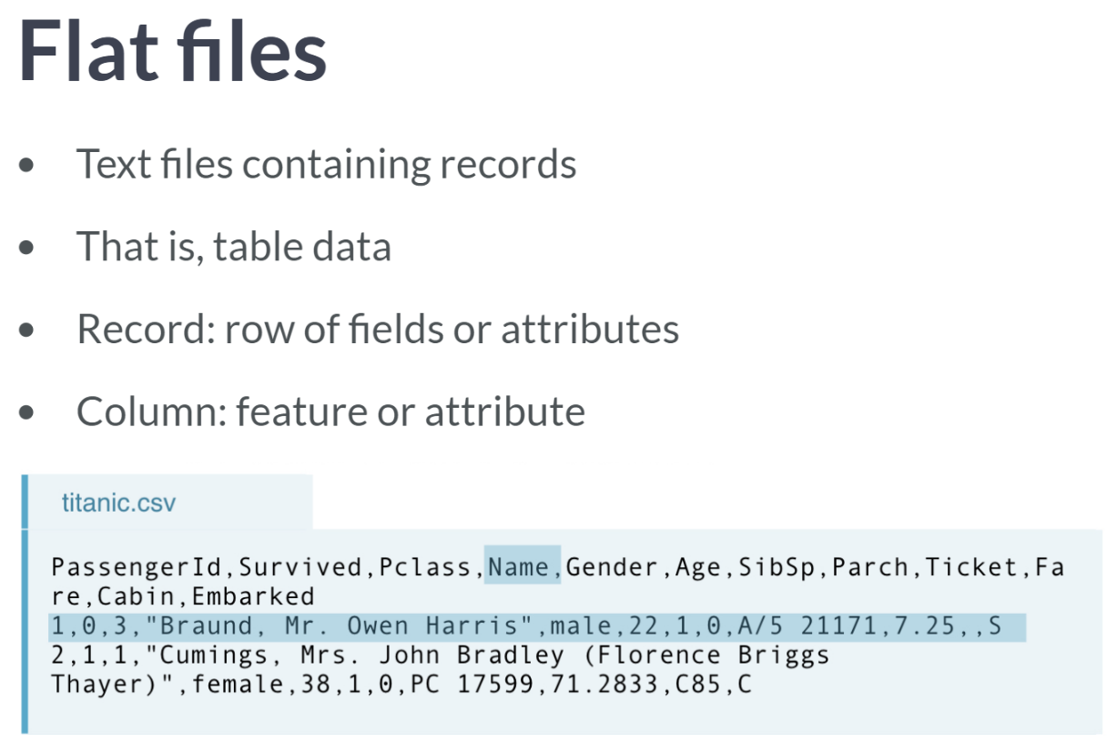

Flat files are basically table data without structured relationship. This is contrast to a relational database in which columns of distinct tables can be related.

In the flat file, *'titanic.csv'*, each row or record is a unique passenger onboard, and each column is a feature or attribute, such as name, gender, and cabin.

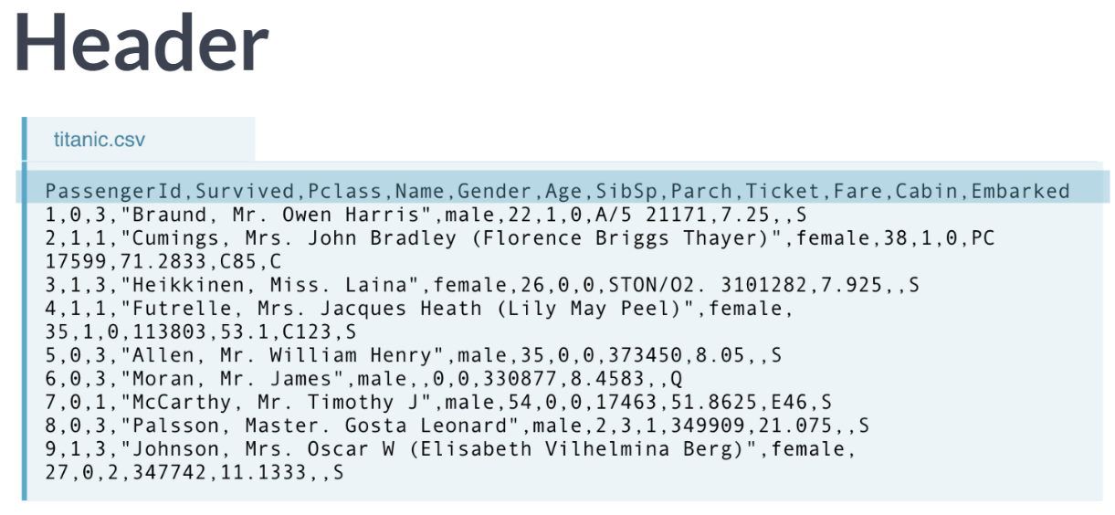Header describes the data columns or states what the corresponding attributes or features in each column are. Knowing whether header exists or not is important as it plays an important role in importing data.

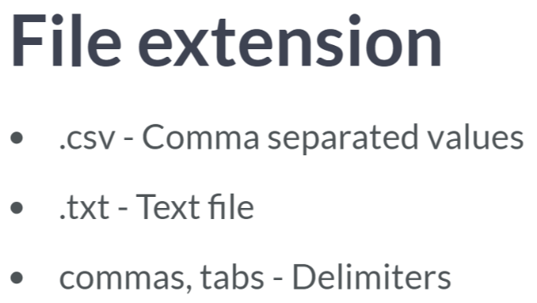Values in flat files can be separated by characters or sequences of characters other than commas, such as a tab, and the character or characters in question is called a delimiter. 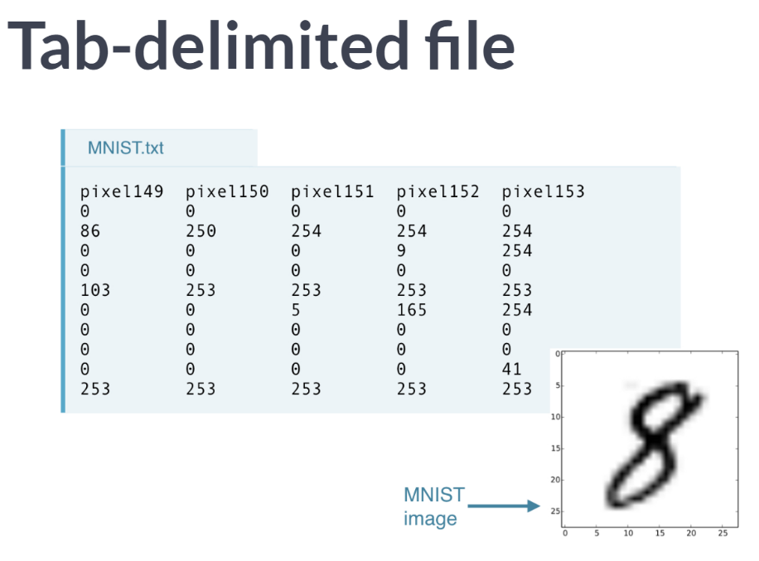   
Note that all fields in the MNIST data are numeric, while the 'titanic.csv' also contained strings.

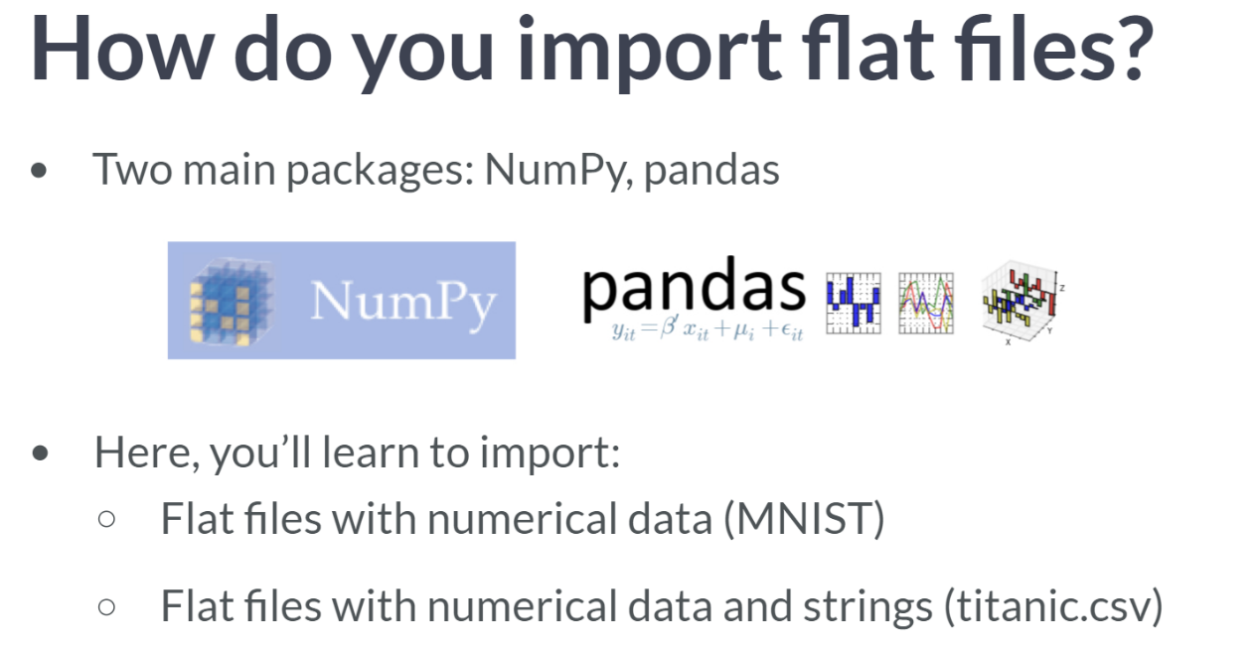

If they consist entirely of numbers and we want to store them as a NumPy array, we will use NumPy. Instead, if we want to store the data in a DataFrame, we could use pandas.

# Pop quiz: examples of flat files

You're now well-versed in importing text files and you're about to become a wiz at importing flat files. But can you remember exactly what a flat file is? Test your knowledge by answering the following question: which of these file types below is NOT an example of a flat file?

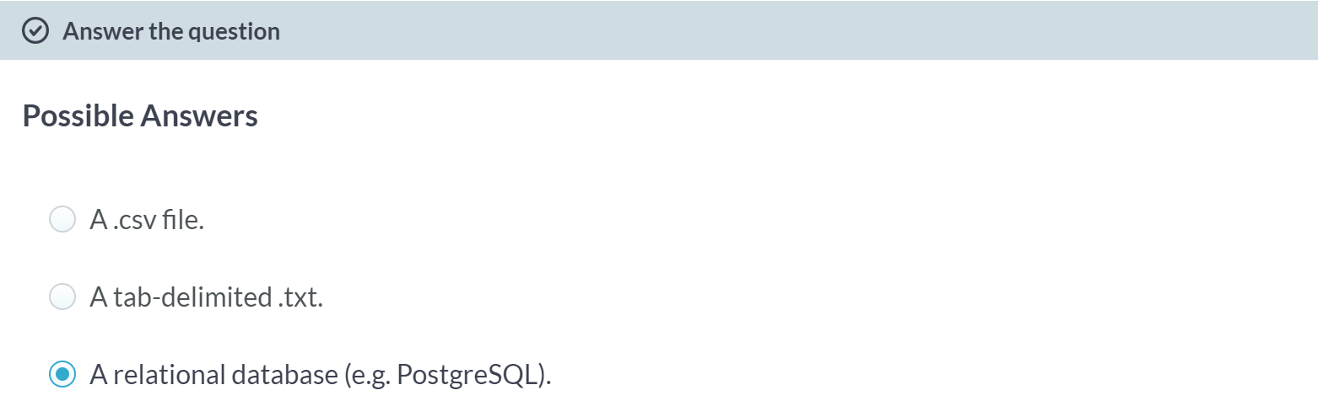That's correct.

# Pop quiz: what exactly are flat files?

Which of the following statements about flat files is incorrect?

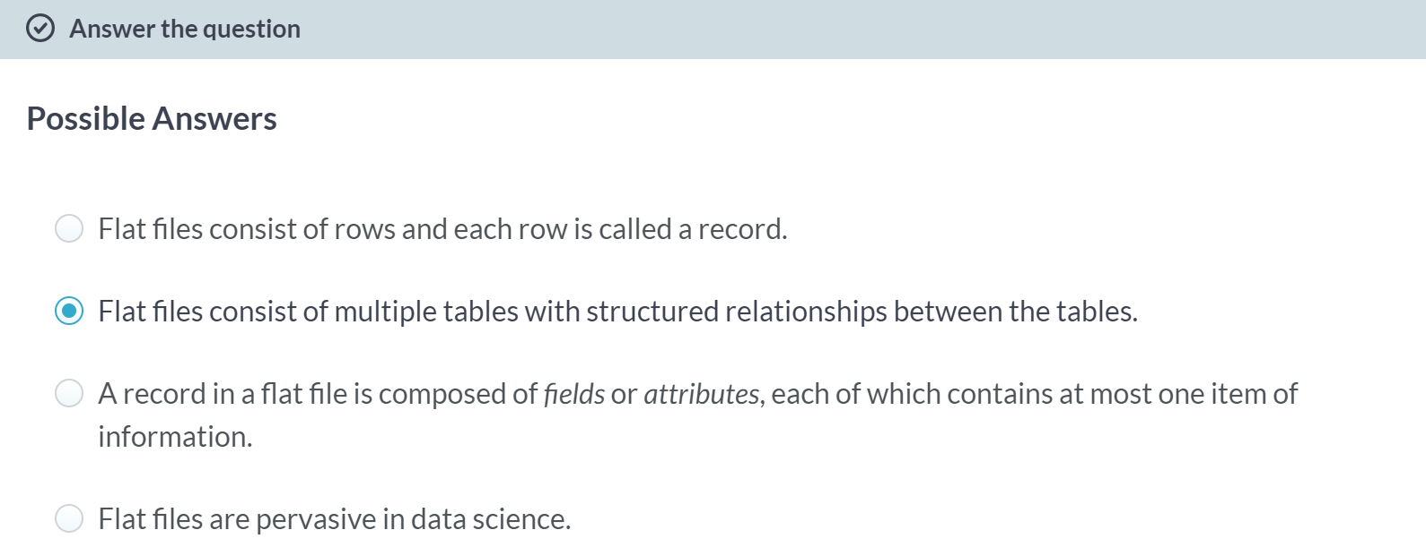  
Indeed, this is not flat at all!

# Why we like flat files and the Zen of Python

In PythonLand, there are currently hundreds of Python Enhancement Proposals, commonly referred to as PEPs. [**PEP8**](https://www.python.org/dev/peps/pep-0008/), for example, is a standard style guide for Python, written by our sensei Guido van Rossum himself. It is the basis for how we here at DataCamp ask our instructors to [**style their code**](https://www.datacamp.com/teach/documentation#tab_style_guide_python). Another one of my favorites is [**PEP20**](https://www.python.org/dev/peps/pep-0020/), commonly called the Zen of Python. Its abstract is as follows:

*Long time Pythoneer Tim Peters succinctly channels the BDFL's guiding principles for Python's design into 20 aphorisms, only 19 of which have been written down.*

If you don't know what the acronym BDFL stands for, I suggest that you look [**here**](https://docs.python.org/3.3/glossary.html#term-bdfl). You can print the Zen of Python in your shell by typing import this into it! You're going to do this now and the 5th aphorism (line) will say something of particular interest.

The question you need to answer is: **what is the 5th aphorism of the Zen of Python?**

**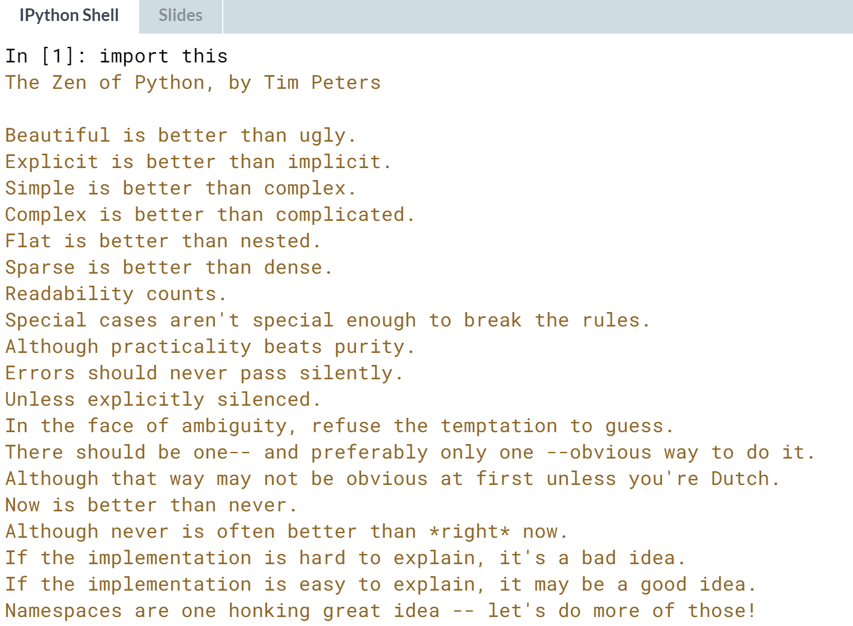  
Answers:** Flat is better than nested.



What if you want to import a flat file and assign it to a variable? NumPy package then comes in handy when all the data are numerical as it can import data as a NumPy array.

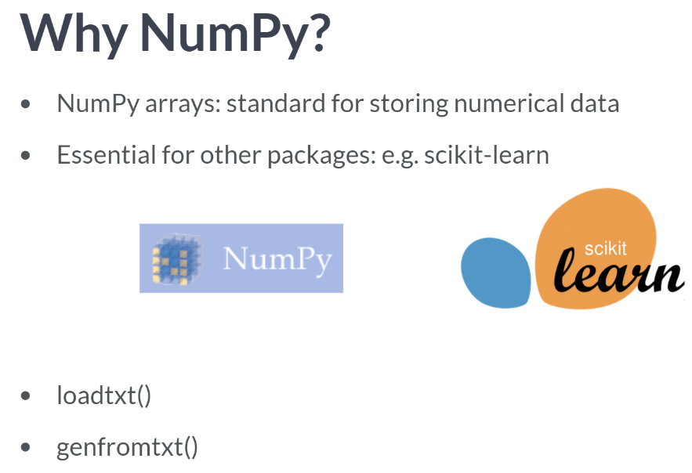NumPy itself has a number of built-in functions that make it far easier and more efficient for us to import data as arrays. Enter the NumPy functions ***loadtxt()*** and ***genfrontxt()***.

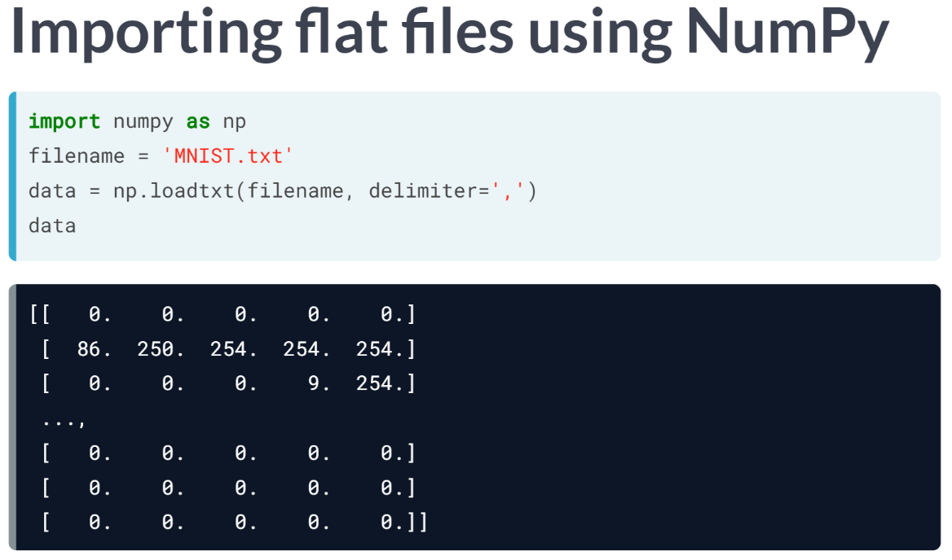

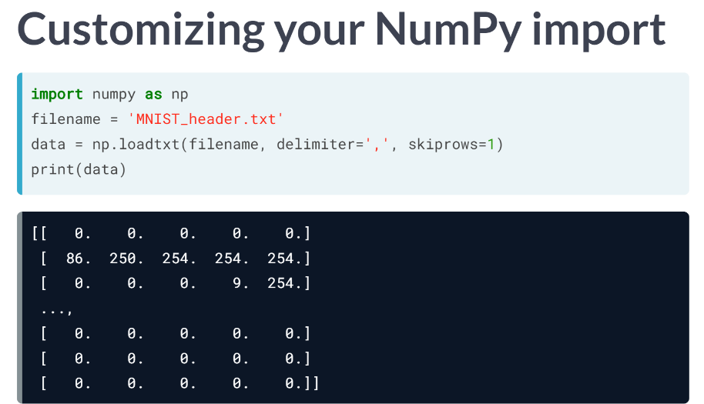For example, if data consists of numeric and your header has strings in it, such as in the MNIST digits data, you will want to skip the first row by calling ***loadtxt()*** with the argument *skiprows* equals 1.

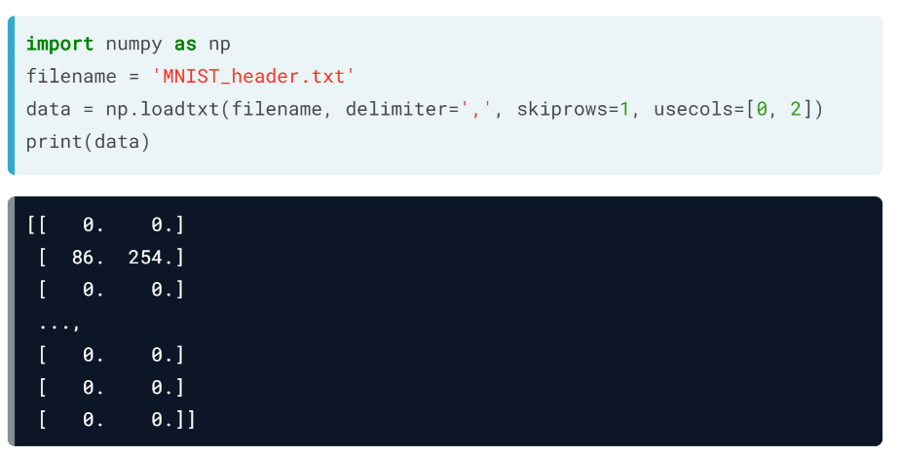  
If you want only the 1st and 3rd columns of the data, you will want to set *usecols* equals the list containing integer 0 and 2.

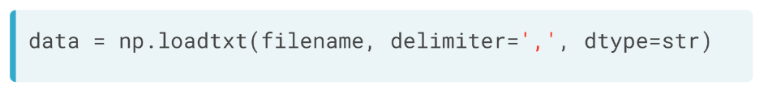

You can also import different datatypes into NumPy arrays: for example, setting the argument *dtype* equals *'str'* will ensure that all entries are imported as strings. ***loadtxt()*** is great for basic cases but tends to break down when we have mixed datatypes. for example, columns consisting of floats and columns consisting of strings.  
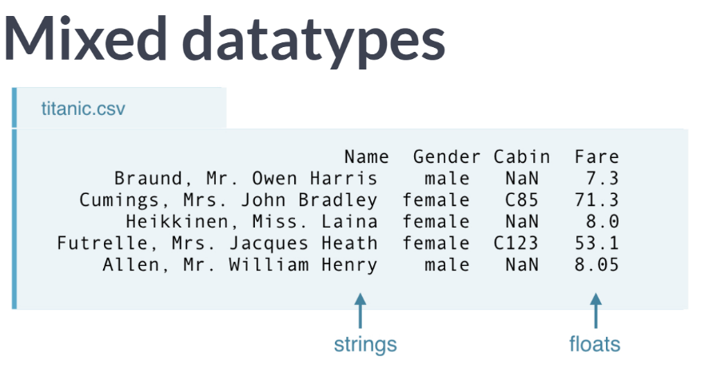

# Using NumPy to import flat files

In this exercise, you're now going to load the MNIST digit recognition dataset using the NumPy function loadtxt() and see just how easy it can be:

* The first argument will be the filename.
* The second will be the delimiter which, in this case, is a comma.

You can find more information about the MNIST dataset [**here**](http://yann.lecun.com/exdb/mnist/) on the webpage of Yann LeCun, who is currently Director of AI Research at Facebook and Founding Director of the NYU Center for Data Science, among many other things.

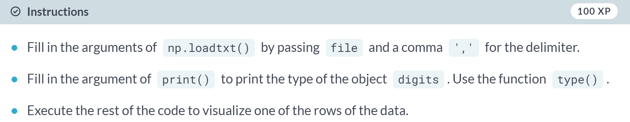

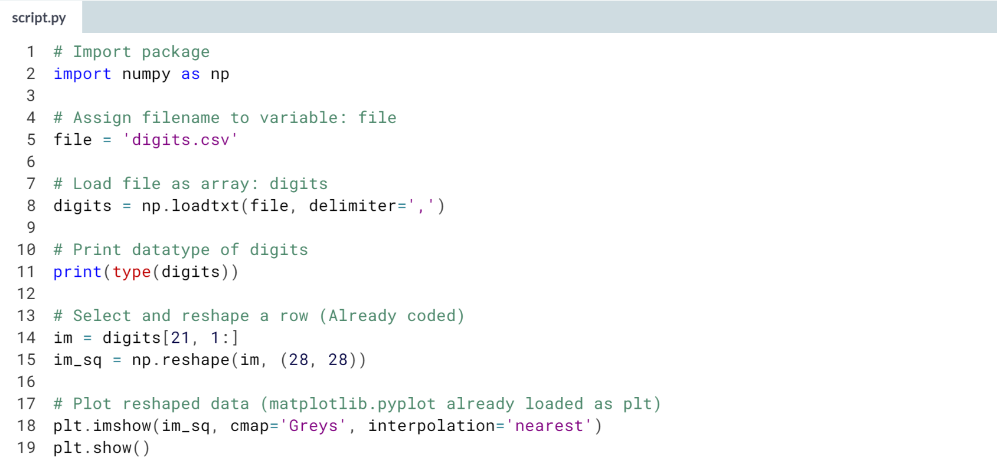

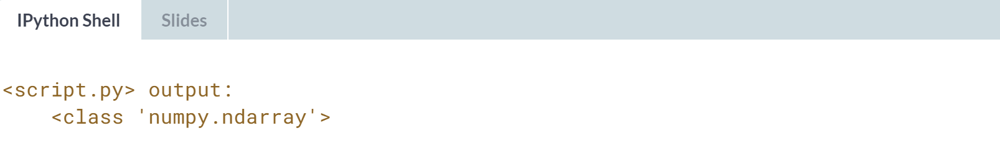

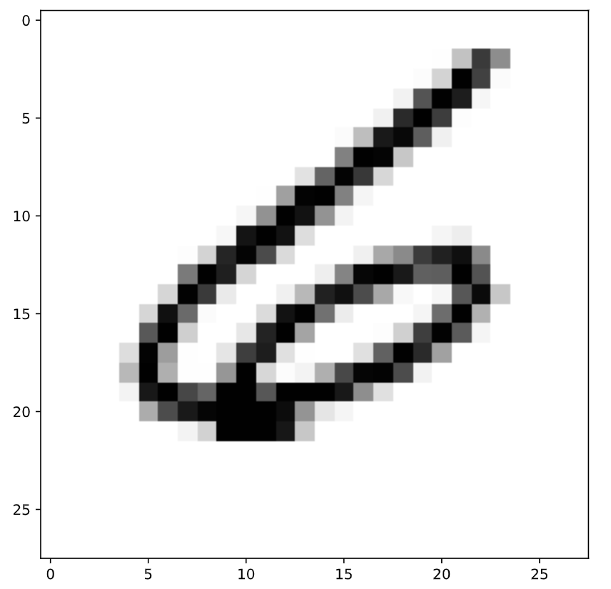

# Customizing your NumPy import

What if there are rows, such as a header, that you don't want to import? What if your file has a delimiter other than a comma? What if you only wish to import particular columns?

There are a number of arguments that np.loadtxt() takes that you'll find useful:

* delimiter changes the delimiter that loadtxt() is expecting.
  + You can use ',' for comma-delimited.
  + You can use '\t' for tab-delimited.
* skiprows allows you to specify how many rows (not indices) you wish to skip
* usecols takes a list of the indices of the columns you wish to keep.

The file that you'll be importing, digits_header.txt, has a header and is tab-delimited.

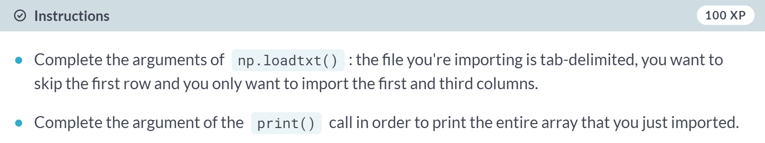

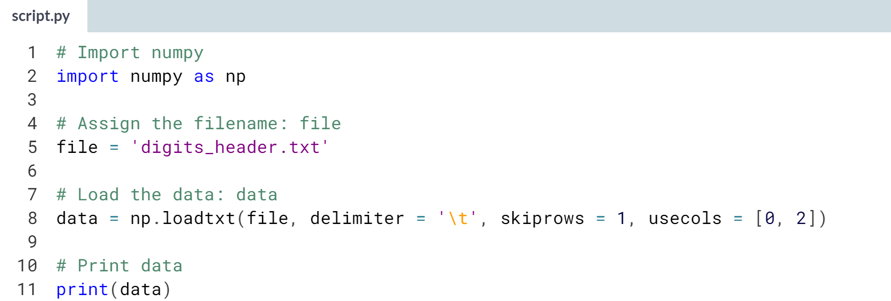  
  
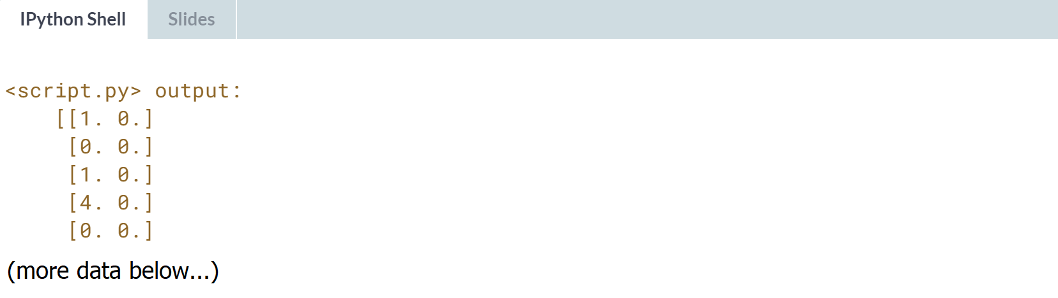

# Importing different datatypes

The file seaslug.txt

* has a text header, consisting of strings
* is tab-delimited.

These data consist of percentage of sea slug larvae that had metamorphosed in a given time period. Read more [**here**](http://www.stat.ucla.edu/~rgould/datasets/aboutseaslugs.html).

Due to the header, if you tried to import it as-is using np.loadtxt(), Python would throw you a ValueError and tell you that it could not convert string to float. There are two ways to deal with this: firstly, you can set the data type argument dtype equal to str (for string).

Alternatively, you can skip the first row as we have seen before, using the skiprows argument.

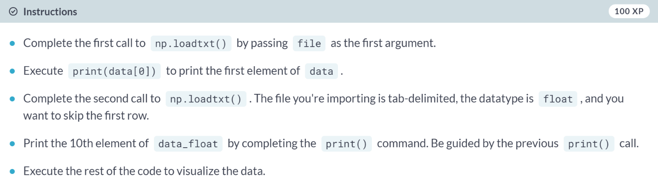  
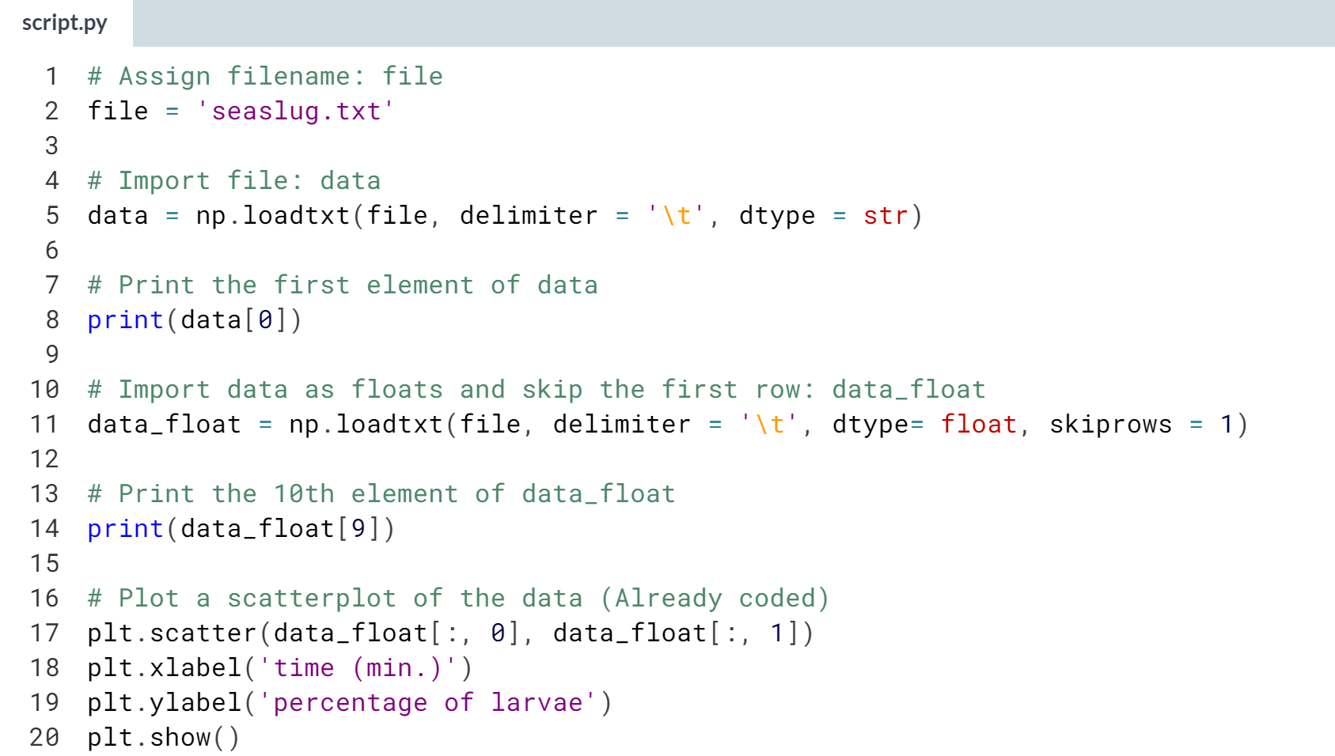

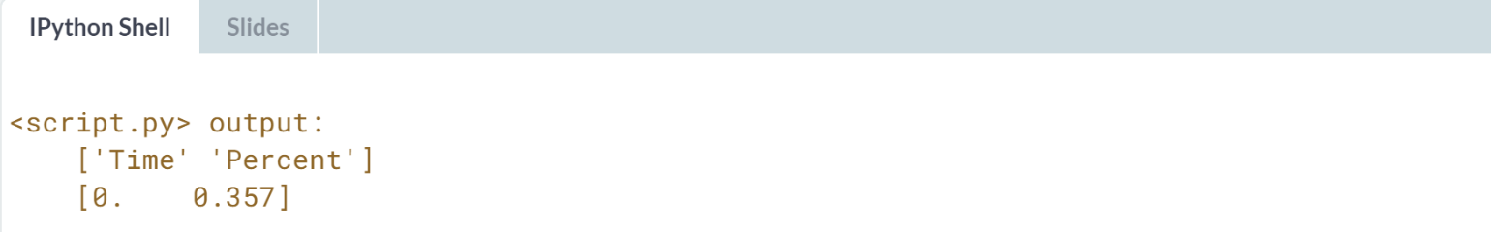

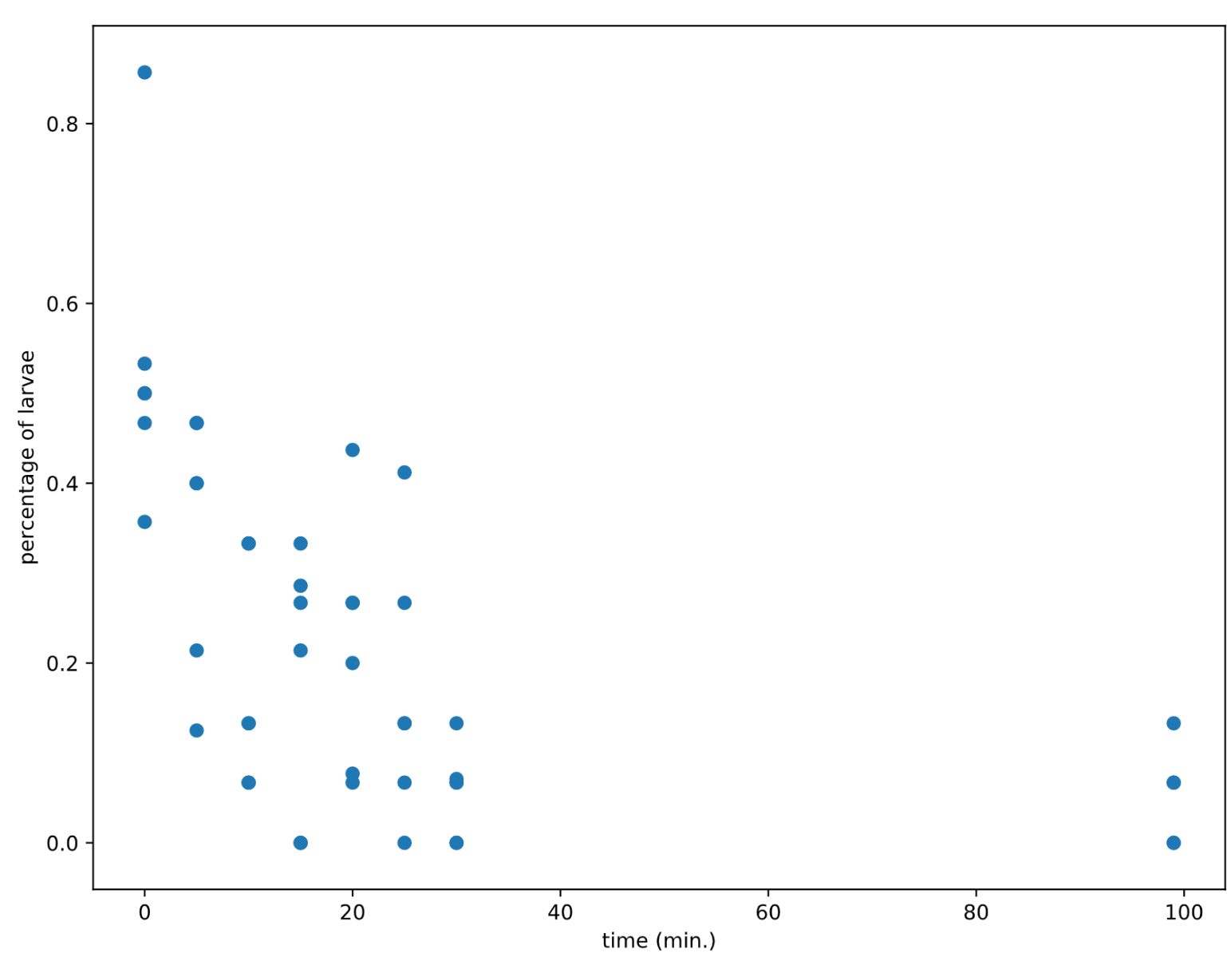

# Working with mixed datatypes (1)

Much of the time you will need to import datasets which have different datatypes in different columns; one column may contain strings and another floats, for example.

The function np.loadtxt() will freak at this. There is another function, np.genfromtxt(), which can handle such structures. If we pass dtype=None to it, it will figure out what types each column should be.

Import 'titanic.csv' using the function np.genfromtxt() as follows:

data = np.genfromtxt('titanic.csv', delimiter=',', names=True, dtype=None)

Here, the first argument is the filename, the second specifies the delimiter , and the third argument names tells us there is a header. Because the data are of different types, data is an object called a [**structured array**](http://docs.scipy.org/doc/numpy/user/basics.rec.html).

Because NumPy arrays have to contain elements that are all the same type, the structured array solves this by being a 1D array, where each element of the array is a row of the flat file imported. You can test this by checking out the array's shape in the shell by executing np.shape(data).

Accessing rows and columns of structured arrays is super-intuitive: to get the ith row, merely execute data[i] and to get the column with name 'Fare', execute data['Fare'].

After importing the Titanic data as a structured array (as per the instructions above), print the entire column with the name Survived to the shell. What are the last 4 values of this column?  
  
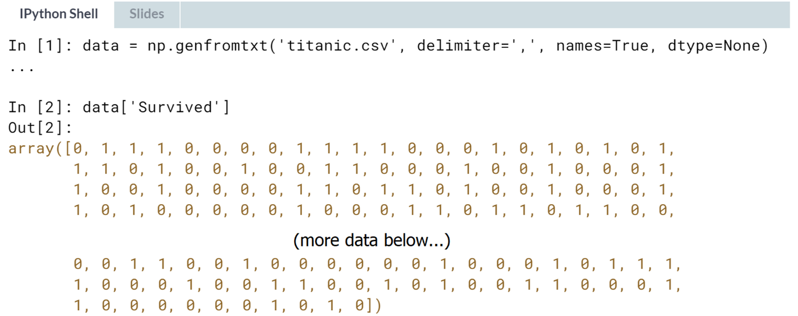  
**Answer**: 1,0,1,0 is the last four values of this column.

# Working with mixed datatypes (2)

You have just used np.genfromtxt() to import data containing mixed datatypes. There is also another function np.recfromcsv() that behaves similarly to np.genfromtxt(), except that its default dtype is None. In this exercise, you'll practice using this to achieve the same result.

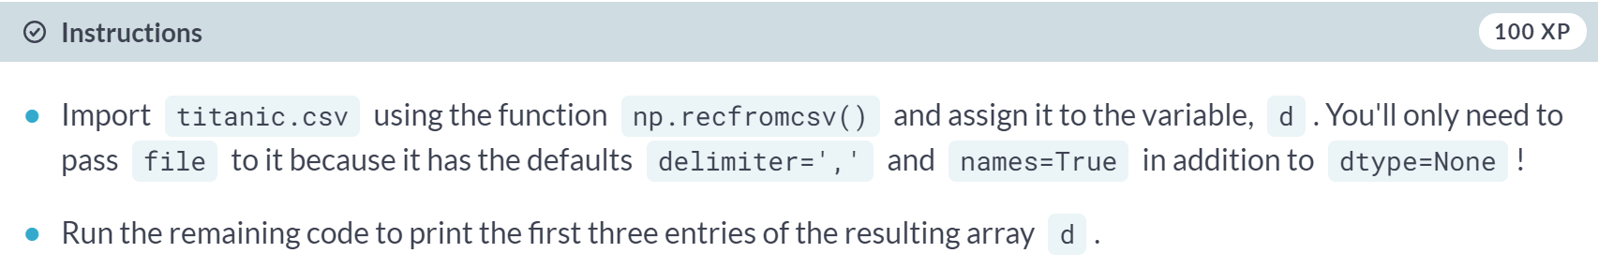

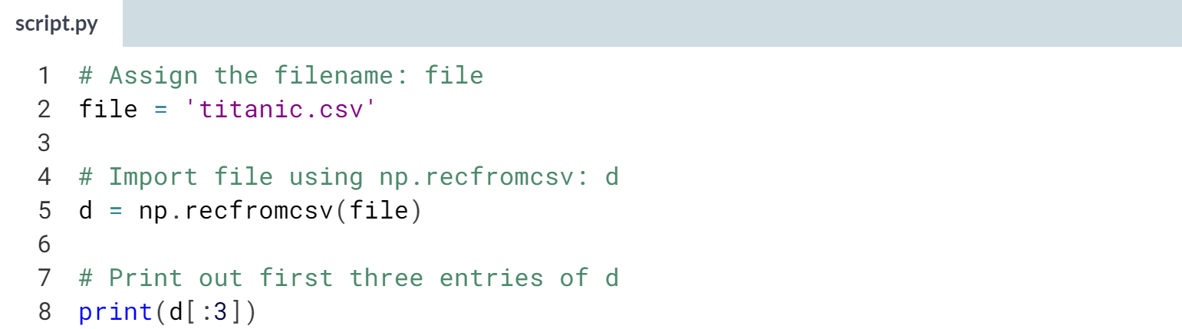

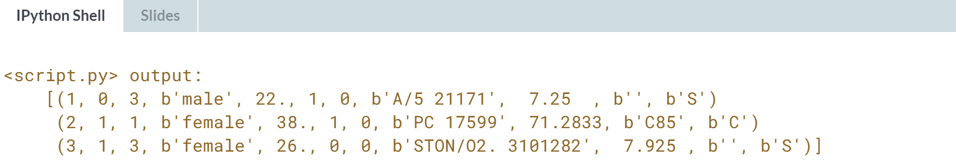



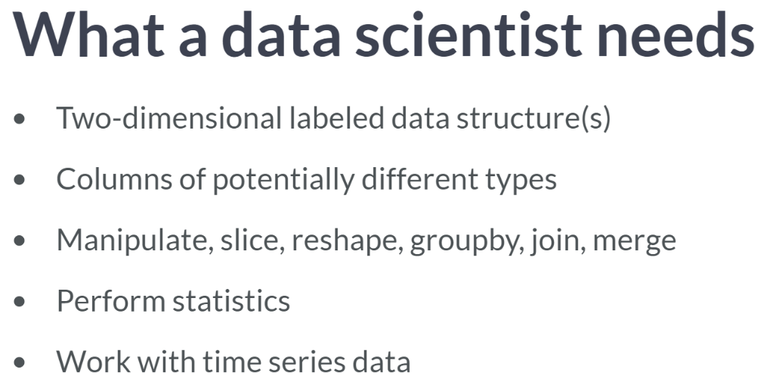

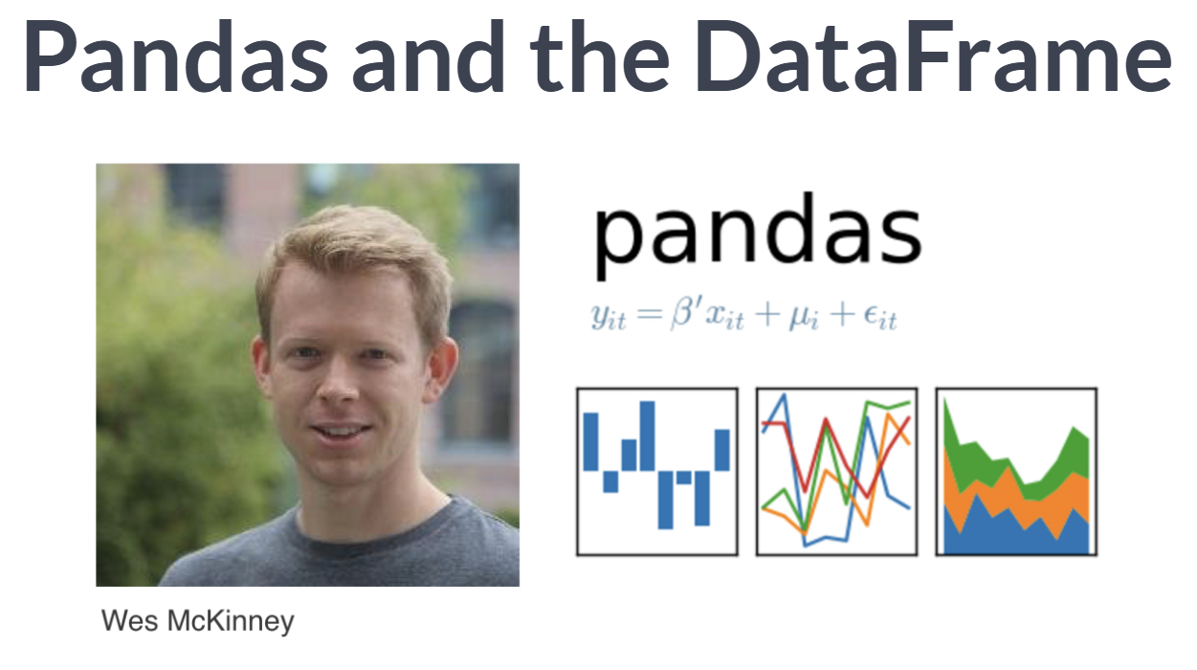  
The need for such a data structure, among other issues, prompted Wes McKinney to develop the pandas library for Python.

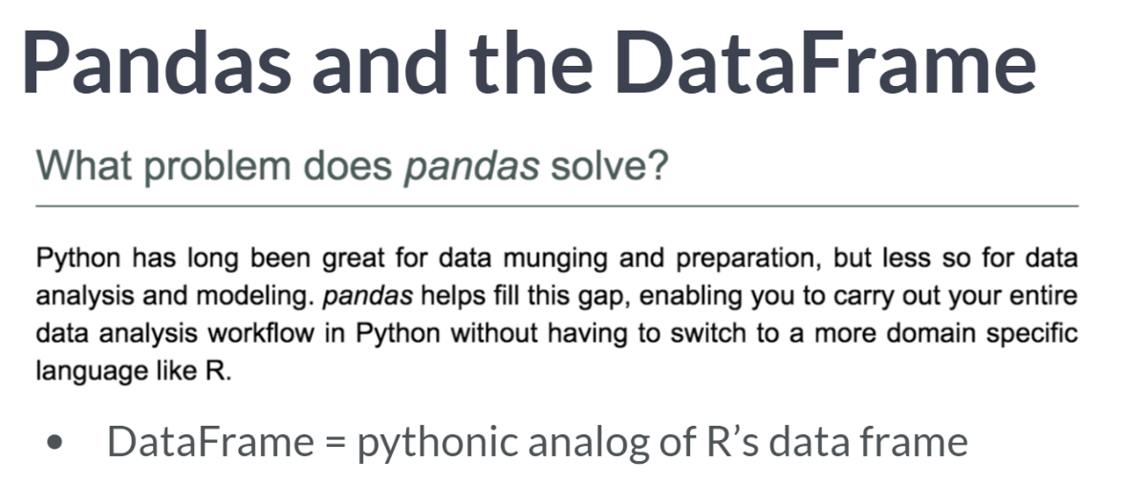  
The data structure most relevant to the data manipulation and analysis workflow that pandas offers is the DataFrame, and it is the Pythonic analogue of R's dataframe.

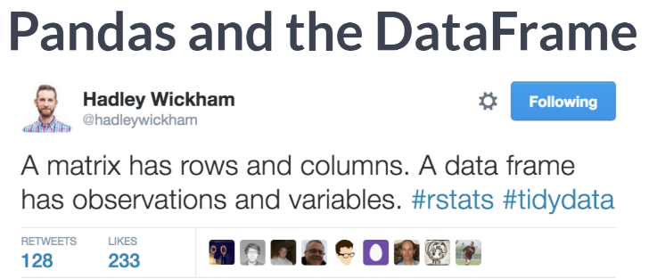

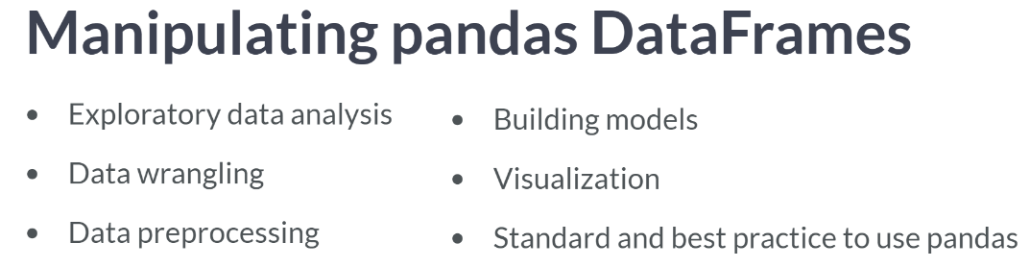  
It is the best practice in data science to use pandas to import flat files as DataFrames. We will see later in this course that how many other types of data, whether they're stored in relational databases, hdf5, MATLAP or excel files, can easily be imported as DataFrames.

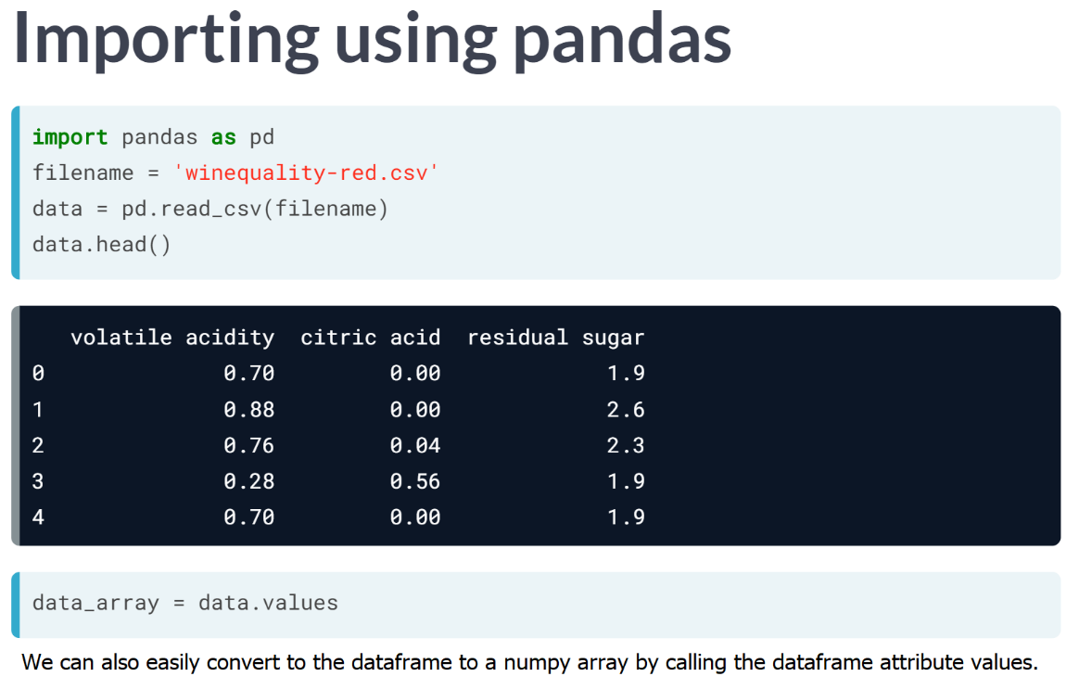  
  
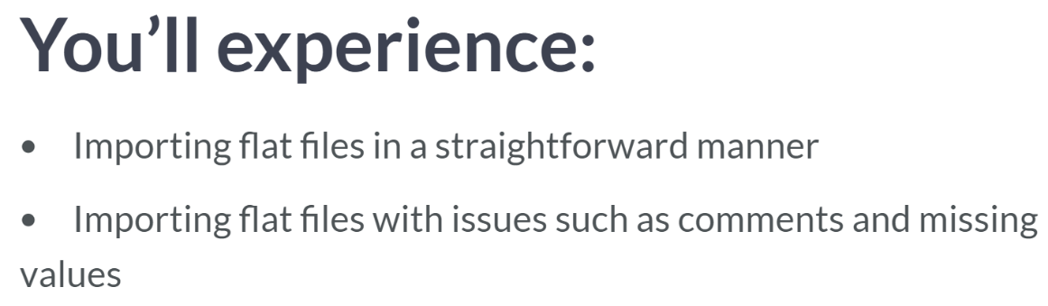

# Using pandas to import flat files as DataFrames (1)

In the last exercise, you were able to import flat files containing columns with different datatypes as numpy arrays. However, the DataFrame object in pandas is a more appropriate structure in which to store such data and, thankfully, we can easily import files of mixed data types as DataFrames using the pandas functions read_csv() and read_table().

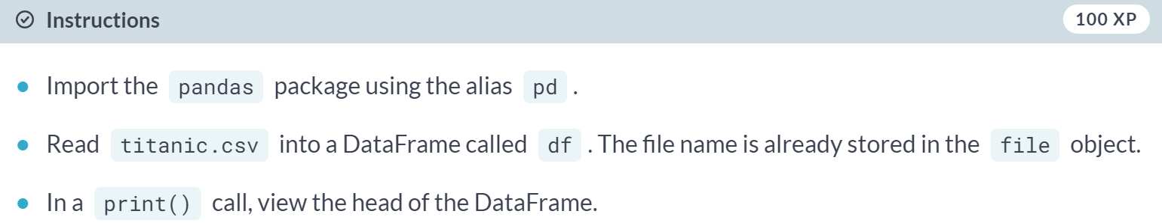  
  
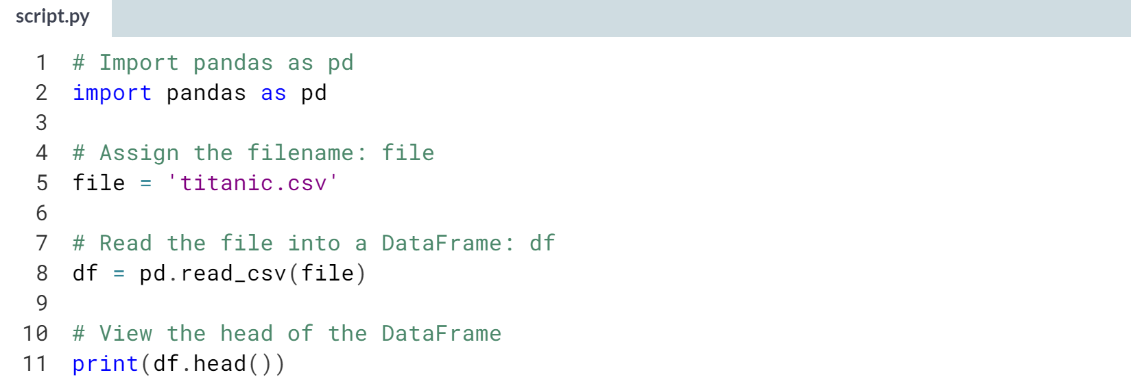

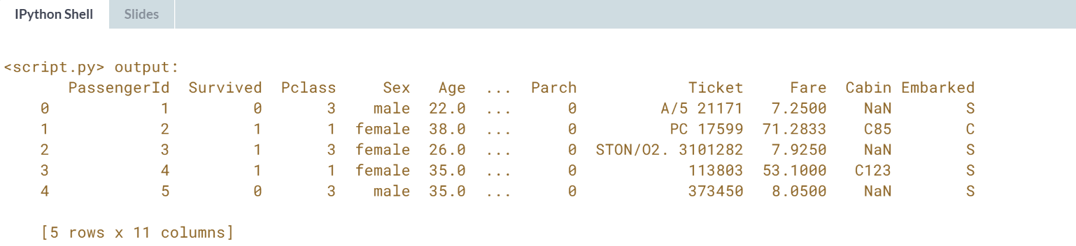

# Using pandas to import flat files as DataFrames (2)

In the last exercise, you were able to import flat files into a pandas DataFrame. As a bonus, it is then straightforward to retrieve the corresponding NumPy array using the attribute values. You'll now have a chance to do this using the MNIST dataset, which is available as digits.csv.

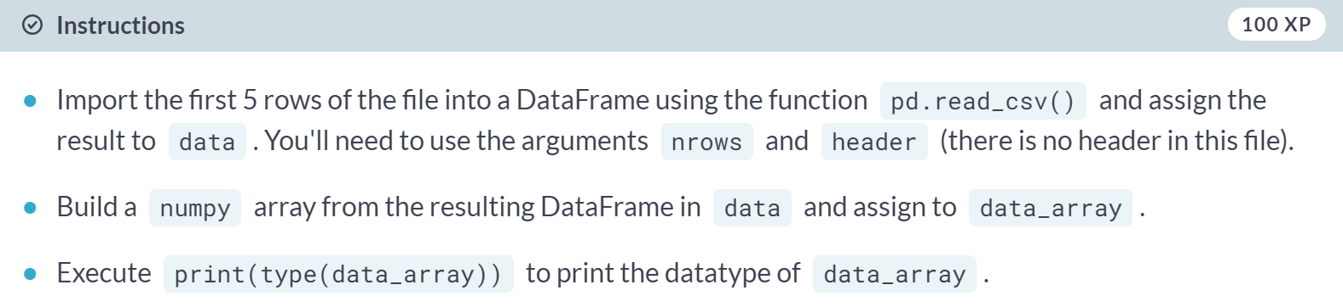

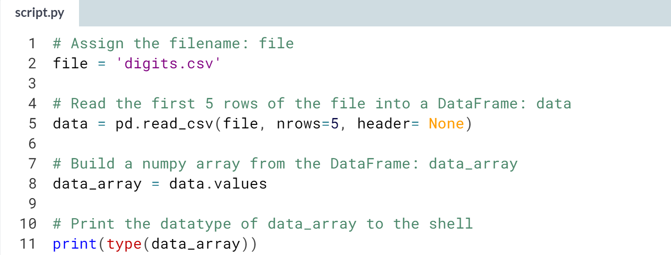

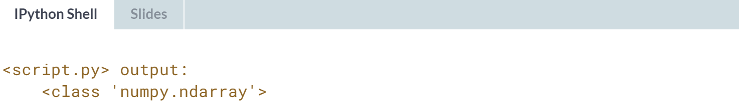

# Customizing your pandas import

The pandas package is also great at dealing with many of the issues you will encounter when importing data as a data scientist, such as comments occurring in flat files, empty lines and missing values. Note that missing values are also commonly referred to as NA or NaN. To wrap up this chapter, you're now going to import a slightly corrupted copy of the Titanic dataset titanic_corrupt.txt, which

* contains comments after the character '#'
* is tab-delimited.

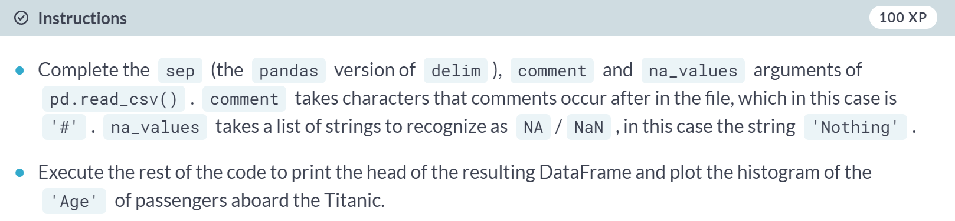

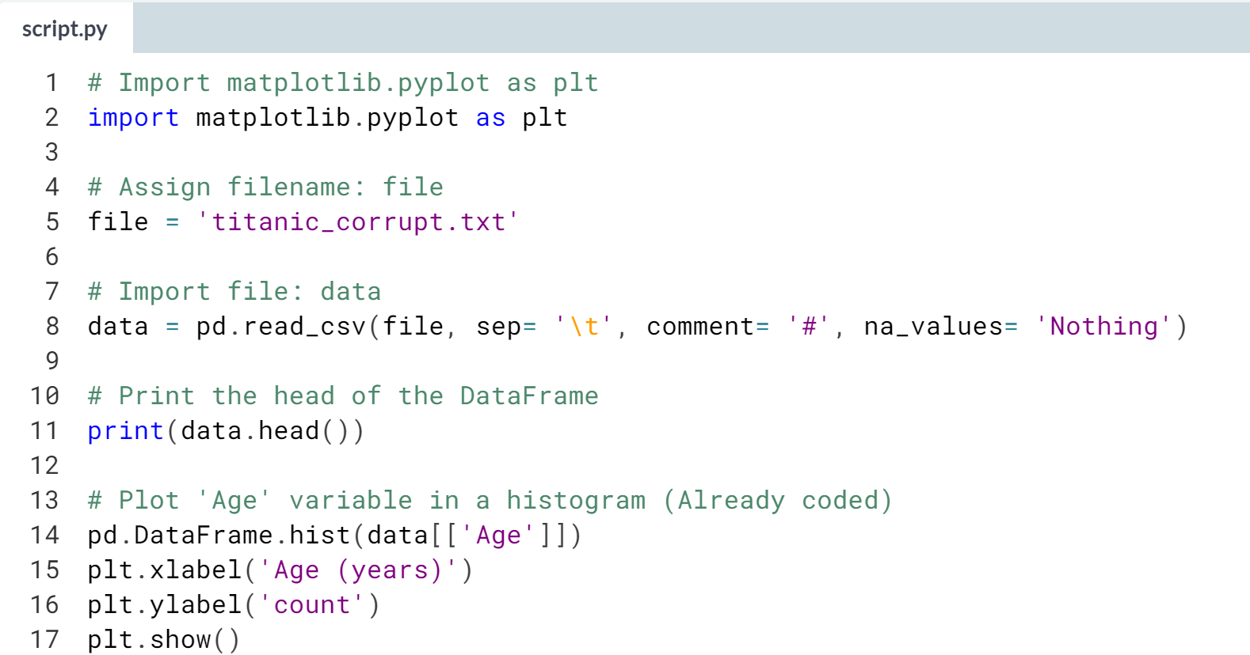

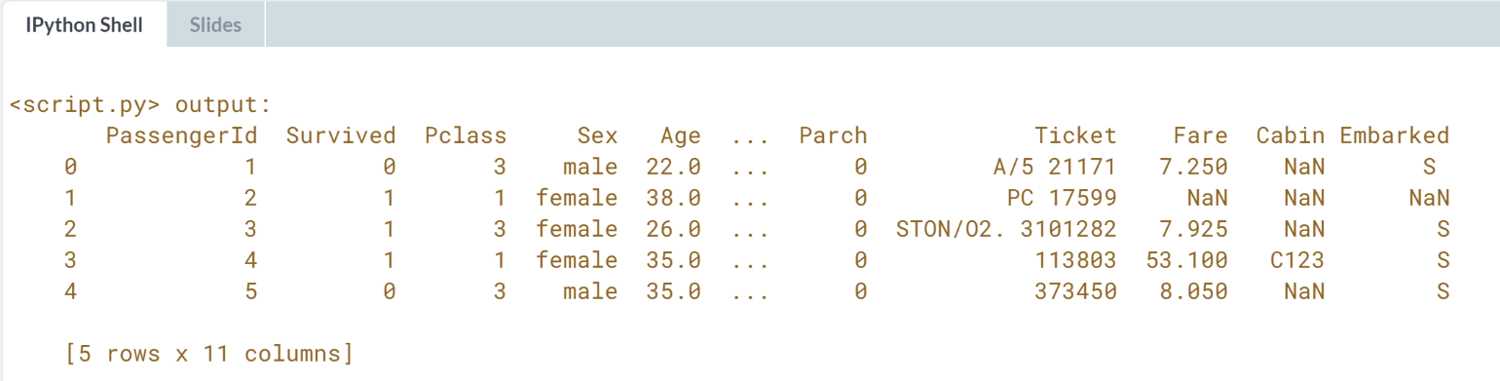

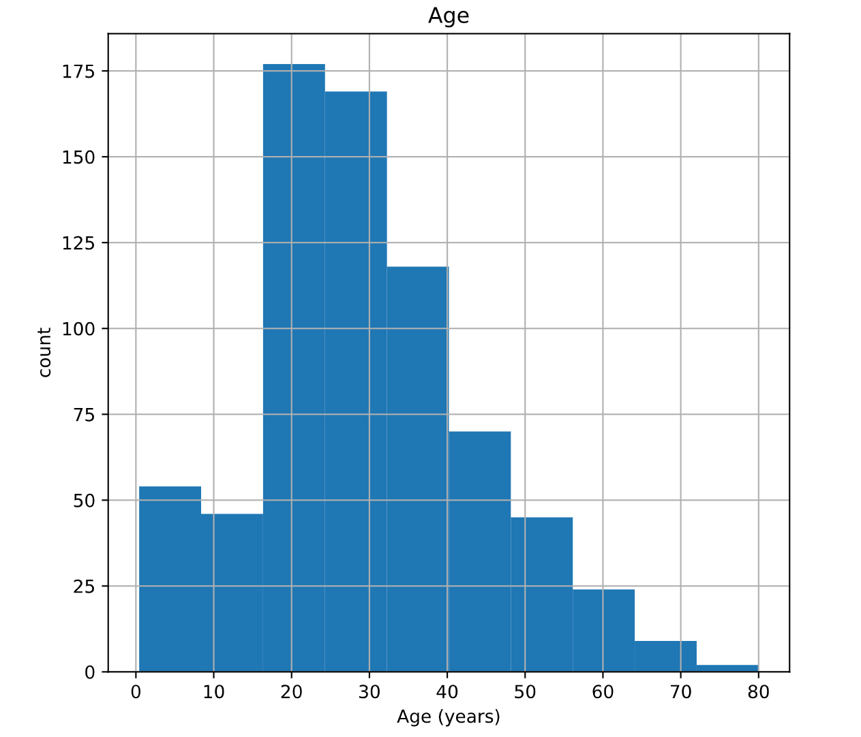



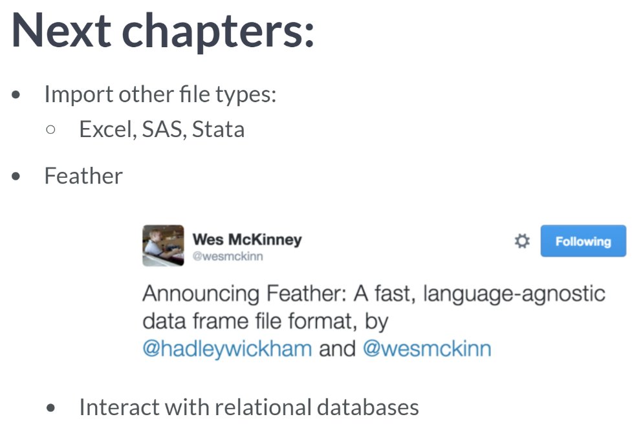  
Due to the active development community in open source software, there is constant activity in file formats and ways to import data: for example, Wes McKinney, the creator of pandas, and Hadley Wickham, of R development fame, announced a new and fast on-disk format for DataFrames for R and Python, called feather. As dataframe are one of the most important data structures for data scientists, let's definitely keep our eyes on feather.

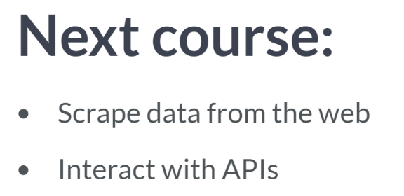  
Then, in the sequel to this course, you'll learn how to tear all types of data down from the web and how to interact with APIs to fulfill your big data fix. These are all essential techniques for the modern day Data Scientist to master.

**2. Importing data from other file types**

You've learned how to import flat files, but there are many other file types you will potentially have to work with as a data scientist. In this chapter, you'll learn how to import data into Python from a wide array of important file types. These include pickled files, Excel spreadsheets, SAS and Stata files, HDF5 files, a file type for storing large quantities of numerical data, and MATLAB files.



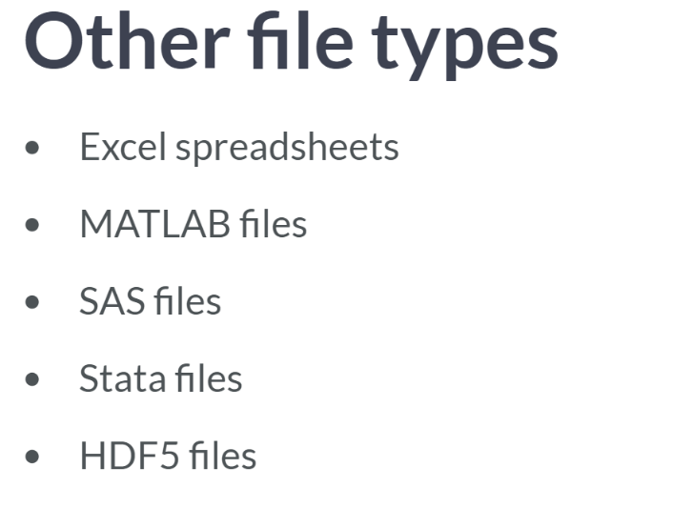  
HDF5 files are becoming a more prevalent way to store large datasets, as demonstrated by the fact hat the LIGO researchers use it to store their data.

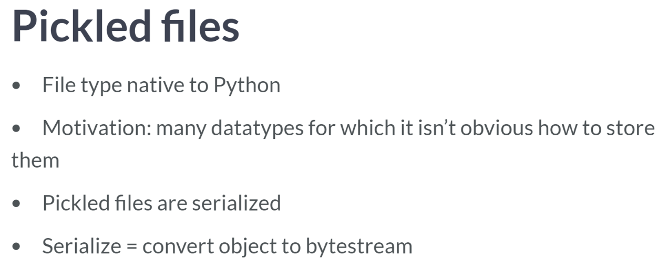  
The concept of pickling a file is motivated by the following: while it may be easy to save a numpy array or a pandas dataframe to a flat file, there are many other datatypes, such as dictionaries and lists, for which it isn't obvious as to how to store them.

If you want your files to be human readable, you may want to save them as text file in a clever manner (JSONs, which you will see in a later chapter) are appropriate for Python dictionaries). If you want to just be able to import them into Python, you can serialize them.

All this means is converting the object into a sequence of bytes, or byte stream.

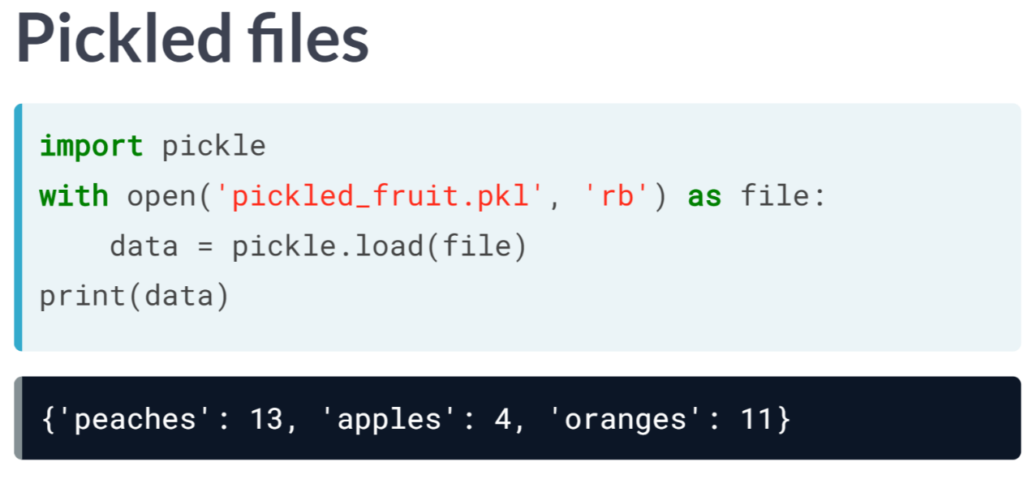  
We will learn how to import files that have been already been pickled. As we've done before, when opening a such file, you will want to specify that it is read only; you'll want to also specify that it is a binary file, meaning that it is computer-readable and not human-readable. To specify both read only and binary, you'll want to pass the string *'rb'* as the second argument of open.

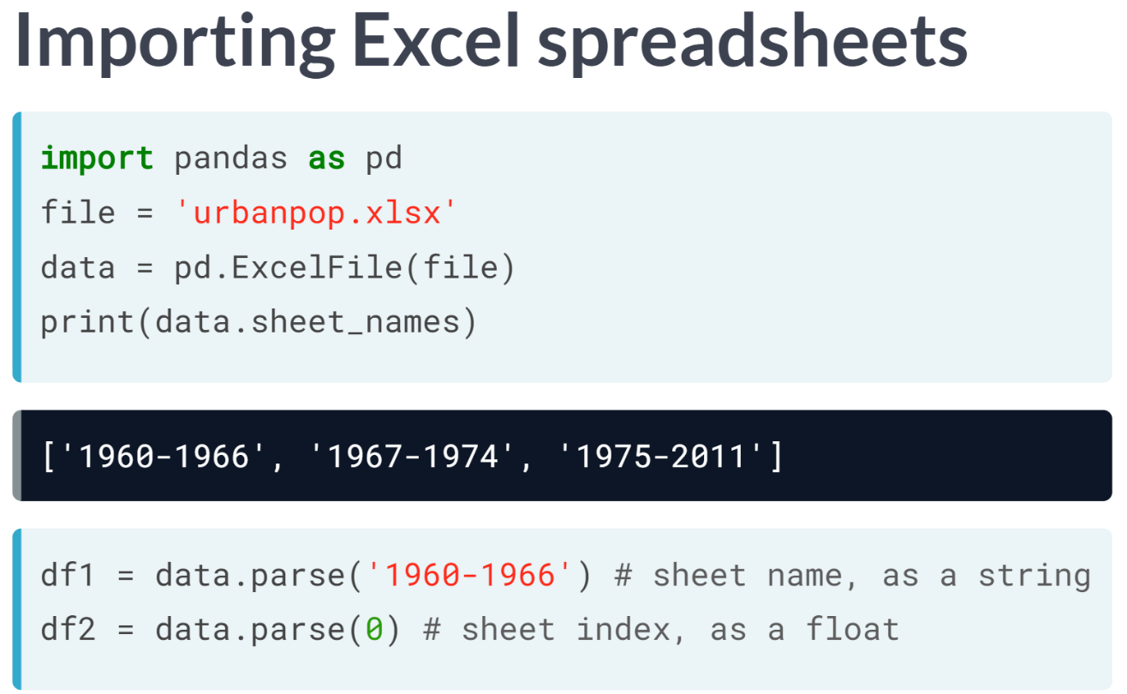  
You will then dive headfirst into Excel spreadsheets, the use of which is so widespread that they need next to no introduction at all. Using Pandas to import excel is a great way because it produces data frames natively. As you can see in the example, you can use the function ***Excelfile()*** to assign an Excel file to a variable data.

As an Excel file consists of sheets, the first thing to do is figure out what the sheets are. This is straightforward with the command *'data.sheet_names'*.

To then load a particular sheet as a dataframe, you need only apply the method parse to the object with a single argument, which is either the name as string or the index as the sheet that you wish to load: pandas is clever enough to know if you are telling it the sheet name or the index.

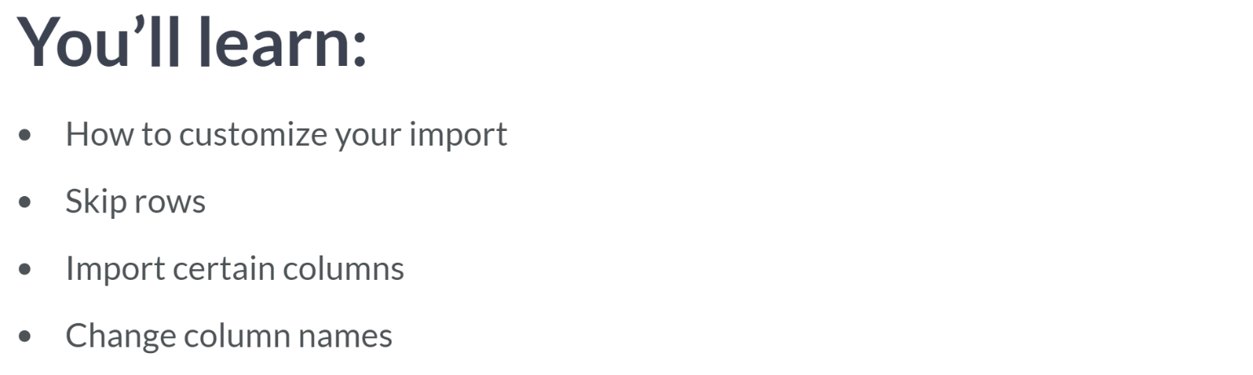

# Not so flat any more

In Chapter 1, you learned how to use the IPython magic command ! ls to explore your current working directory. You can also do this natively in Python using the [**library os**](https://docs.python.org/2/library/os.html), which consists of miscellaneous operating system interfaces.

The first line of the following code imports the library os, the second line stores the name of the current directory in a string called wd and the third outputs the contents of the directory in a list to the shell.

import os

wd = os.getcwd()

os.listdir(wd)

Run this code in the IPython shell and answer the following questions. Ignore the files that begin with ..

Check out the contents of your current directory and answer the following questions: (1) which file is in your directory and NOT an example of a flat file; (2) why is it not a flat file?

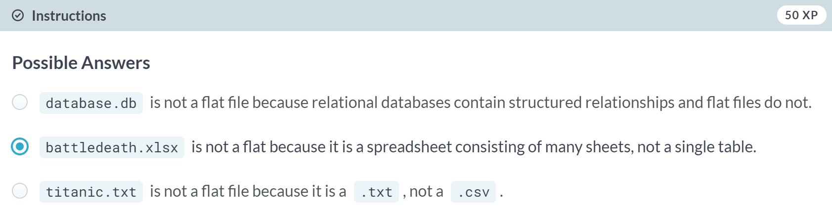

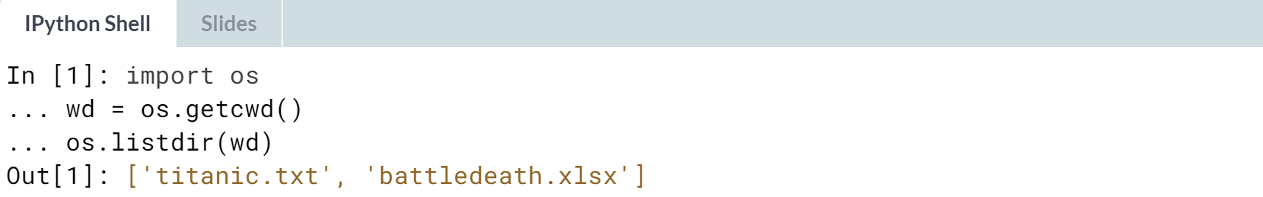

# Loading a pickled file

There are a number of datatypes that cannot be saved easily to flat files, such as lists and dictionaries. If you want your files to be human readable, you may want to save them as text files in a clever manner. JSONs, which you will see in a later chapter, are appropriate for Python dictionaries.

However, if you merely want to be able to import them into Python, you can [**serialize**](https://en.wikipedia.org/wiki/Serialization) them. All this means is converting the object into a sequence of bytes, or a bytestream.

In this exercise, you'll import the pickle package, open a previously pickled data structure from a file and load it.

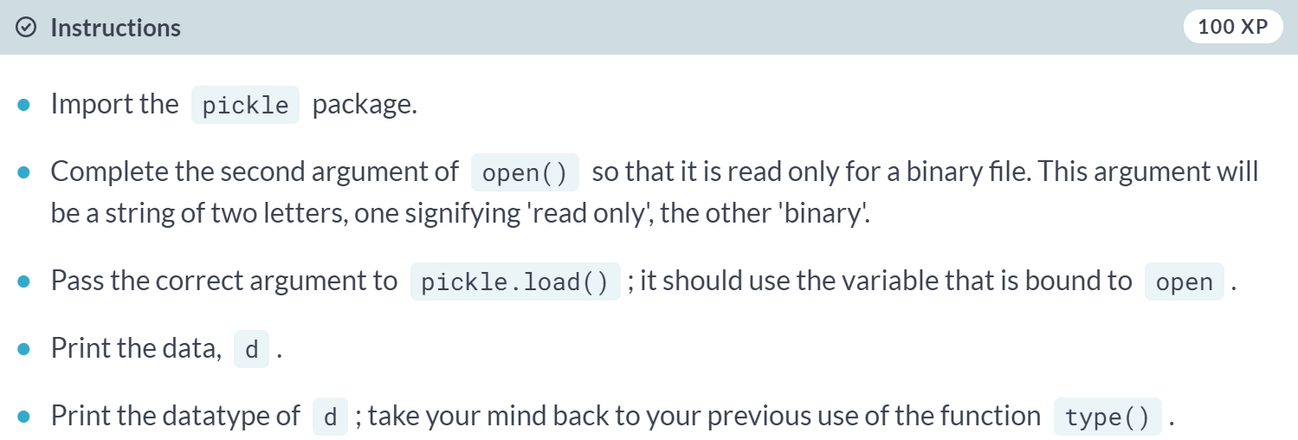

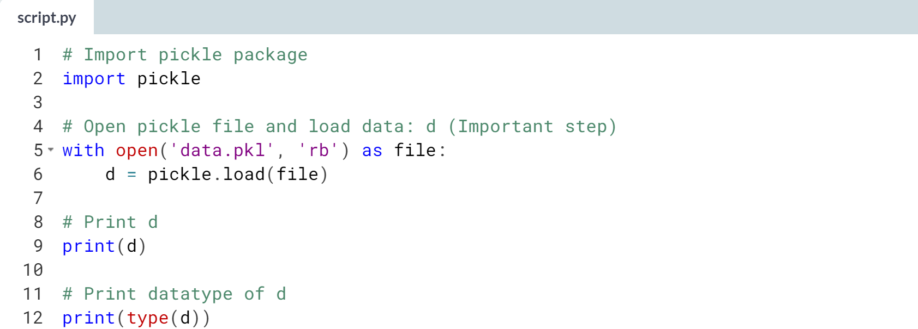  
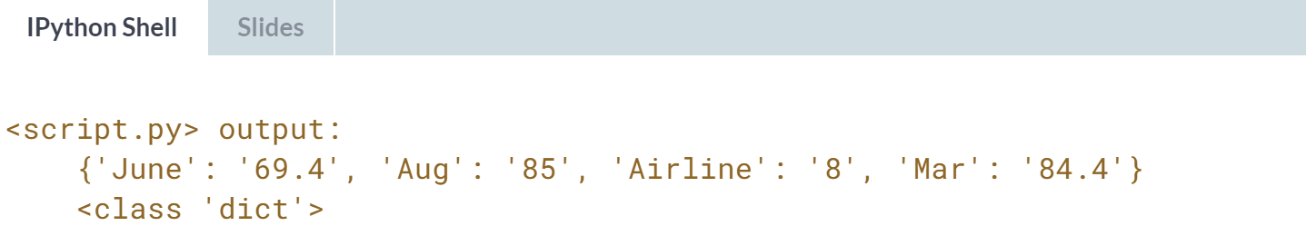

# Listing sheets in Excel files

Whether you like it or not, any working data scientist will need to deal with Excel spreadsheets at some point in time. You won't always want to do so in Excel, however!

Here, you'll learn how to use pandas to import Excel spreadsheets and how to list the names of the sheets in any loaded .xlsx file.

Recall from the video that, given an Excel file imported into a variable spreadsheet, you can retrieve a list of the sheet names using the attribute spreadsheet.sheet_names.

Specifically, you'll be loading and checking out the spreadsheet 'battledeath.xlsx', modified from the Peace Research Institute Oslo's (PRIO) [**dataset**](https://www.prio.org/Data/Armed-Conflict/Battle-Deaths/The-Battle-Deaths-Dataset-version-30/). This data contains age-adjusted mortality rates due to war in various countries over several years.

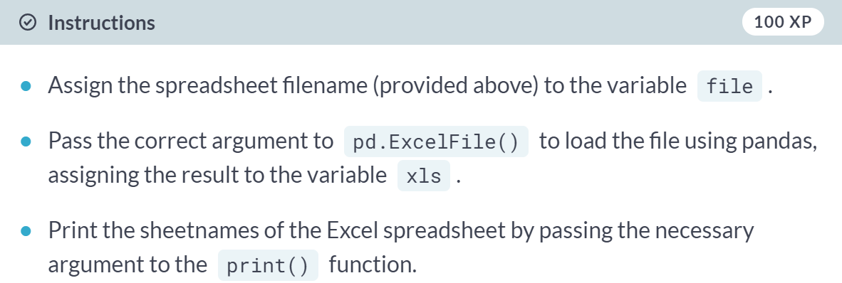  
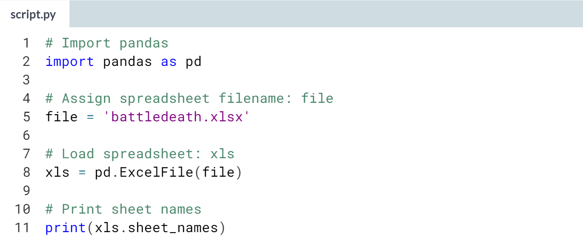  
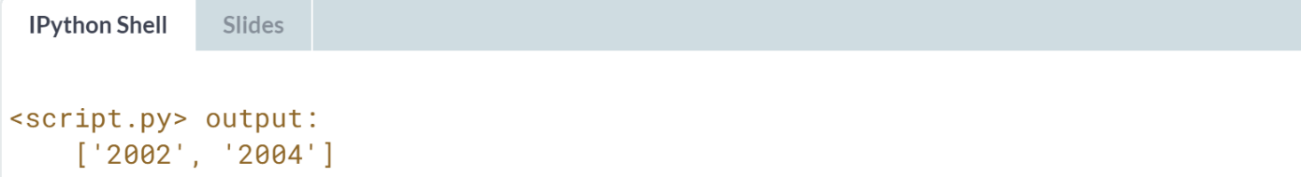

# Importing sheets from Excel files

In the previous exercises, you saw that the Excel file contains two sheets, '2002' and '2004'. The next step is to import these.

In this exercise, you'll learn how to import any given sheet of your loaded .xlsx file as a DataFrame. You'll be able to do so by specifying either the sheet's name or its index.

The spreadsheet 'battledeath.xlsx' is already loaded as xls.

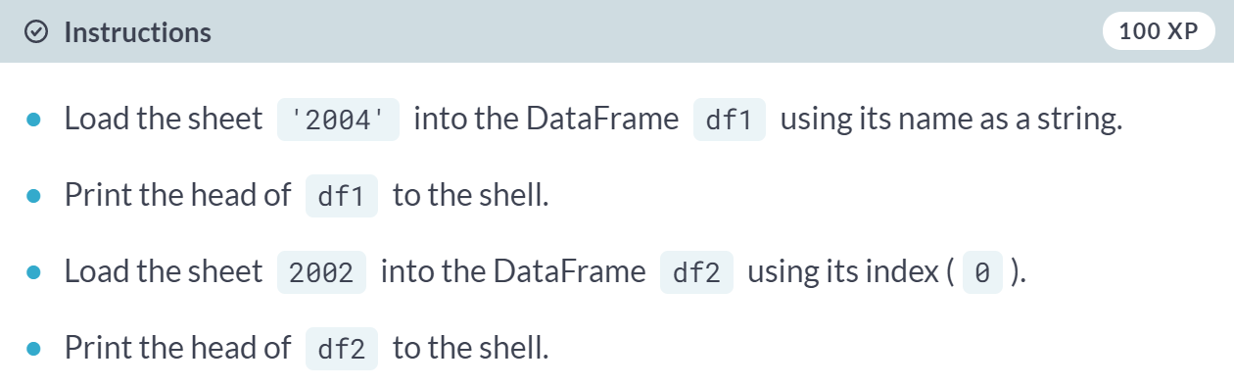  
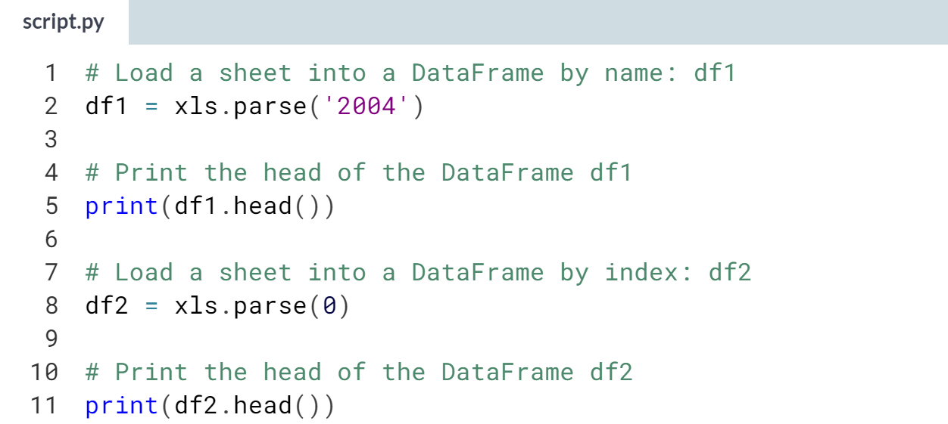  
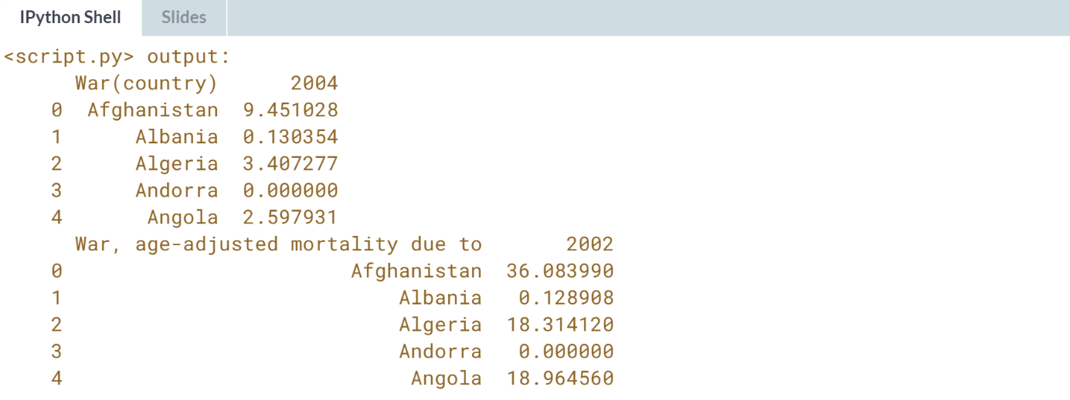  
Awesome! You'll typically find yourself referring to the Excel sheet by name, but it's good to know you can also use indexes.

# Customizing your spreadsheet import

Here, you'll parse your spreadsheets and use additional arguments to skip rows, rename columns and select only particular columns.

The spreadsheet 'battledeath.xlsx' is already loaded as xls. As before, you'll use the method parse(). This time, however, you'll add the additional arguments skiprows, names and usecols.

These skip rows name the columns and designate which columns to parse, respectively. All these arguments can be assigned to lists containing the specific row numbers, strings, and column numbers, as appropriate.

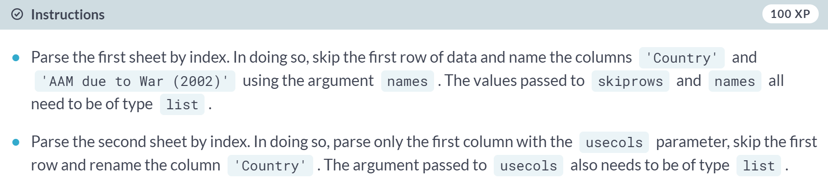

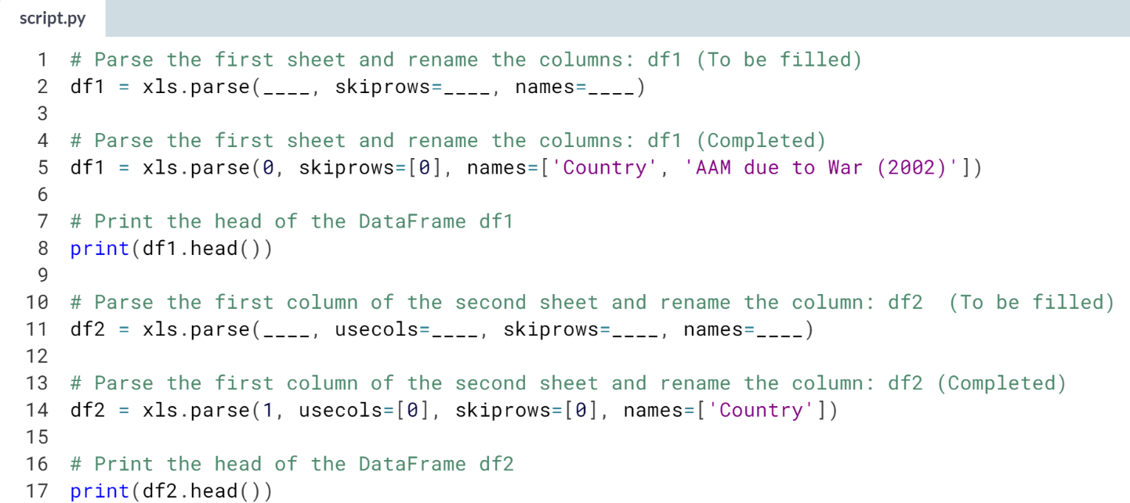  
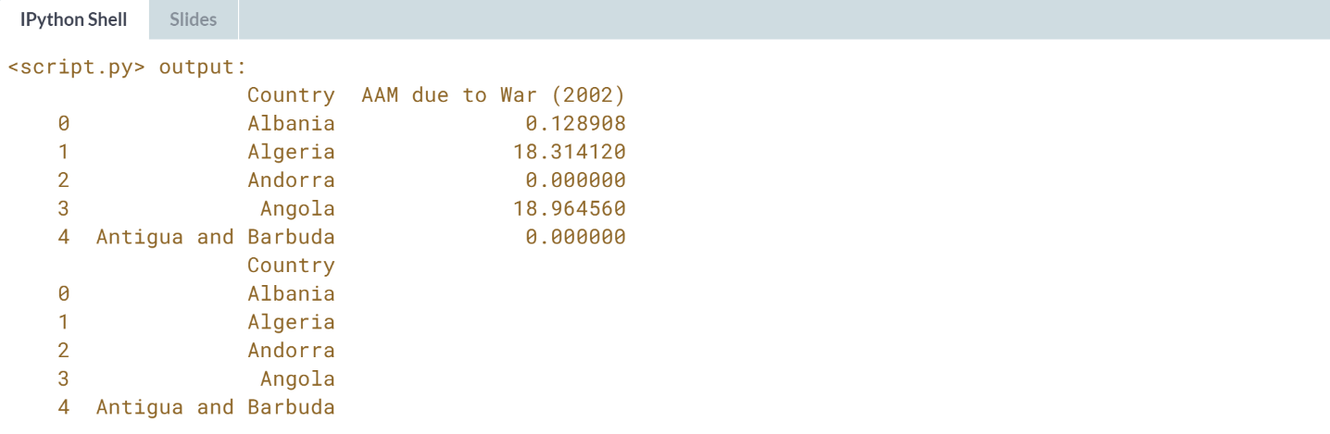



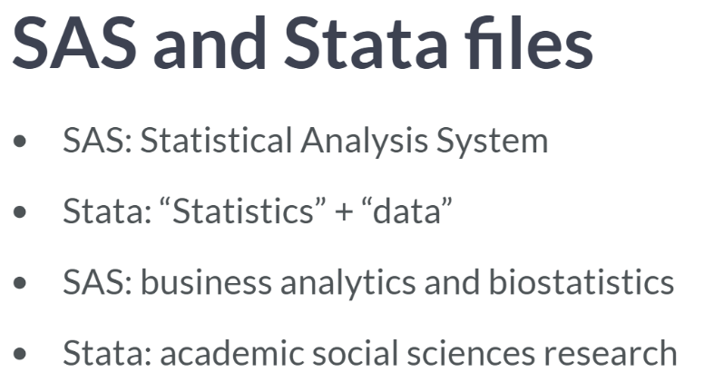

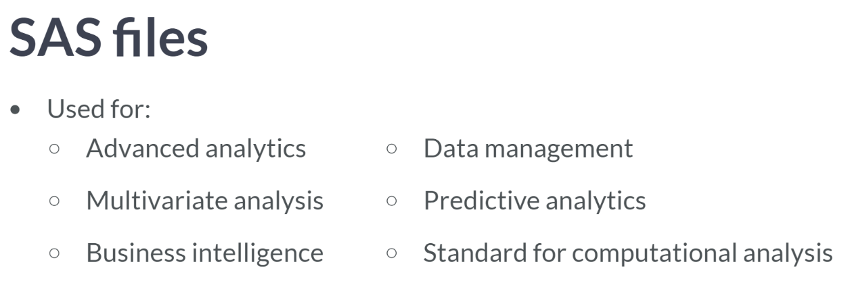

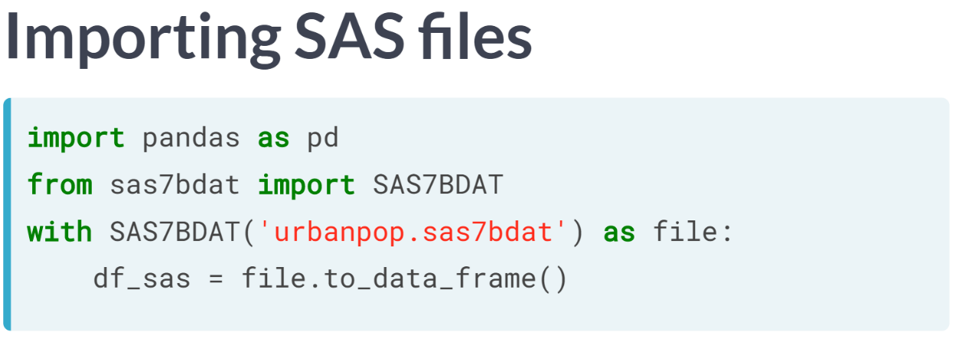The most common SAS files have the extension .sas7bdat and .sas7bcat, which are dataset files and catalog files respectively.

You'll learn how to import former as DataFrames using the function SAS7BDAT (upper case) from the package sas7bdat (lower case).

In this case, we can bind the variable file to a connection to the file, 'urbanpop.sas7bdat' in a context manager. Within this context, you can assign to a variable df_sas the result of applying method to_data_frame to file.

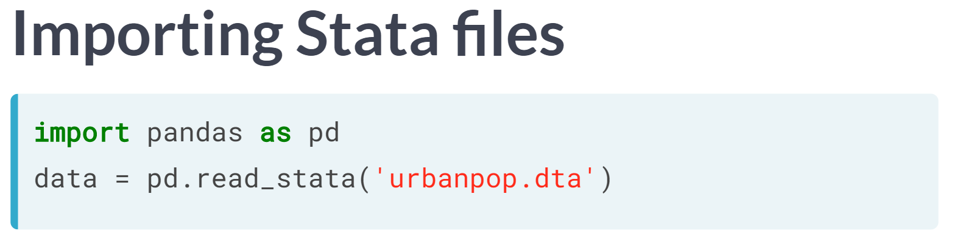Stata files have extension .dta, and we can import them using pandas. We don't even need to initialize a context manager in this case. We merely pass the filename to the function read_stata and assign it to a variable.

# How to import SAS7BDAT

How do you correctly import the function SAS7BDAT() from the package sas7bdat?

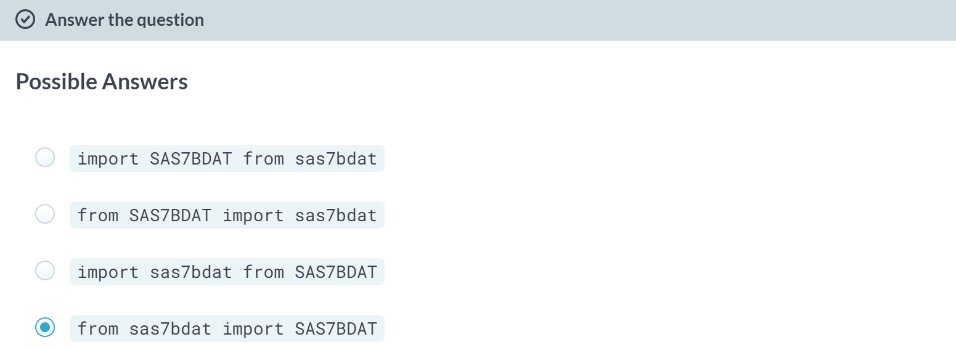

# Importing SAS files

In this exercise, you'll figure out how to import a SAS file as a DataFrame using SAS7BDAT and pandas. The file 'sales.sas7bdat' is already in your working directory and both pandas and matplotlib.pyplot have already been imported as follows:

import pandas as pd

import matplotlib.pyplot as plt

The data are adapted from the website of the undergraduate text book [**Principles of Econometrics**](http://www.principlesofeconometrics.com/) by Hill, Griffiths and Lim.

**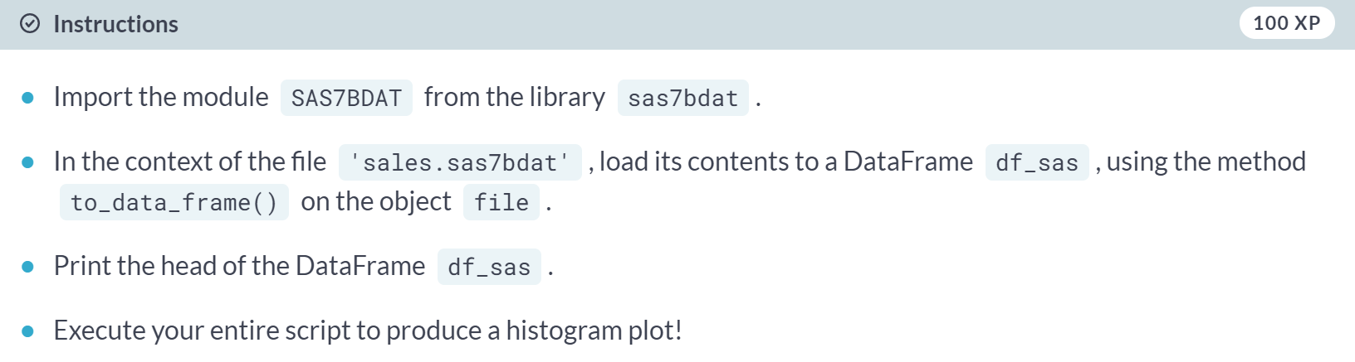  
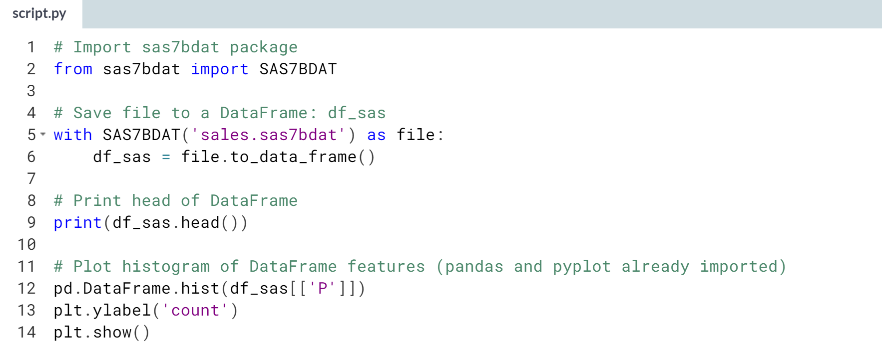**

(Result on the next page)

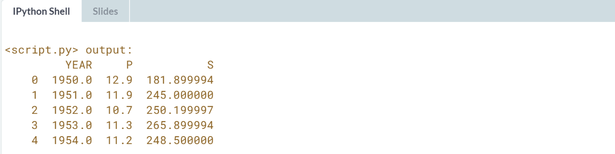

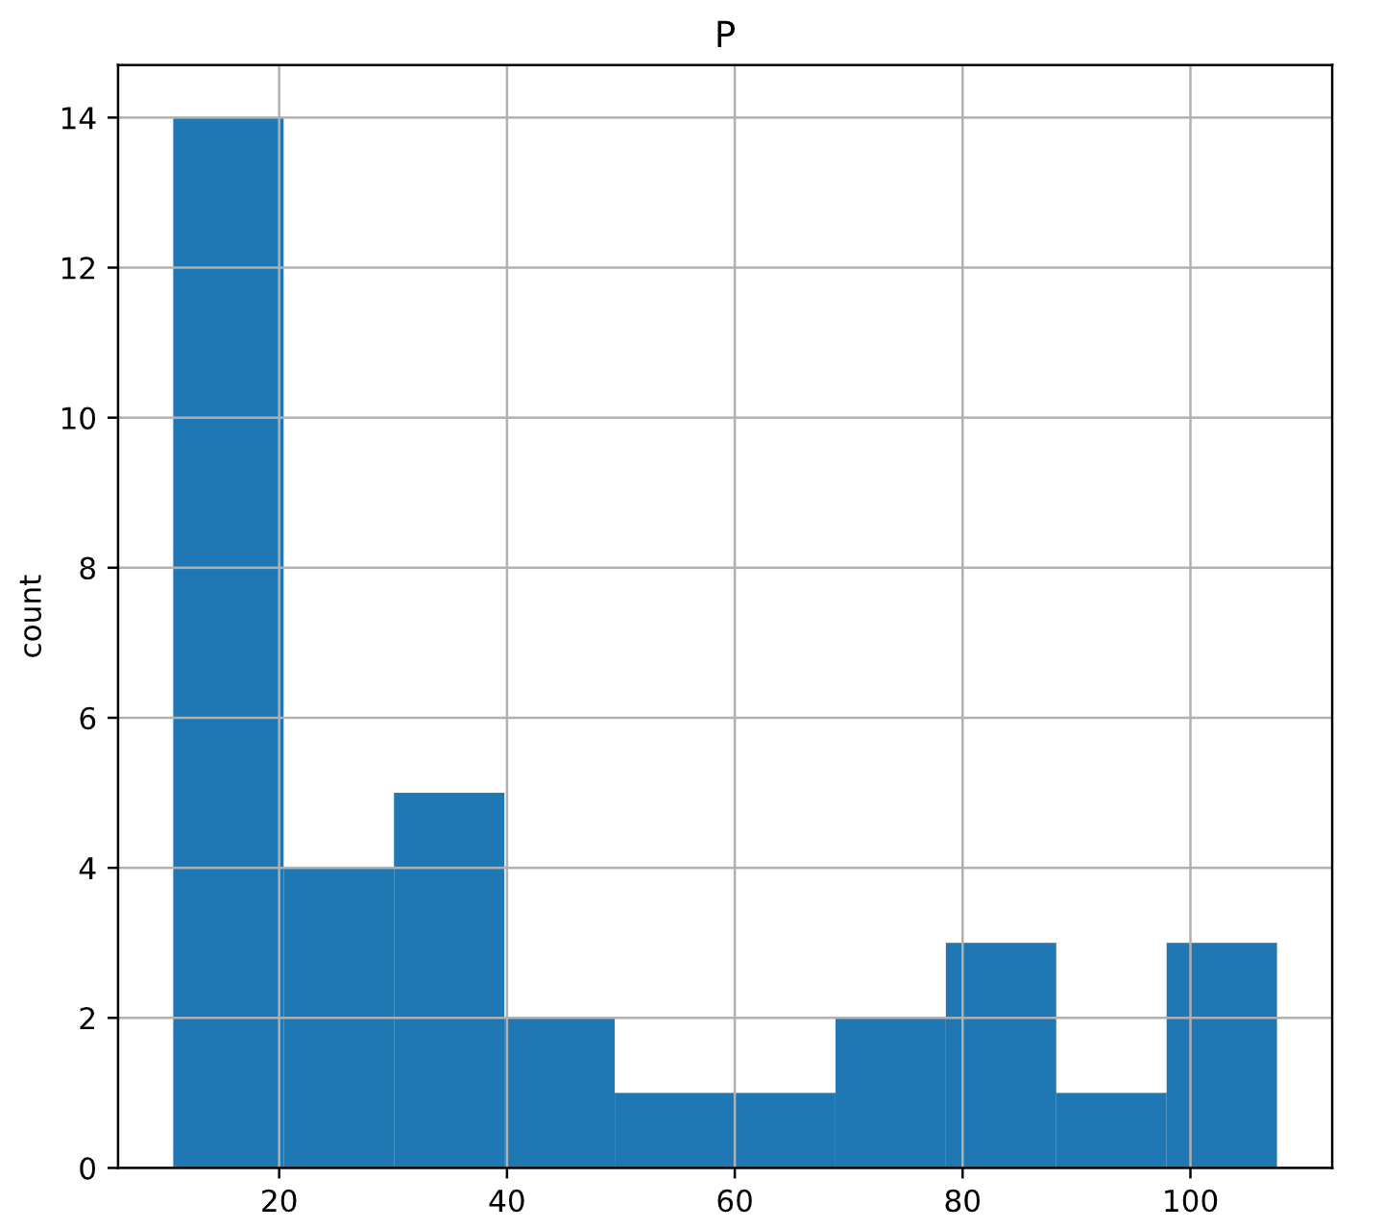

# Using read_stata to import Stata files

The pandas package has been imported in the environment as pd and the file disarea.dta is in your working directory. The data consist of disease extents for several diseases in various countries (more information can be found [**here**](http://www.cid.harvard.edu/ciddata/geog/readme_disarea.html)).

What is the correct way of using the read_stata() function to import disarea.dta into the object df?

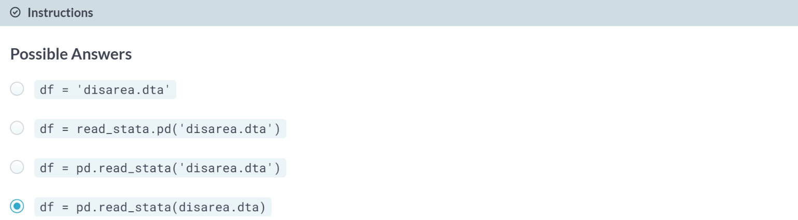

# Importing Stata files

Here, you'll gain expertise in importing Stata files as DataFrames using the the pd.read_stata() function from pandas. The last exercise's file, 'disarea.dta', is still in your working directory.

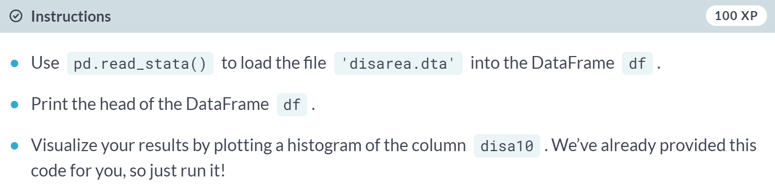

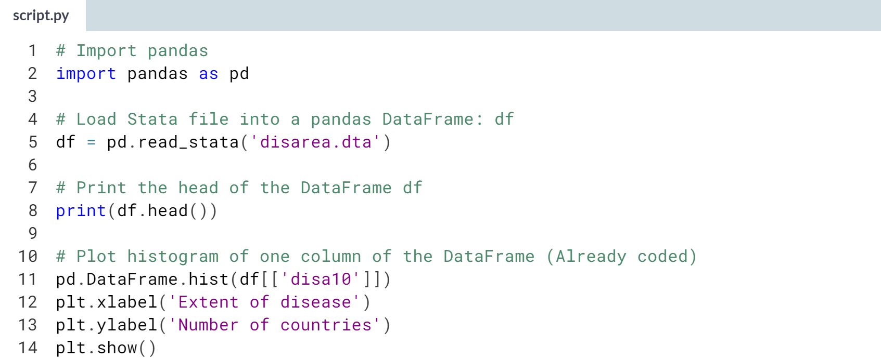

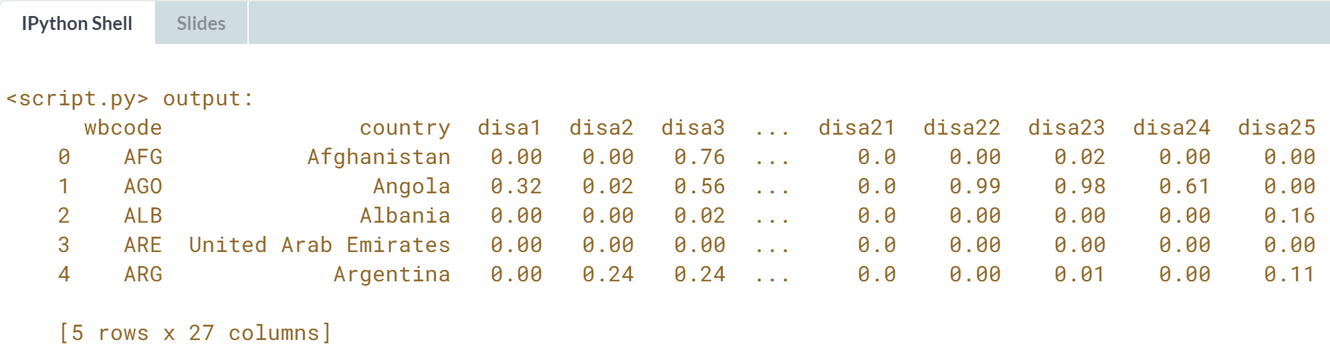

(plot on the next page)

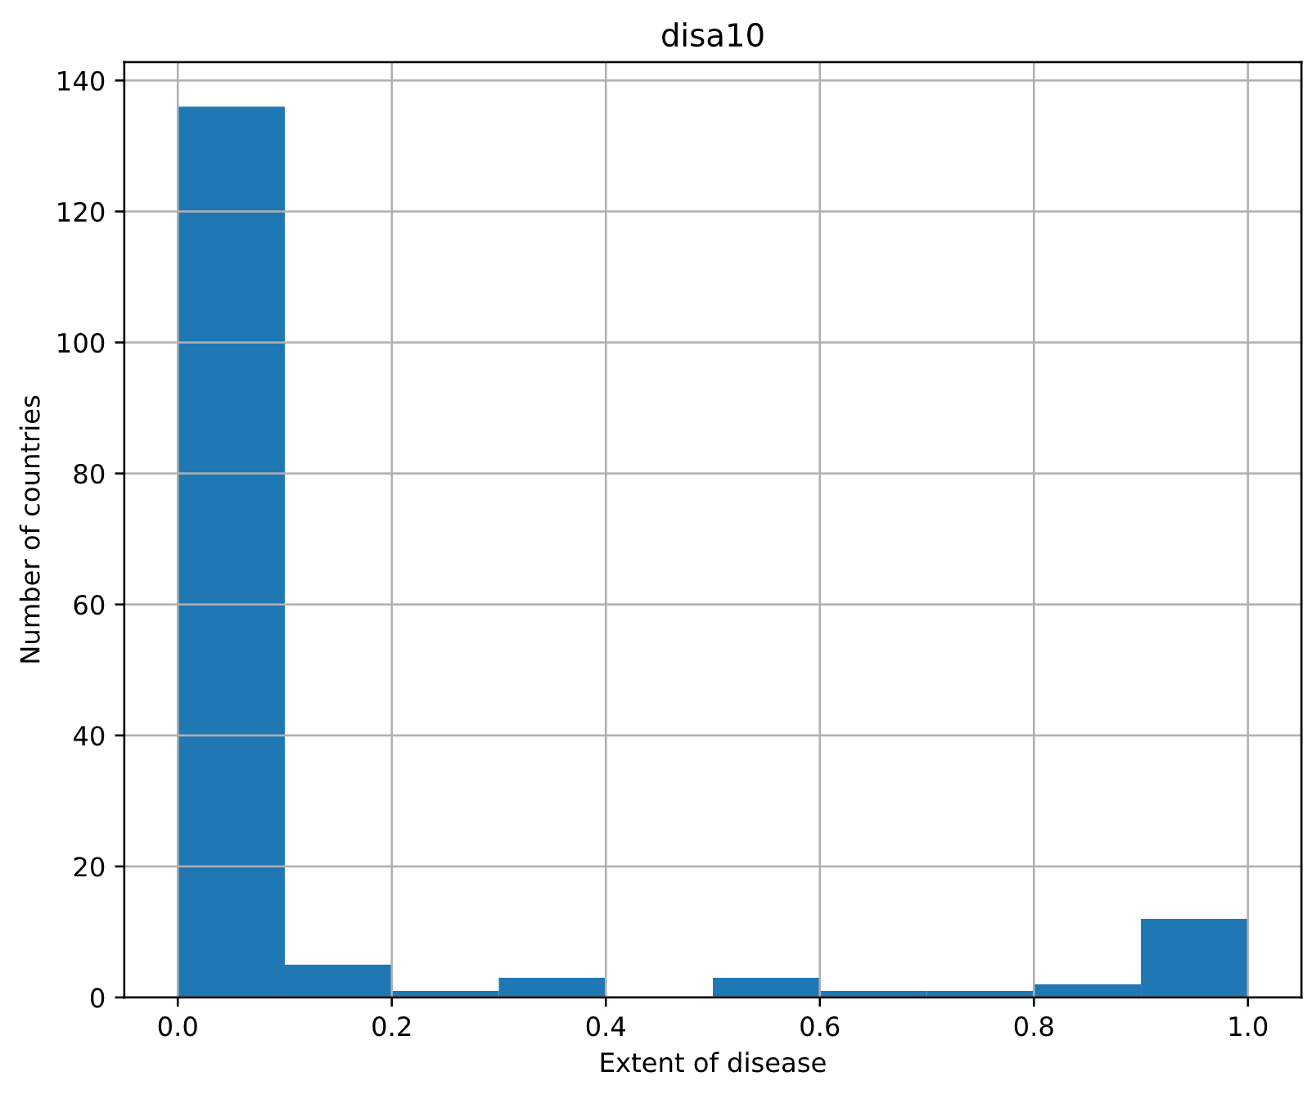



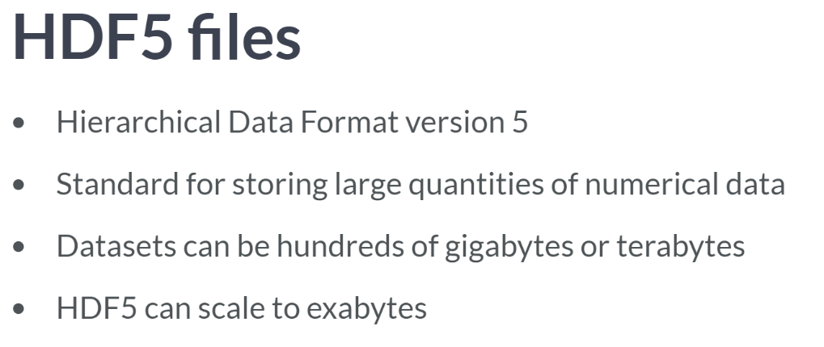

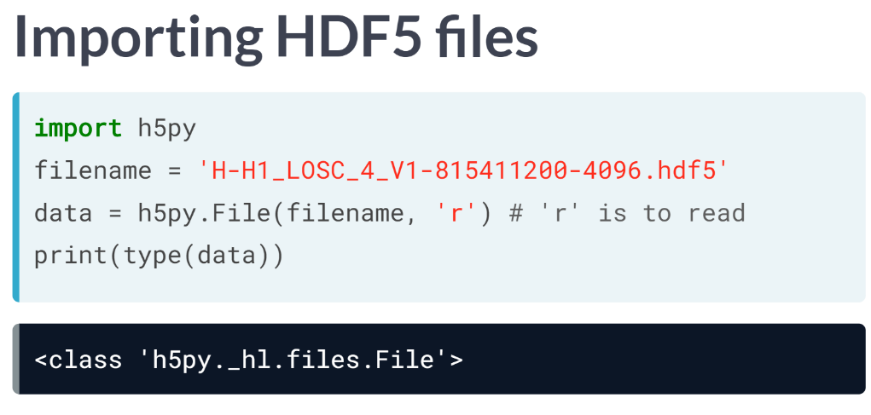

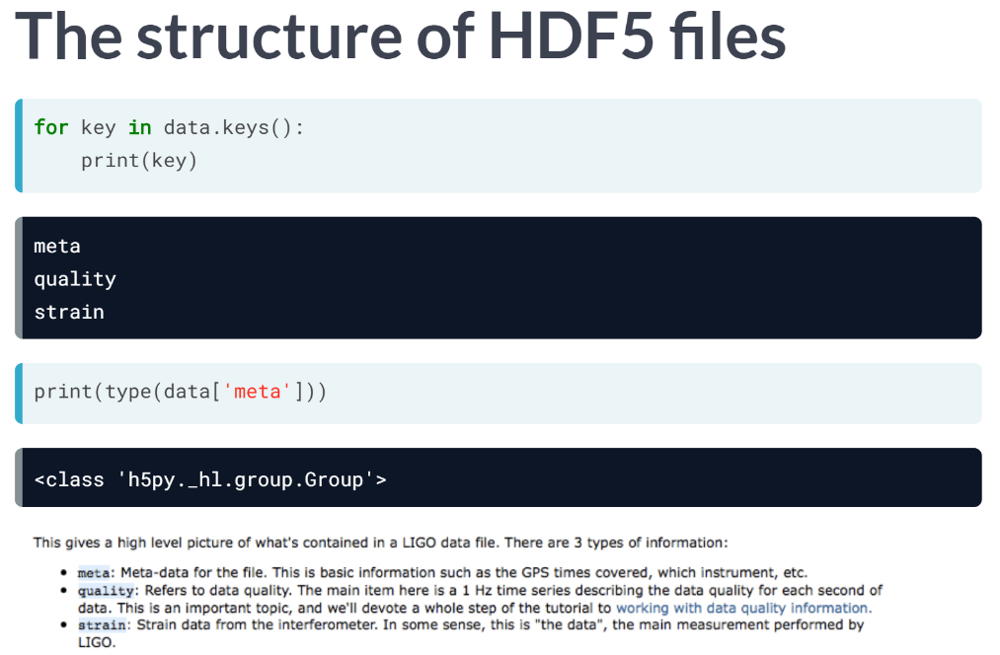You can explore its hierarchical structure as you would that of a Python dictionary using the method keys. Each of these keys is an HDF group. You can think of these groups as directories.

If you knew what data and metadata should be in each group, you could access it straightforwardly. However, if not, due to the hierarchical nature of the file structure, it is easy to explore.

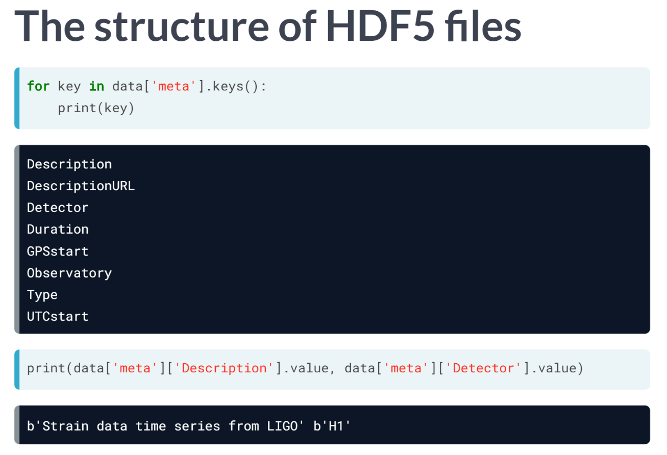  
For example, let's say you wanted to find out what type of metadata there is, you could easily print out the keys.

And now we know the keys, we can access any metadata of interest. If you are interested in 'Description' and 'Detector', all you need to do is print the corresponding values.

You see that the data in the file is 'Strain data time series from LIGO' and that the detector used was 'H1'. Next, you might perhaps want to check out the actual data. And that is what we are going to do next.

# Using File to import HDF5 files

The h5py package has been imported in the environment and the file LIGO_data.hdf5 is loaded in the object h5py_file.

What is the correct way of using the h5py function, File(), to import the file in h5py_file into an object, h5py_data, for reading only?

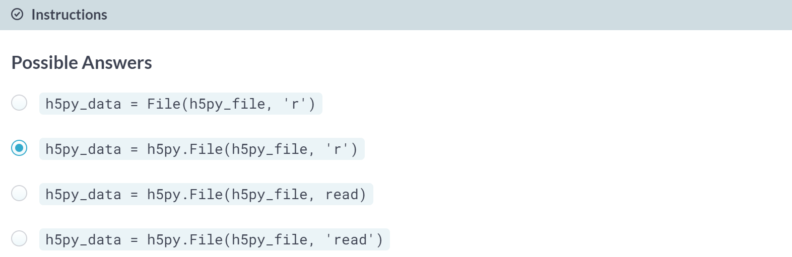

# Using h5py to import HDF5 files

The file 'LIGO_data.hdf5' is already in your working directory. In this exercise, you'll import it using the h5py library. You'll also print out its datatype to confirm you have imported it correctly. You'll then study the structure of the file in order to see precisely what HDF groups it contains.

You can find the LIGO data plus loads of documentation and tutorials [**here**](https://losc.ligo.org/events/GW150914/). There is also a great tutorial on Signal Processing with the data [**here**](https://www.gw-openscience.org/GW150914data/LOSC_Event_tutorial_GW150914.html).

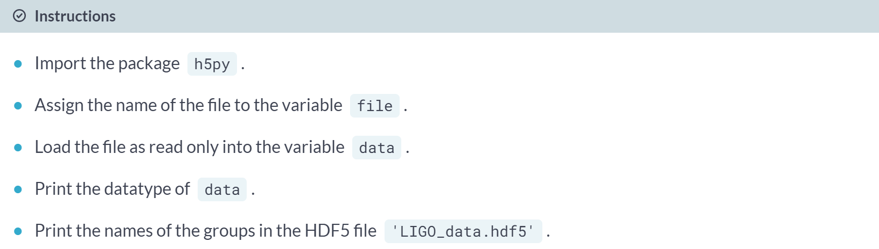

**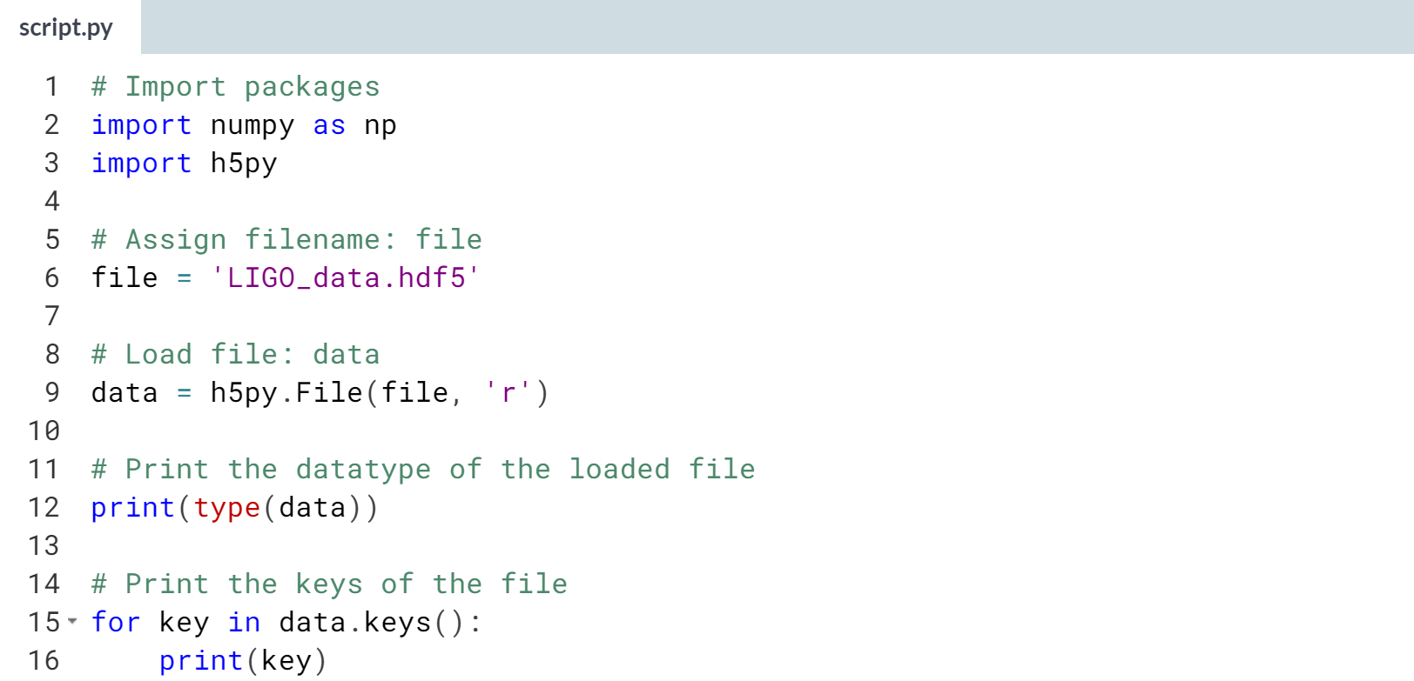  
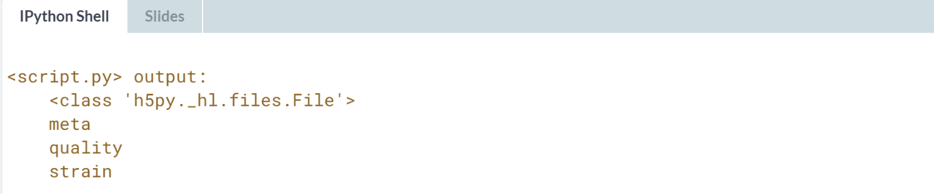**

# Extracting data from your HDF5 file

In this exercise, you'll extract some of the LIGO experiment's actual data from the HDF5 file and you'll visualize it.

To do so, you'll need to first explore the HDF5 group 'strain'.

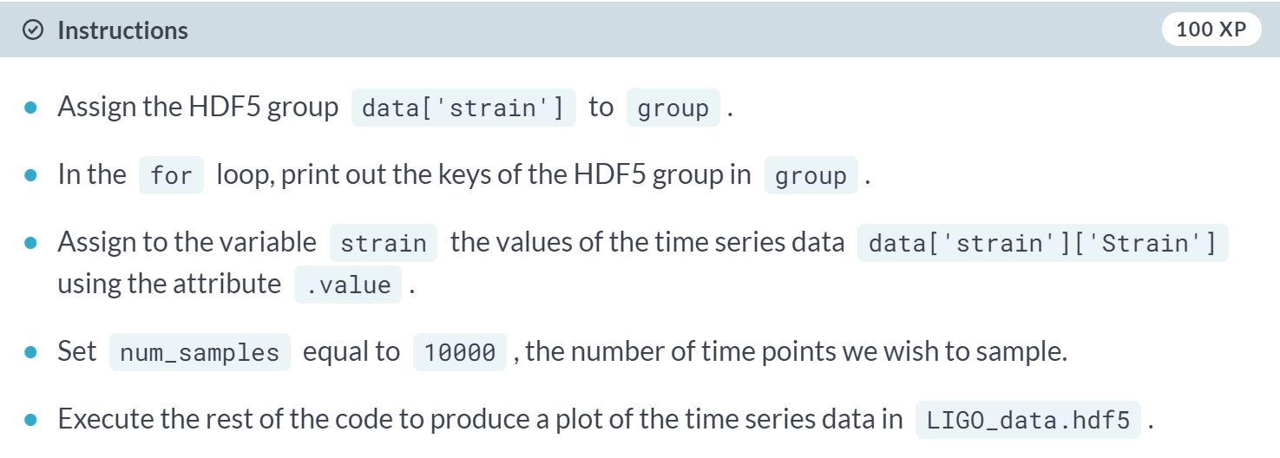

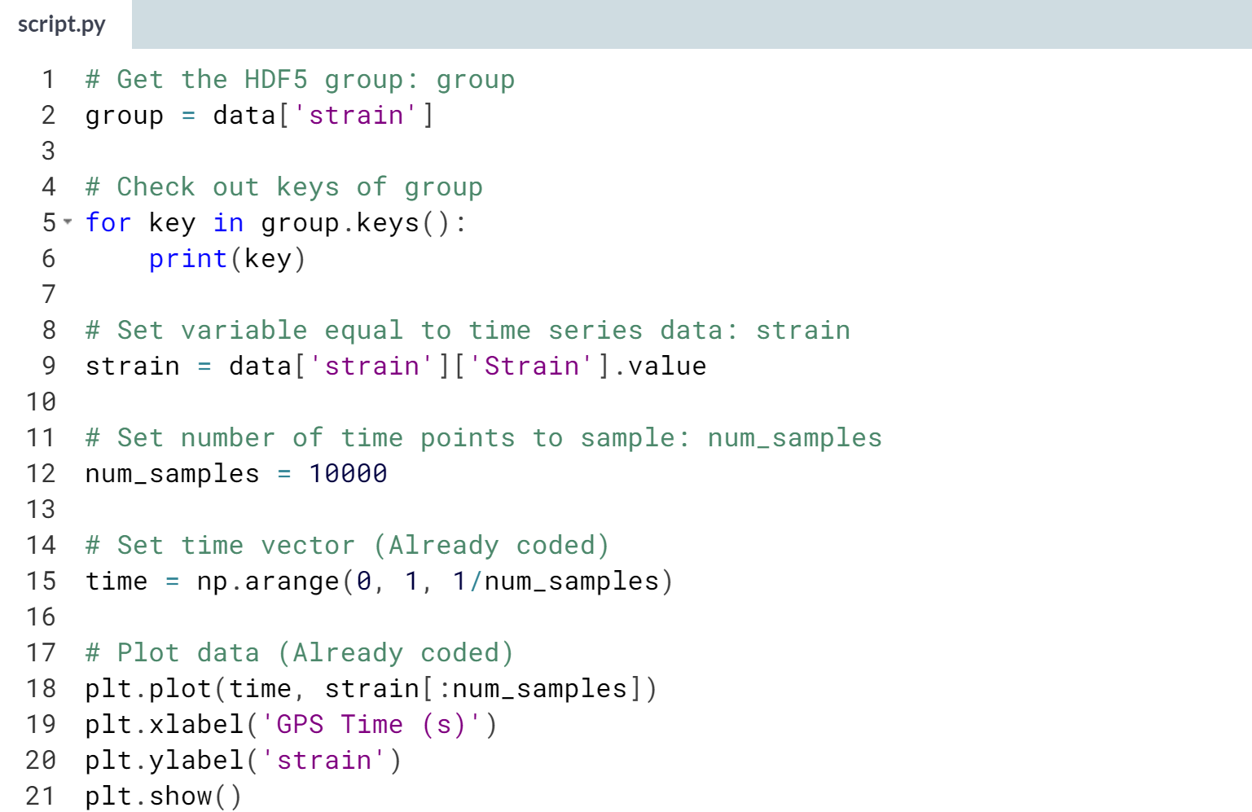

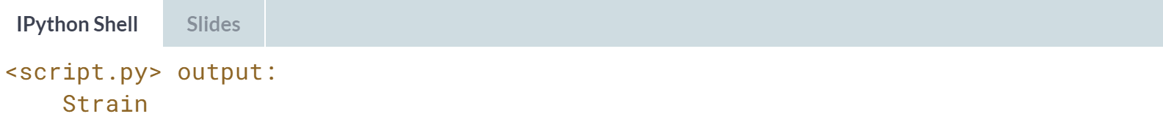

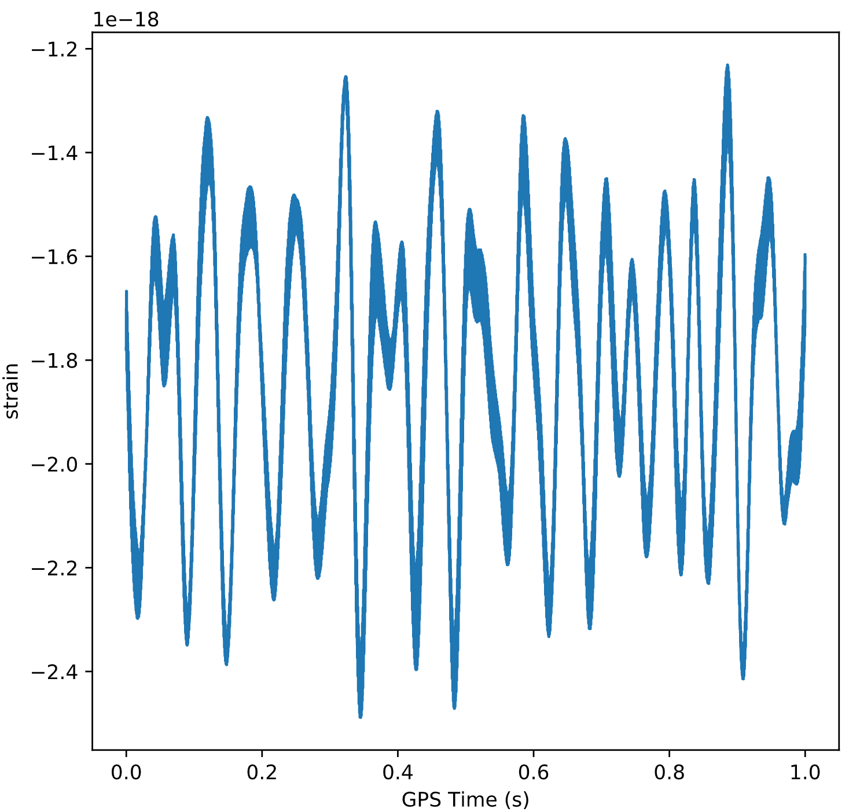



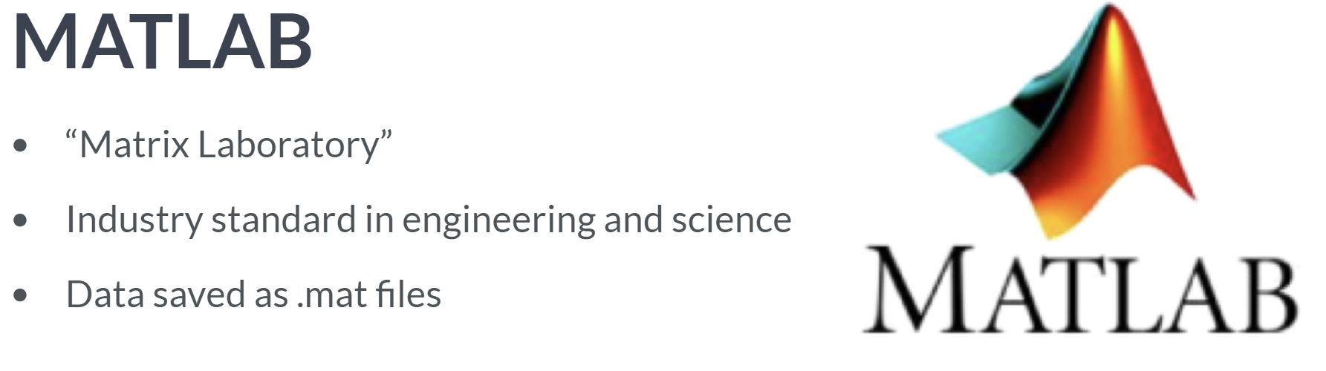

MATLAB, which is short for Matrix Laboratory, is a numerical computing environment that is an industry standard in the disciplines of engineering and science.

This is due in part to its powerful linear algebra and matrix capabilities, in part to its proprietary nature and in part to how difficult the academic world finds it to shake off old habits.

Regardless of the reasons for its widespread use, the fact of the matter is that a lot of people use MATLAB and save their data as '.map. files, the file format native to MATLAB.

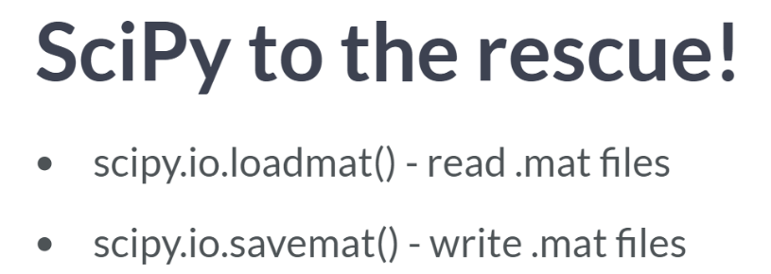

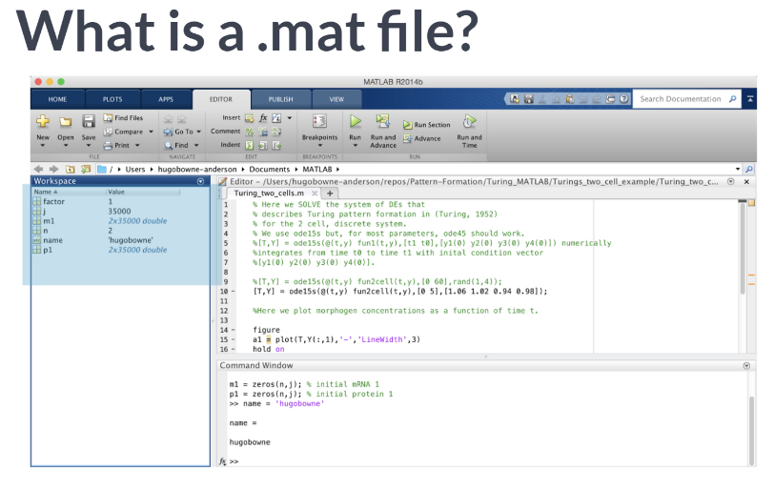What exactly is in a *.map* file? To answer this, let's look at the MATLAB IDE. In particular, check out the MATLAB workspace where all your variables are stored. This workspace contains strings, floats, vectors, and arrays, among many other objects. *.map* file is simply a collection of such objects.

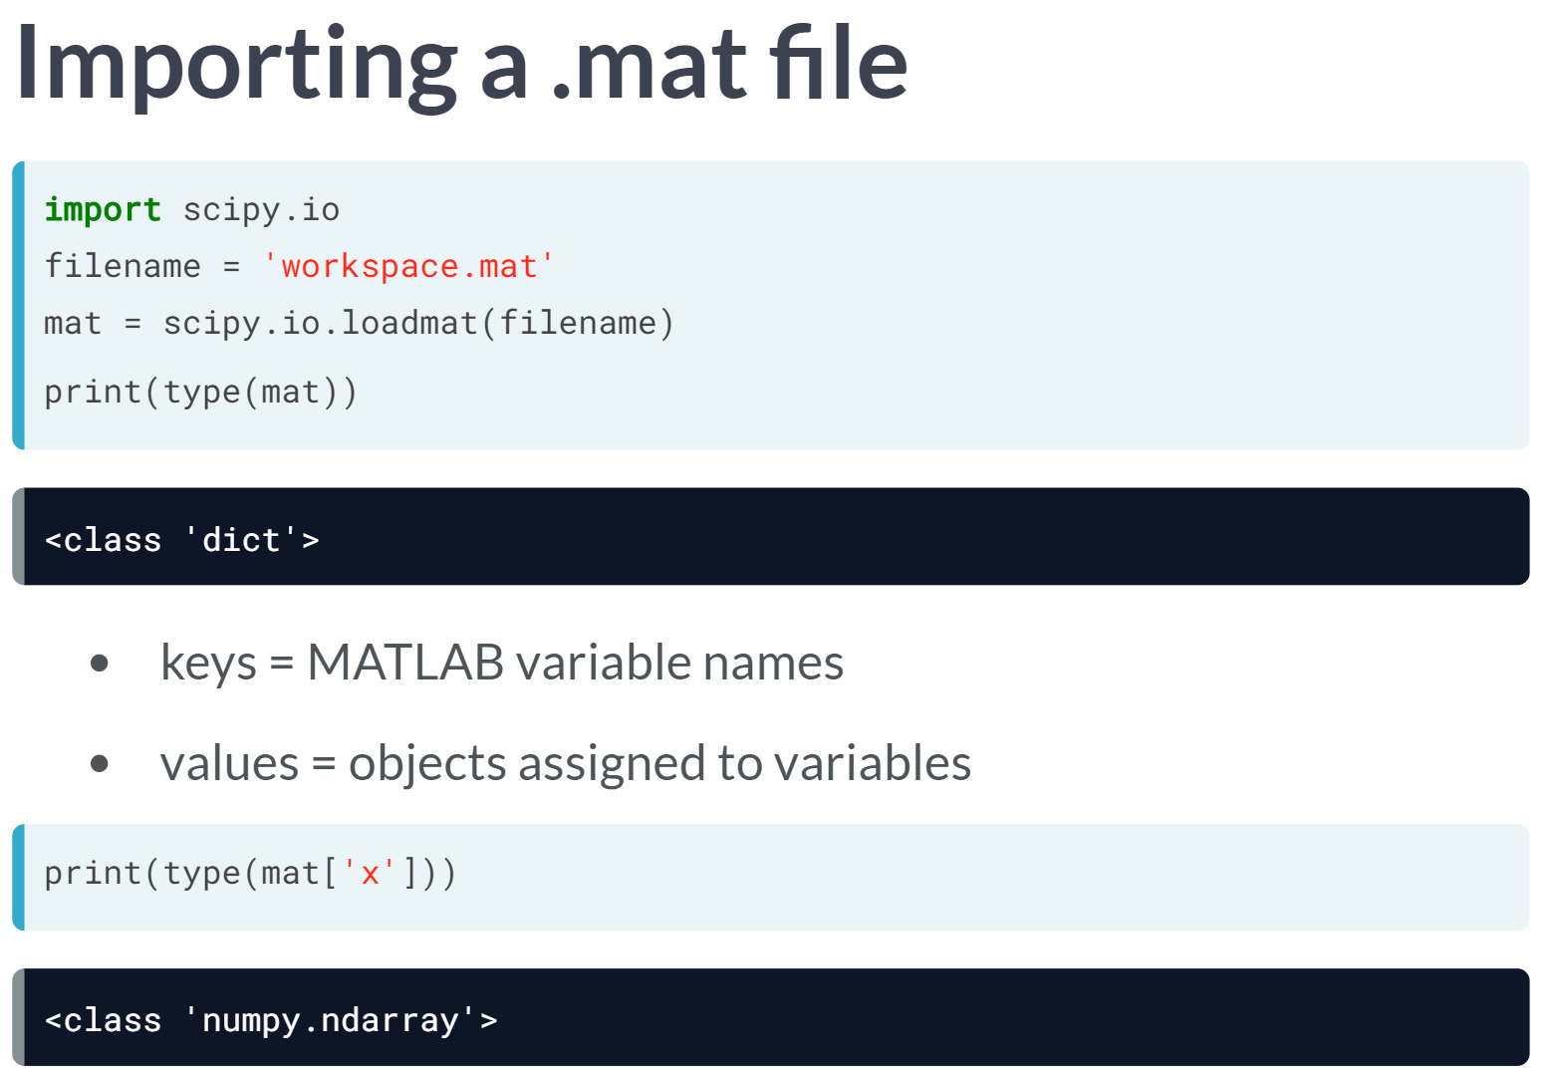Now this means, when importing a .map file in Python, we should expect to see a number of different variable and objects. How this dictionary related to a MATLAB workspace is straightforward. For example, mat['x'] is a NumPy corresponding to the MATLAB array x in your MATLAB workspace.

# Loading .mat files

In this exercise, you'll figure out how to load a MATLAB file using scipy.io.loadmat() and you'll discover what Python datatype it yields.

The file 'albeck_gene_expression.mat' is in your working directory. This file contains [**gene expression data**](https://www.mcb.ucdavis.edu/faculty-labs/albeck/workshop.htm) from the Albeck Lab at UC Davis. You can find the data and some great documentation [**here**](https://www.mcb.ucdavis.edu/faculty-labs/albeck/workshop.htm).

**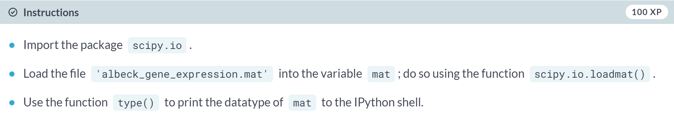  
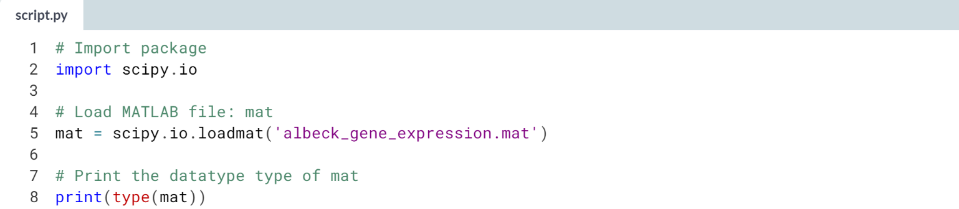  
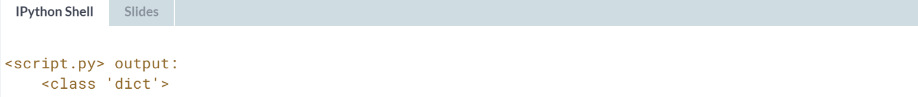**

# The structure of .mat in Python

Here, you'll discover what is in the MATLAB dictionary that you loaded in the previous exercise.

The file 'albeck_gene_expression.mat' is already loaded into the variable mat. The following libraries have already been imported as follows:

import scipy.io

import matplotlib.pyplot as plt

import numpy as np

Once again, this file contains [**gene expression data**](https://www.mcb.ucdavis.edu/faculty-labs/albeck/workshop.htm) from the Albeck Lab at UCDavis. You can find the data and some great documentation [**here**](https://www.mcb.ucdavis.edu/faculty-labs/albeck/workshop.htm).

**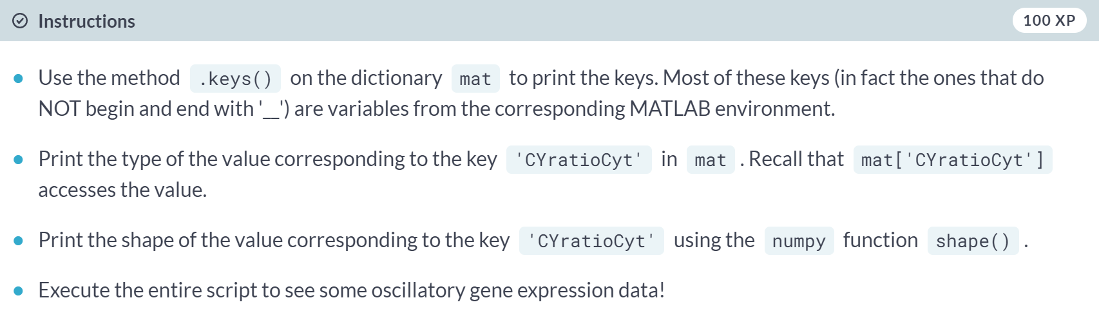  
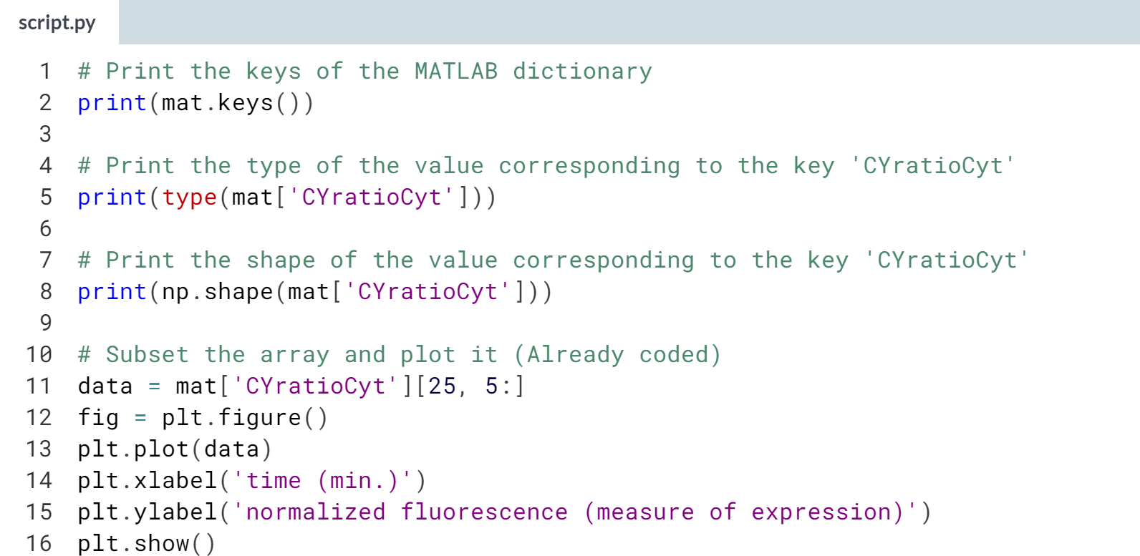**

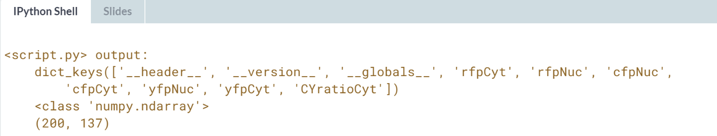

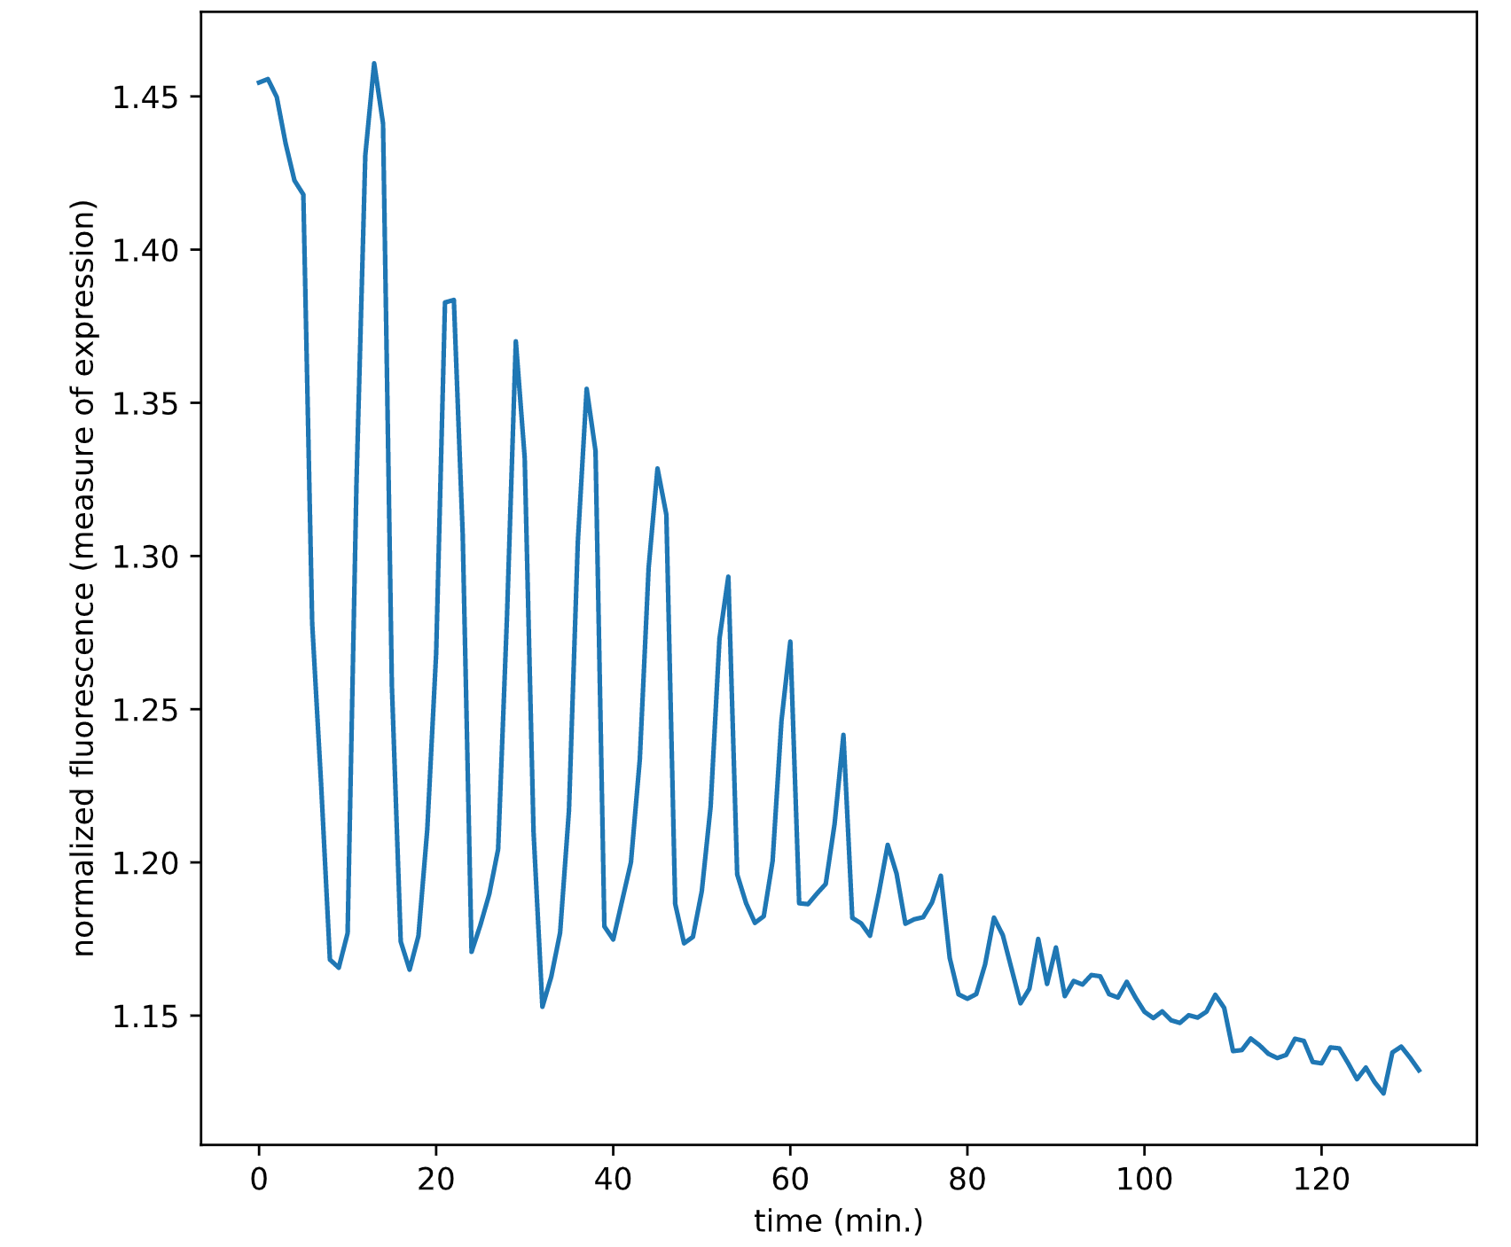

**3. Working with relational databases in Python**

In this chapter, you'll learn how to extract meaningful data from relational databases, an essential skill for any data scientist. You will learn about relational models, how to create SQL queries, how to filter and order your SQL records, and how to perform advanced queries by joining database tables.



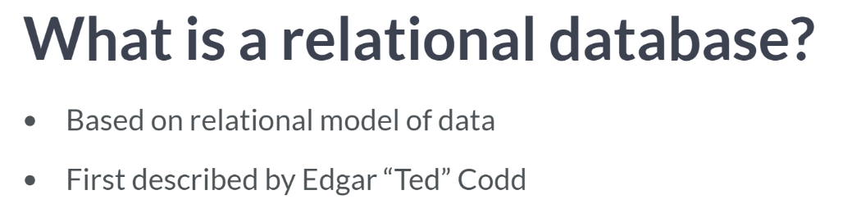

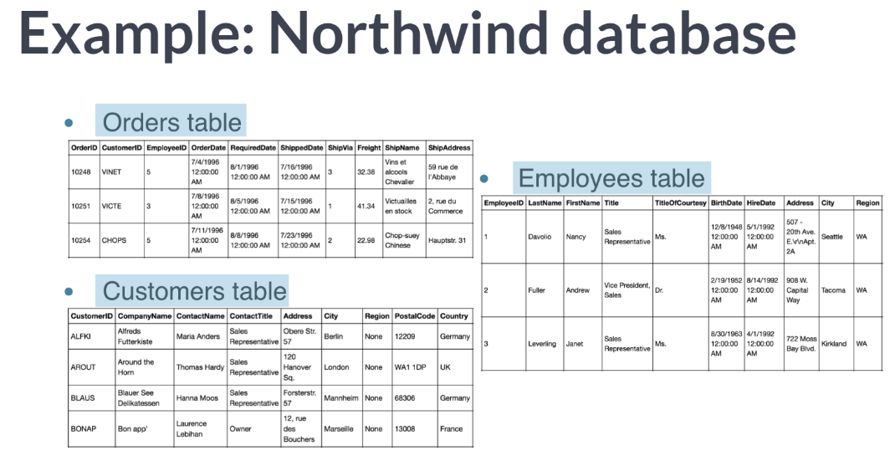  
A table generally represents one entity type, such as 'Order'. Notice that this tables look a lot like a dataframe. In a relational databases table, each row or record represents an instance of the entity type: in this case, each row is an Order. Each column represents an attribute of each instance. In this sense, a table in entirely analogous to a dataframe. It is essential that each row contain a unique identifier, known as a primary key, that we can use to explicitly access the row in question.

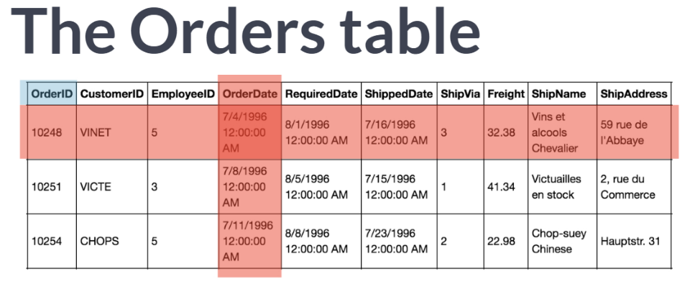  
In our 'Orders' table, you can see that the key is 'OrderID', the first column. But recall that a database consists of many tables. The really cool thing about relational databases is not merely that you have a bunch of tables, but that the tables are linked.

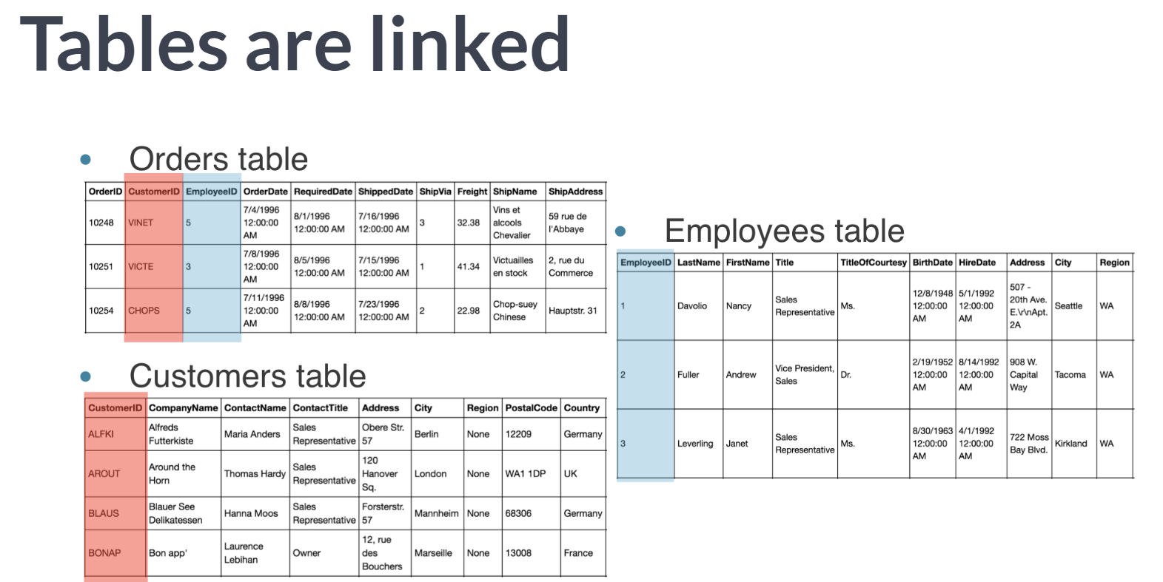

How this linking works is ultra-intuitive: notice how *CustomerID* and *EmplolyeeID* column corresponds to the one in Customer table and Employees table, respectively. So given an order, you can immediately look up the details of the relevant Customer or Employee.

This is cool because it means that you don't need to store all the Customer details, such as first name, last name, company with every order that they place: you merely need to look it up in the *'Customers'* table. All in all, this saves an incredible amount of space and time.

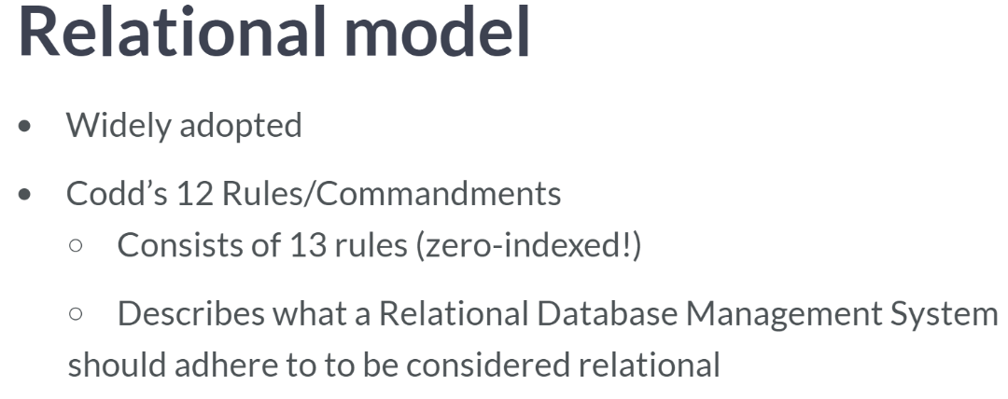  
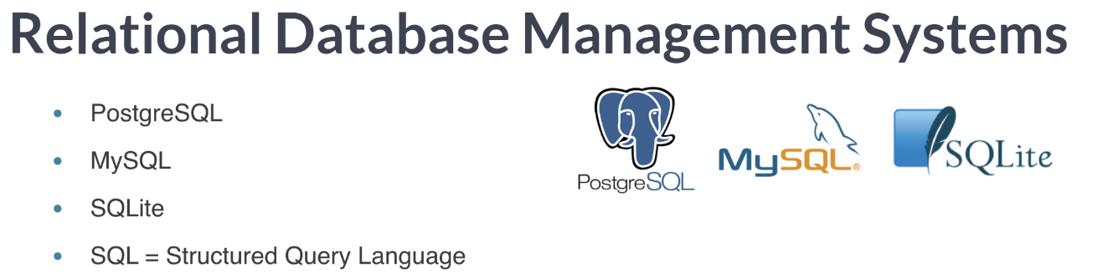

# Pop quiz: The relational model

Which of the following is not part of the relational model?

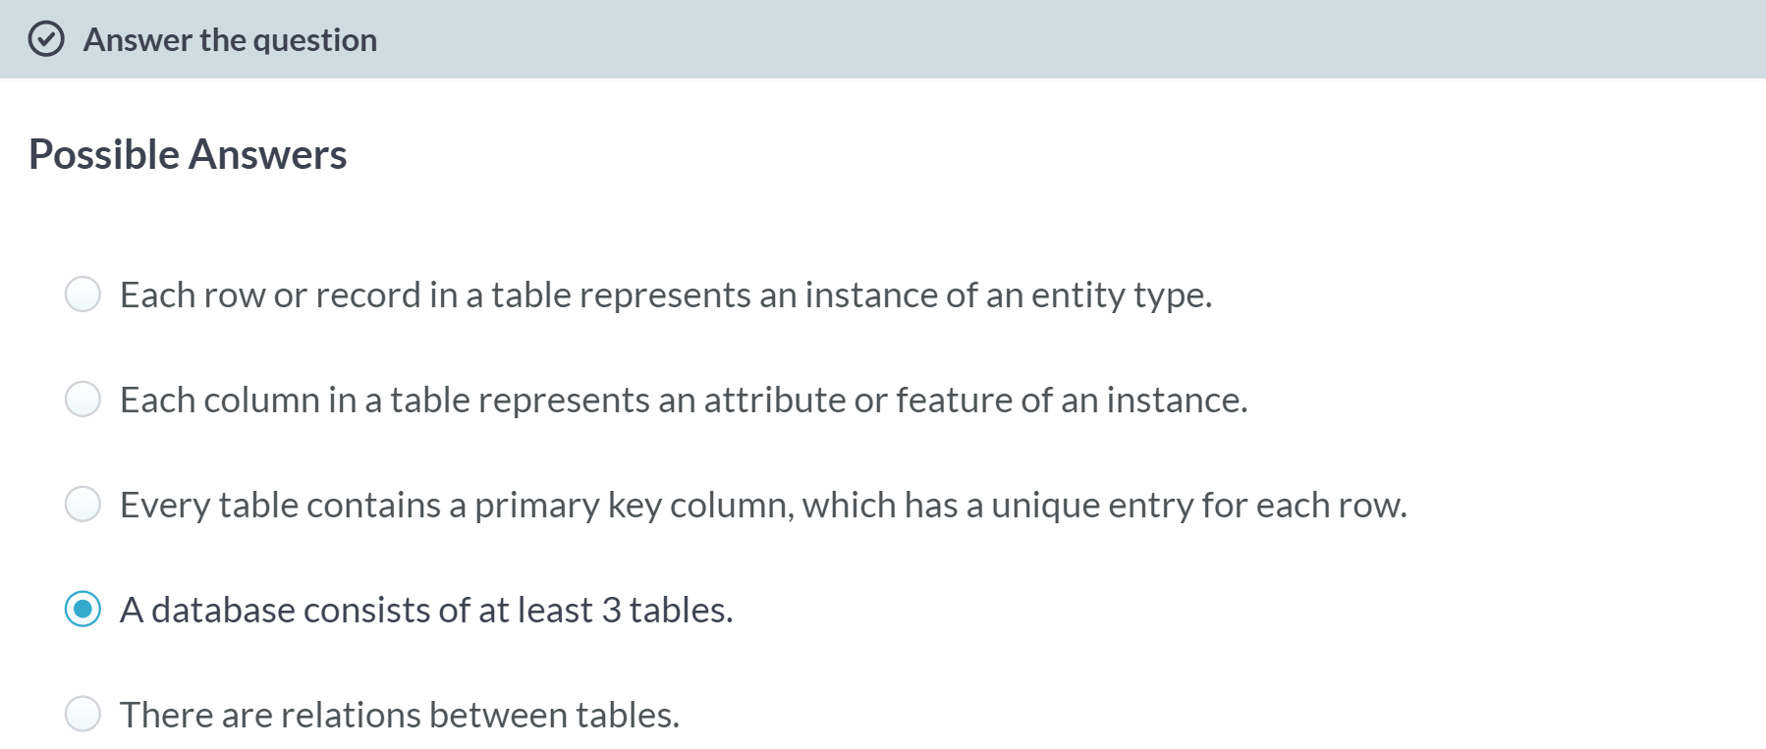



Let's figure out how to connect to a database before getting data out of our databases using SQL.

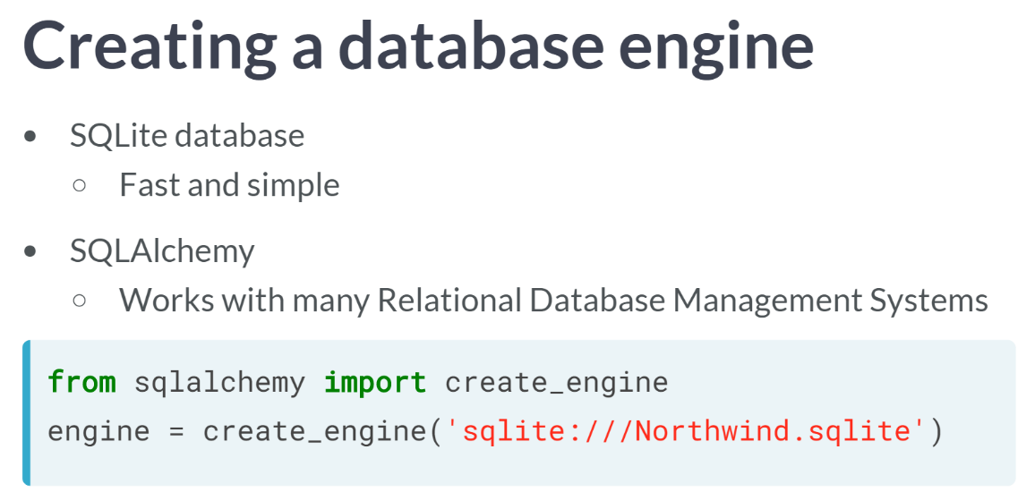  
There are many packages we could use to access an SQLite database such as *sqlite3* and *SQLAlchemy*. And we will use the latter as it works with many other Relational Database Management Systems, such as Postgres and MySQL.

To do so, we need to import *create_engine* from *sqlalchemy*. We then use the function ***create_engine()*** to fire up an SQL engine that will communicate our queries to the database. Only argument required is a string that indicates the type of database you are connecting to and the name of the database. Next, to query the database, we need to connect to the engine to do so.

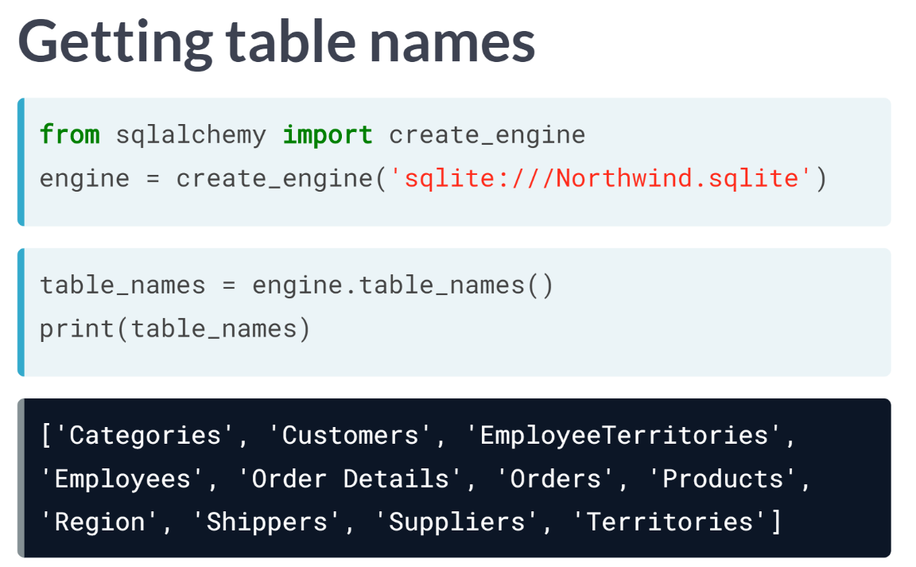  
But before we do this, we would like to know the names of the table it contains. To do this, simply apply the method ***table_names()***to the object engine. This will return a list of the table names that you can then print the console.

# Creating a database engine

Here, you're going to fire up your very first SQL engine. You'll create an engine to connect to the SQLite database 'Chinook.sqlite', which is in your working directory. Remember that to create an engine to connect to 'Northwind.sqlite', Hugo executed the command

engine = create_engine('sqlite:///Northwind.sqlite')

Here, 'sqlite:///Northwind.sqlite' is called the connection string to the SQLite database Northwind.sqlite. A little bit of background on the [**Chinook database**](https://github.com/lerocha/chinook-database): the Chinook database contains information about a semi-fictional digital media store in which media data is real and customer, employee and sales data has been manually created.

Why the name Chinook, you ask? According to their [**website**](https://github.com/lerocha/chinook-database),

*The name of this sample database was based on the Northwind database. Chinooks are winds in the interior West of North America, where the Canadian Prairies and Great Plains meet various mountain ranges. Chinooks are most prevalent over southern Alberta in Canada. Chinook is a good name choice for a database that intends to be an alternative to Northwind.*

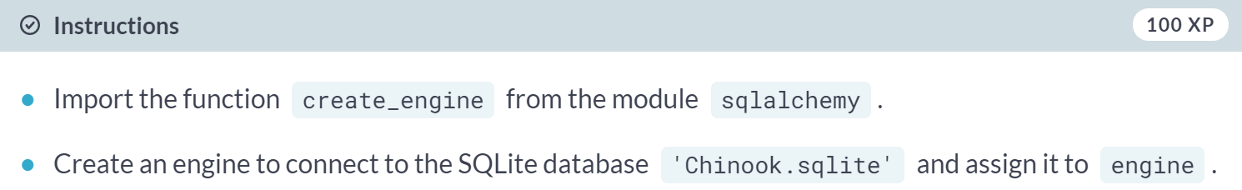

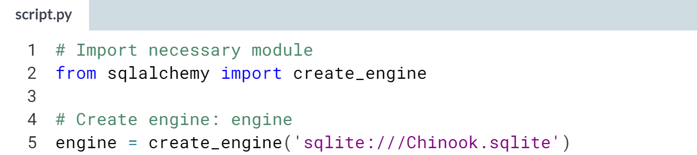

# What are the tables in the database?

In this exercise, you'll once again create an engine to connect to 'Chinook.sqlite'. Before you can get any data out of the database, however, you'll need to know what tables it contains!

To this end, you'll save the table names to a list using the method table_names() on the engine and then you will print the list.

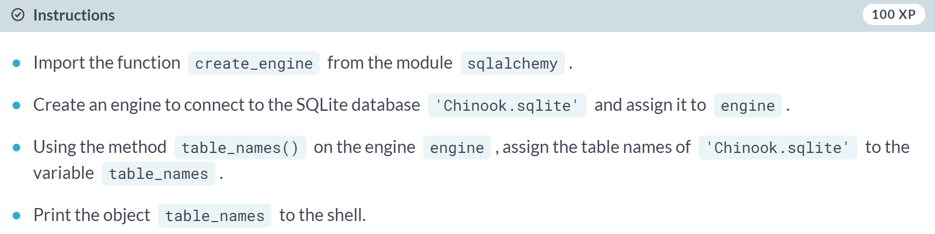

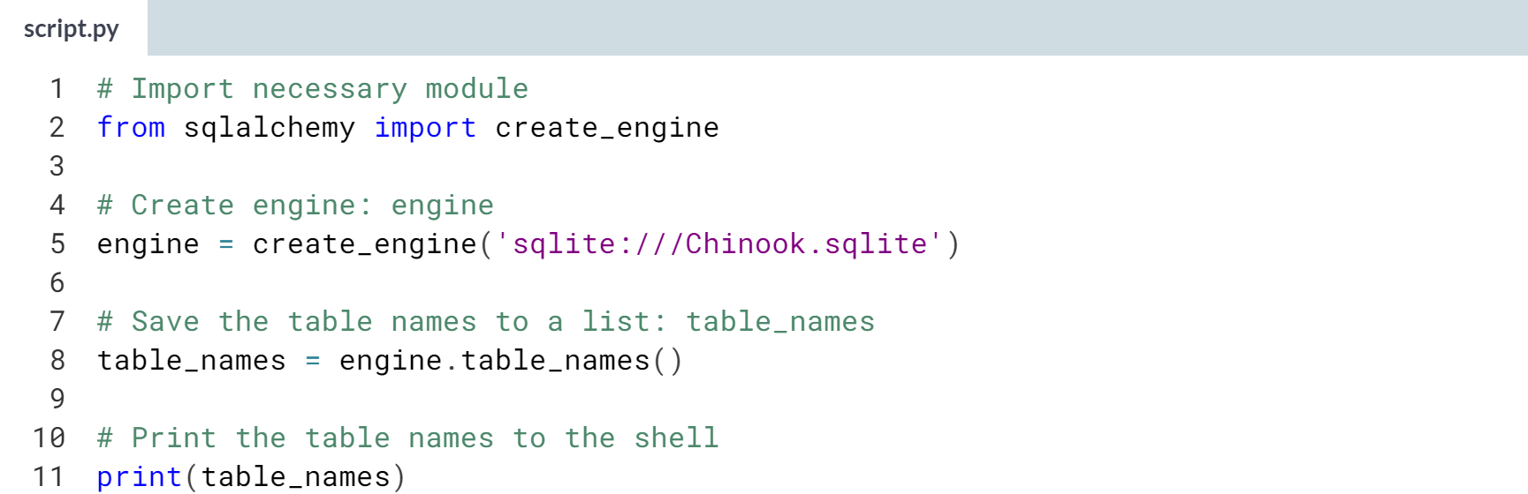

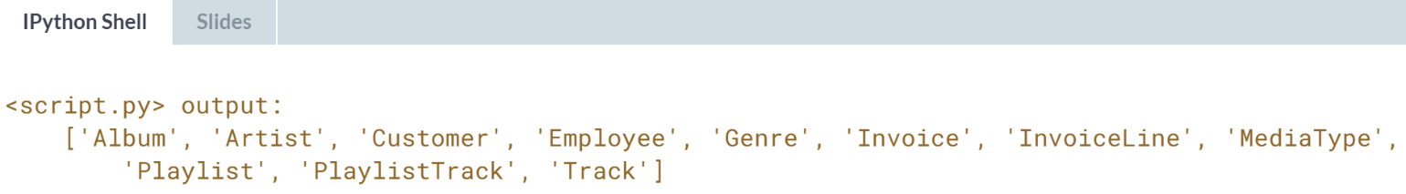



Now we know how to create a database engine and to list the table of the database in question, it's time to connect to the engine and query the database. Once again, the term "querying" is just a fancy way of saying getting data out from the database.

The star after SELECT means 'all columns' and it will return all the items associated to with that column.

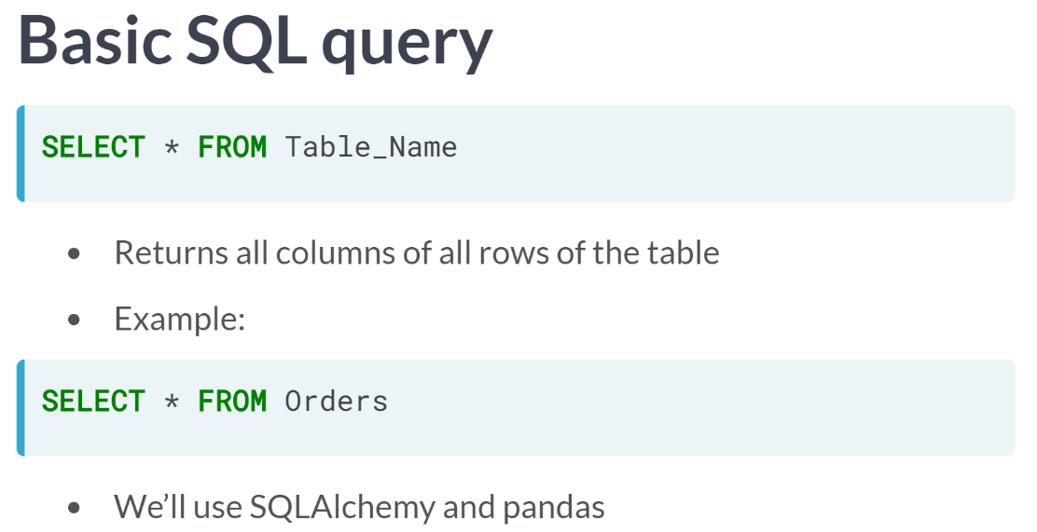

This is an SQL query, and we need to figure out how to make such a query using Python, SQLAlchemy, and, in fact, we will also use pandas to store the results of our queries.

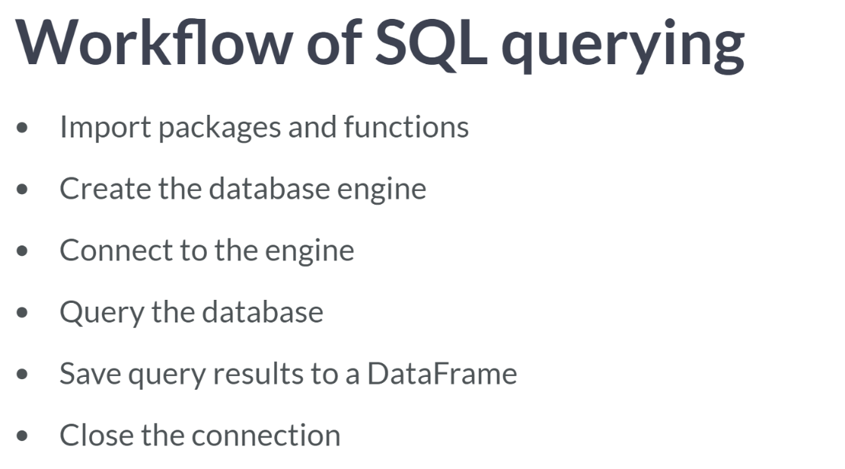

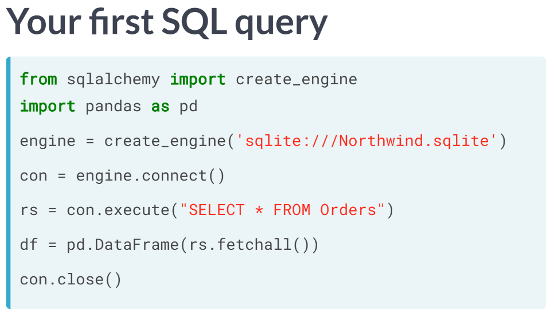

1. Create the engine using the function ***create_engine()***.
2. To connect to the database after creating the engine, you create a connection object **con** by applying the method ***connect()*** to the engine.
3. To query the database, apply the method ***execute()*** to the connection **con** and pass it a single argument, the relevant SQL query.
4. This creates a SQLAlchemy results object, which we assign to the variable **rs**.
5. To turn the results object rs into a dataframe, we apply the method ***fetchall()*** to **rs** and save it as a dataframe using the pandas function ***DataFrame()***. ***fetchall()*** fetches all rows, as you would expect.
6. To close the connection, execute *'****con.close()’***.

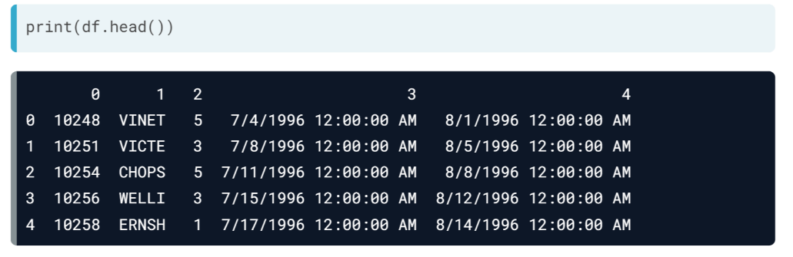  
Then we can print out the head of the dataframe for the sanity check. All the rows look good, but the column names aren't correct.

To fix this, before closing the connection, you can set the dataframe's column names by executing 'df.columns = rs.keys'.  
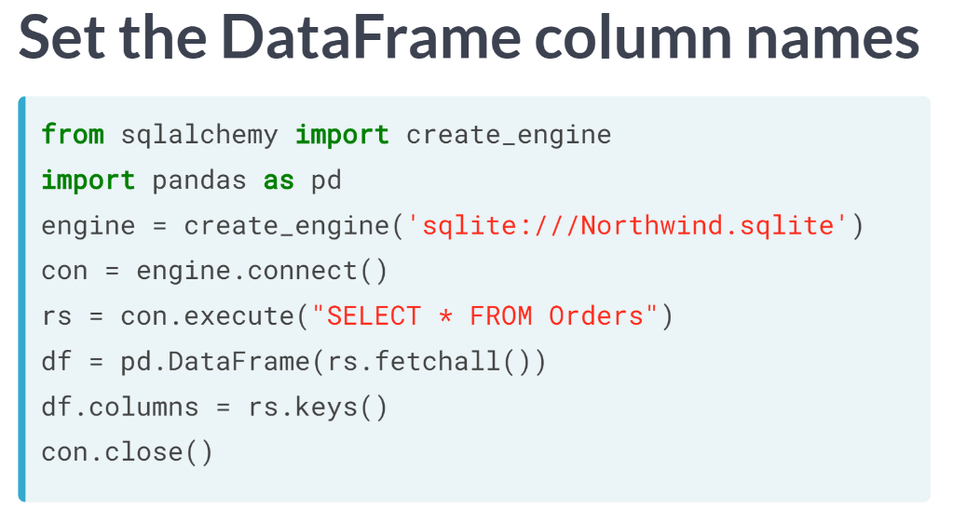

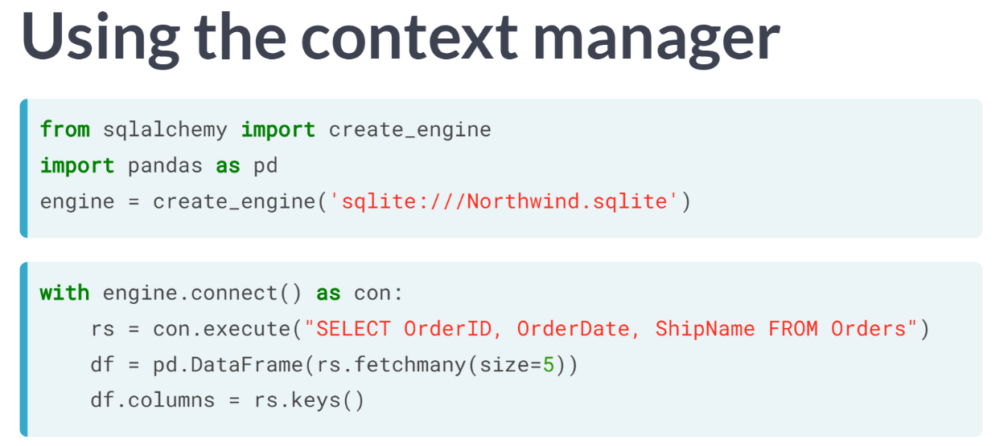

One last note: analogous to what we saw in previous chapter when opening plain text files, we can use the context manager construct to open a connection, which will save you the trouble of closing the connection later, or save you the trouble of forgetting to close it.

There are two other differences that you may have noticed between this and the previous code:

Firstly, I no longer have 'SELECT *' in the SQL query; instead, I now have the column names of the table '**Orders'**, which only import the orders column opposed to all columns.

Secondly, instead of applying the method ***fetchall()*** to the result *rs*, I apply the method ***fetchmany()*** with the argument size equals 5; Using this method imports 5 rows instead of all rows.

# The Hello World of SQL Queries!

Now, it's time for liftoff! In this exercise, you'll perform the Hello World of SQL queries, SELECT, in order to retrieve all columns of the table Album in the Chinook database. Recall that the query SELECT * selects all columns.

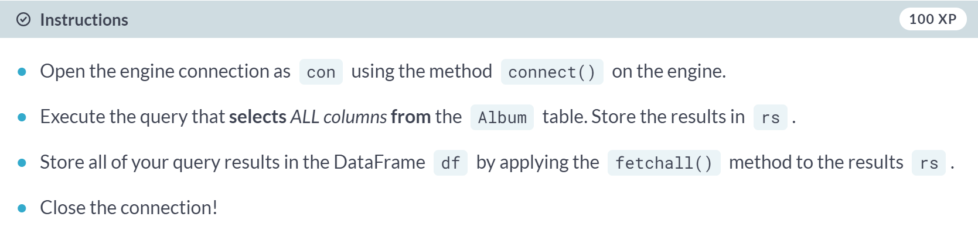

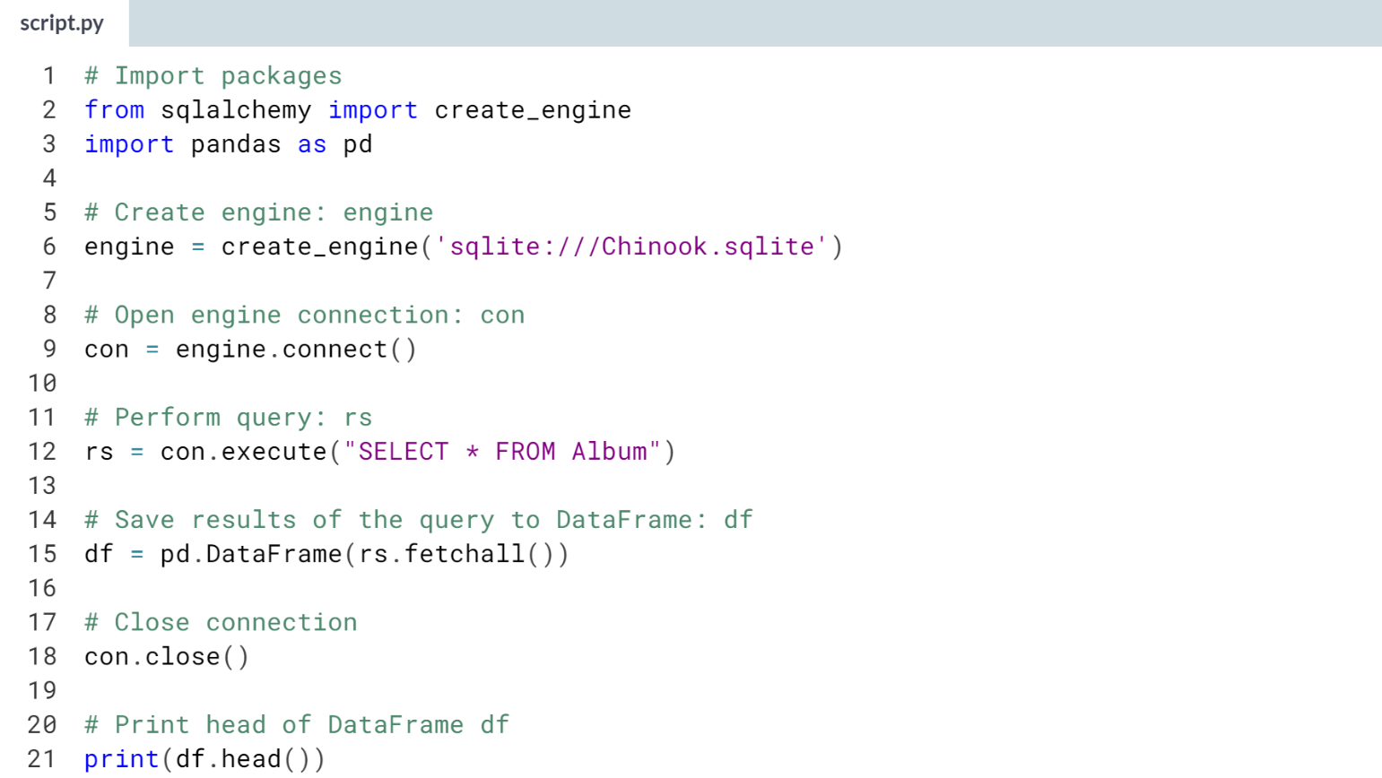  
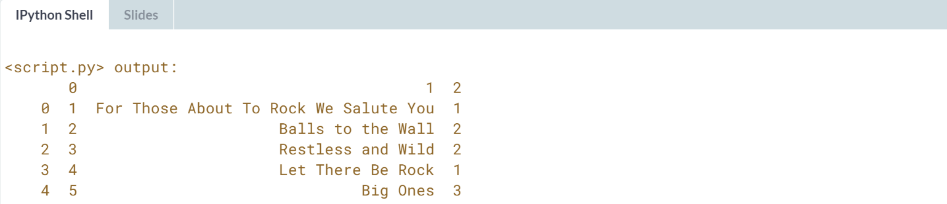

# Customizing the Hello World of SQL Queries

Congratulations on executing your first SQL query! Now you're going to figure out how to customize your query in order to:

* Select specified columns from a table;
* Select a specified number of rows;
* Import column names from the database table.

Recall that Hugo performed a very similar query customization in the video:

engine = create_engine('sqlite:///Northwind.sqlite')

with engine.connect() as con:

rs = con.execute("SELECT OrderID, OrderDate, ShipName FROM Orders")

df = pd.DataFrame(rs.fetchmany(size=5))

df.columns = rs.keys()

Packages have already been imported as follows:

from sqlalchemy import create_engine

import pandas as pd

The engine has also already been created:

engine = create_engine('sqlite:///Chinook.sqlite')

The engine connection is already open with the statement

with engine.connect() as con:

All the code you need to complete is within this context.

(Exercise on the next page)

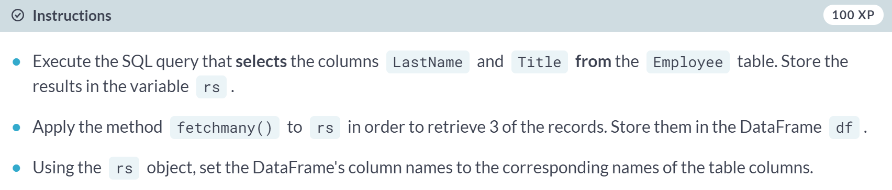

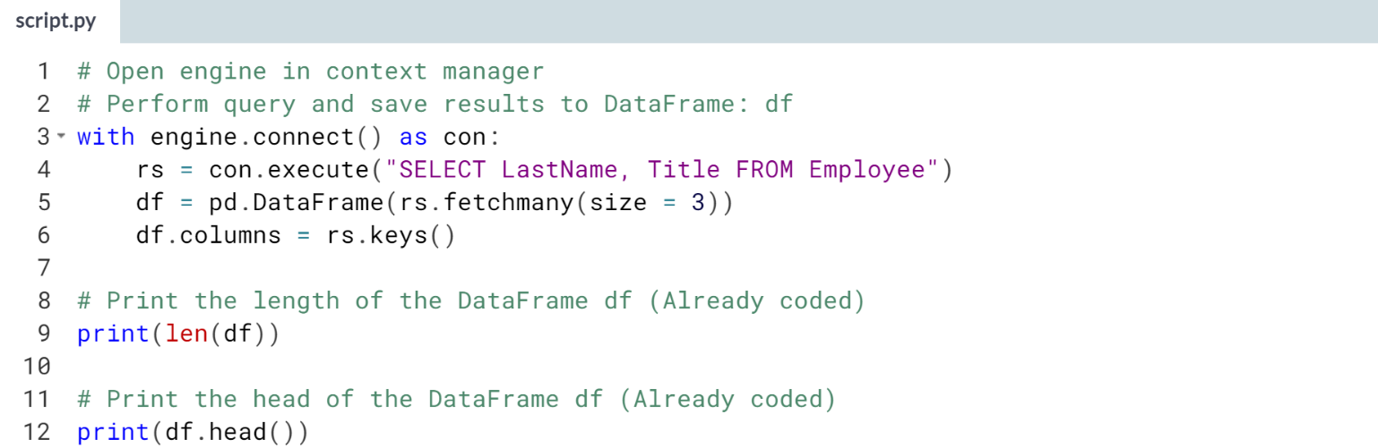  
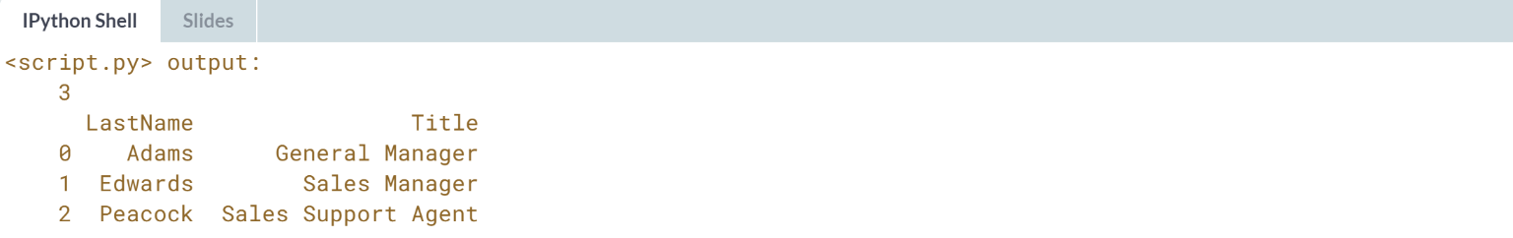

# Filtering your database records using SQL's WHERE

You can now execute a basic SQL query to select records from any table in your database and you can also perform simple query customizations to select particular columns and numbers of rows.

There are a couple more standard SQL query chops that will aid you in your journey to becoming an SQL ninja.

Let's say, for example that you wanted to get all records from the Customer table of the Chinook database for which the Country is 'Canada'.

You can do this very easily in SQL using a SELECT statement followed by a WHERE clause as follows:

SELECT * FROM Customer WHERE Country = 'Canada'

In fact, you can filter any SELECT statement by any condition using a WHERE clause. This is called filtering your records.

In this interactive exercise, you'll select all records of the Employee table for which 'EmployeeId' is greater than or equal to 6.

Packages are already imported as follows:

import pandas as pd

from sqlalchemy import create_engine

Query away!

(Exercise on the next page)

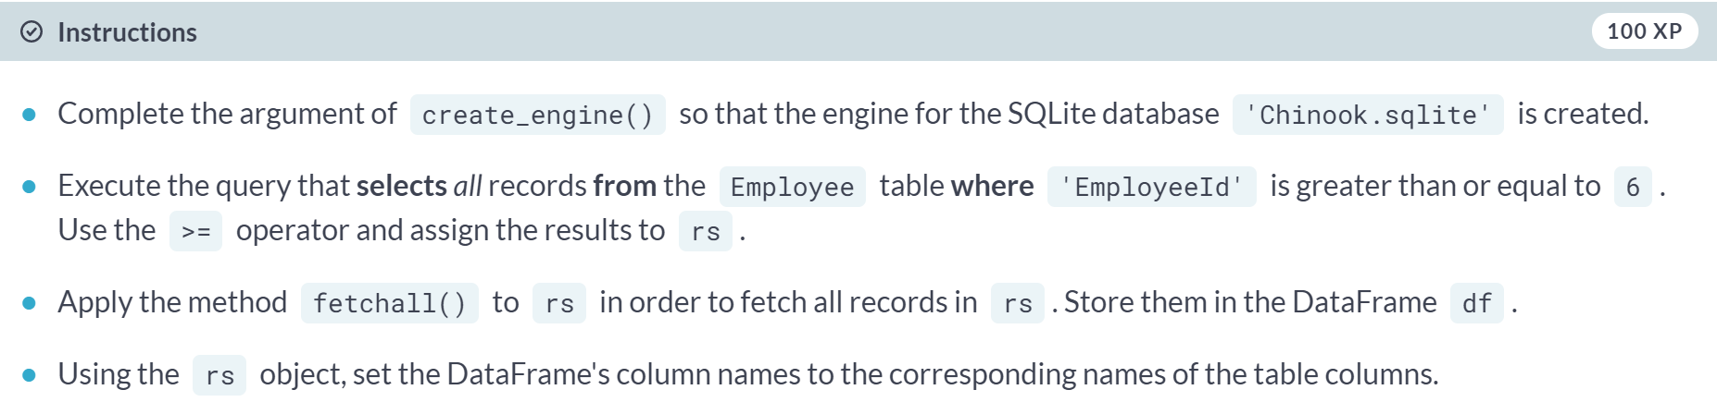  
  
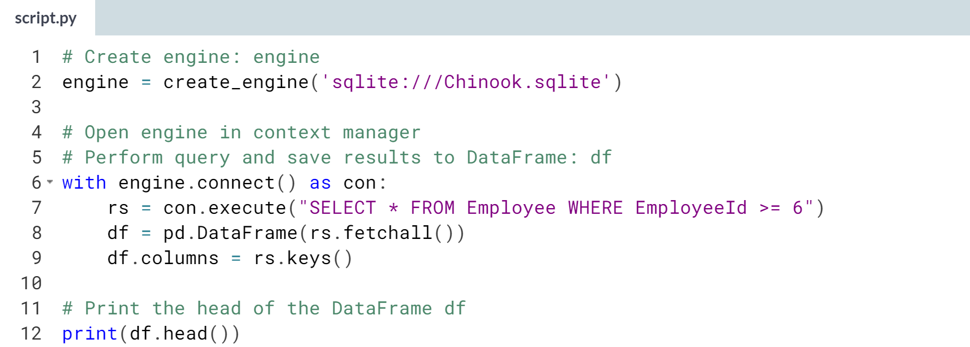

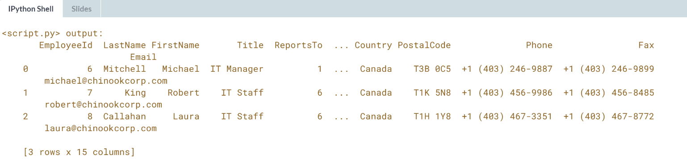

# Ordering your SQL records with ORDER BY

You can also order your SQL query results. For example, if you wanted to get all records from the Customer table of the Chinook database and order them in increasing order by the column SupportRepId, you could do so with the following query:

"SELECT * FROM Customer ORDER BY SupportRepId"

In fact, you can order any SELECT statement by any column.

In this interactive exercise, you'll select all records of the Employee table and order them in increasing order by the column BirthDate.

Packages are already imported as follows:

import pandas as pd

from sqlalchemy import create_engine

Get querying!

(Exercise starts on the next page)

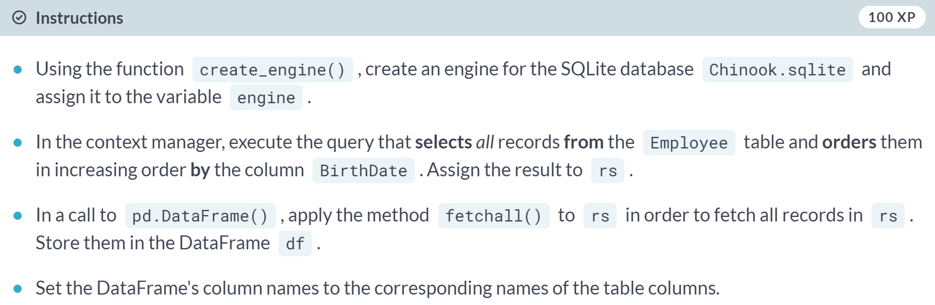

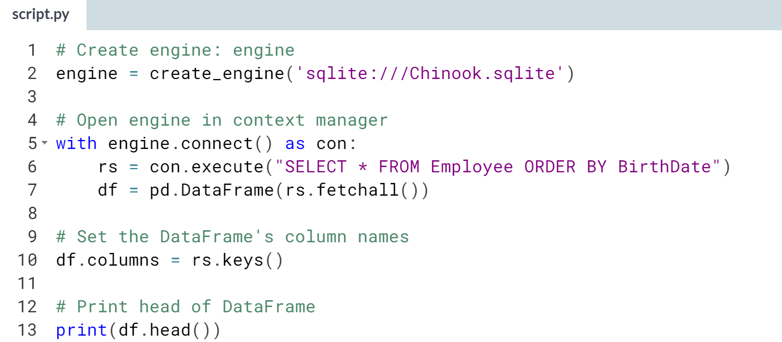  
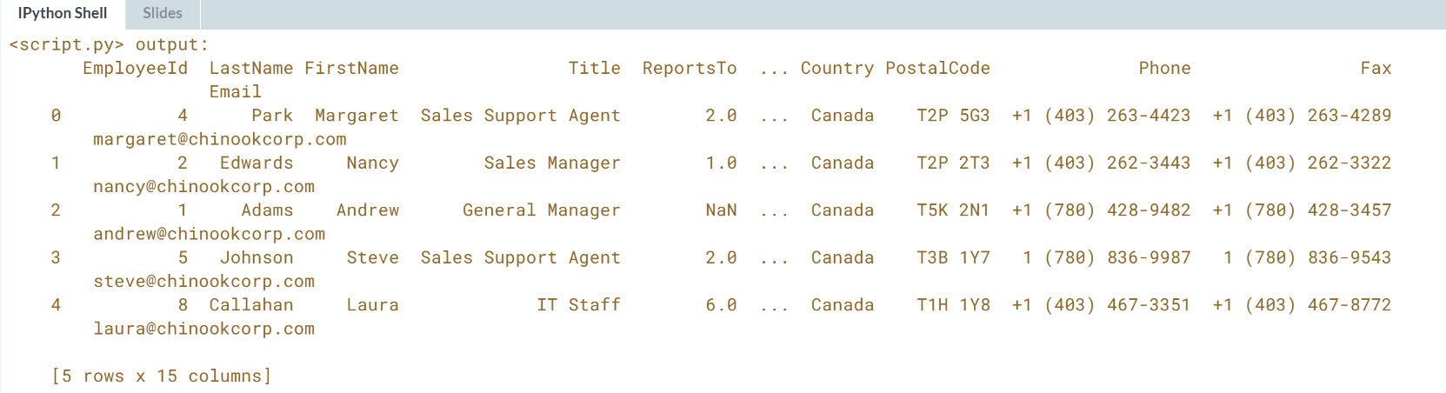



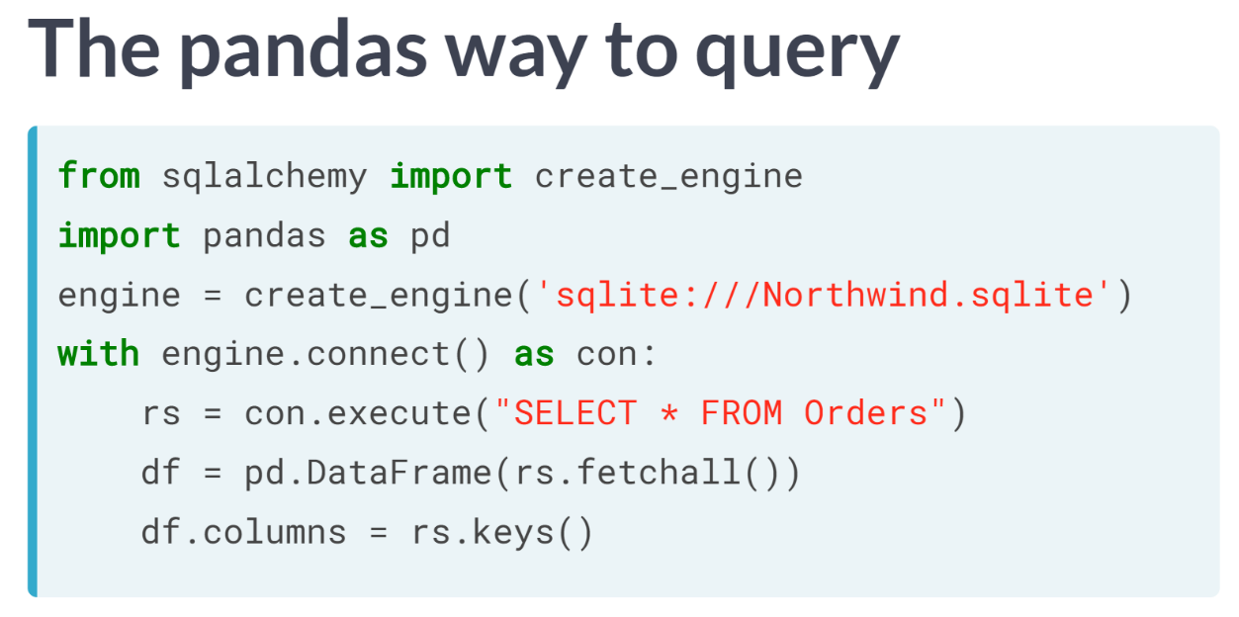  
After creating a database engine, we can get the result of any particular line using 4 lines of code: connecting, executing a query, passing the results to a dataframe, and naming the columns.

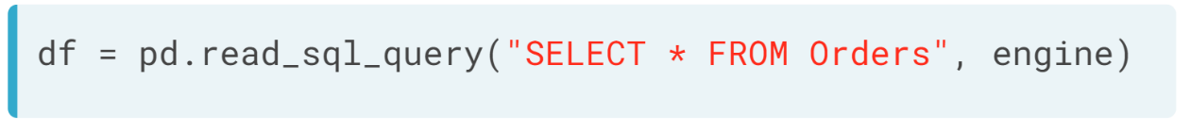  
You can surprisingly do it in 1 line, too, by utilizing the pandas function ***read_sql_query()*** and passing it two arguments.

The first argument will be the query you wish to make, the 2nd argument the engine you want to connect to. And thus, you can achieve the same as this code by executing this single line.

# Pandas and The Hello World of SQL Queries!

Here, you'll take advantage of the power of pandas to write the results of your SQL query to a DataFrame in one swift line of Python code!

You'll first import pandas and create the SQLite 'Chinook.sqlite' engine. Then you'll query the database to select all records from the Album table.

Recall that to select all records from the Orders table in the Northwind database, Hugo executed the following command:

df = pd.read_sql_query("SELECT * FROM Orders", engine)

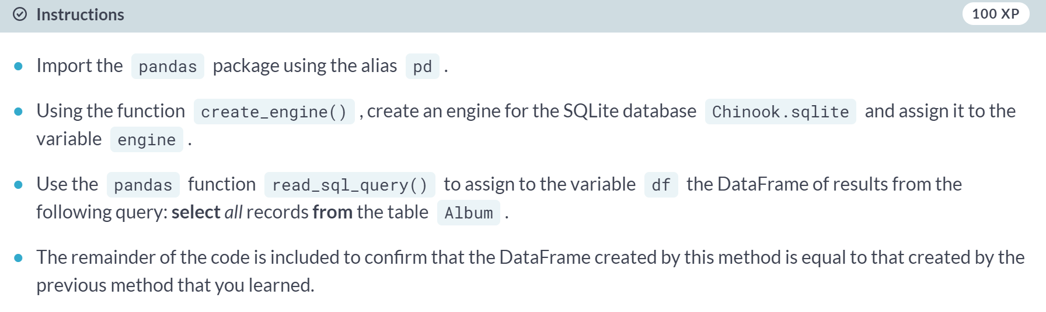

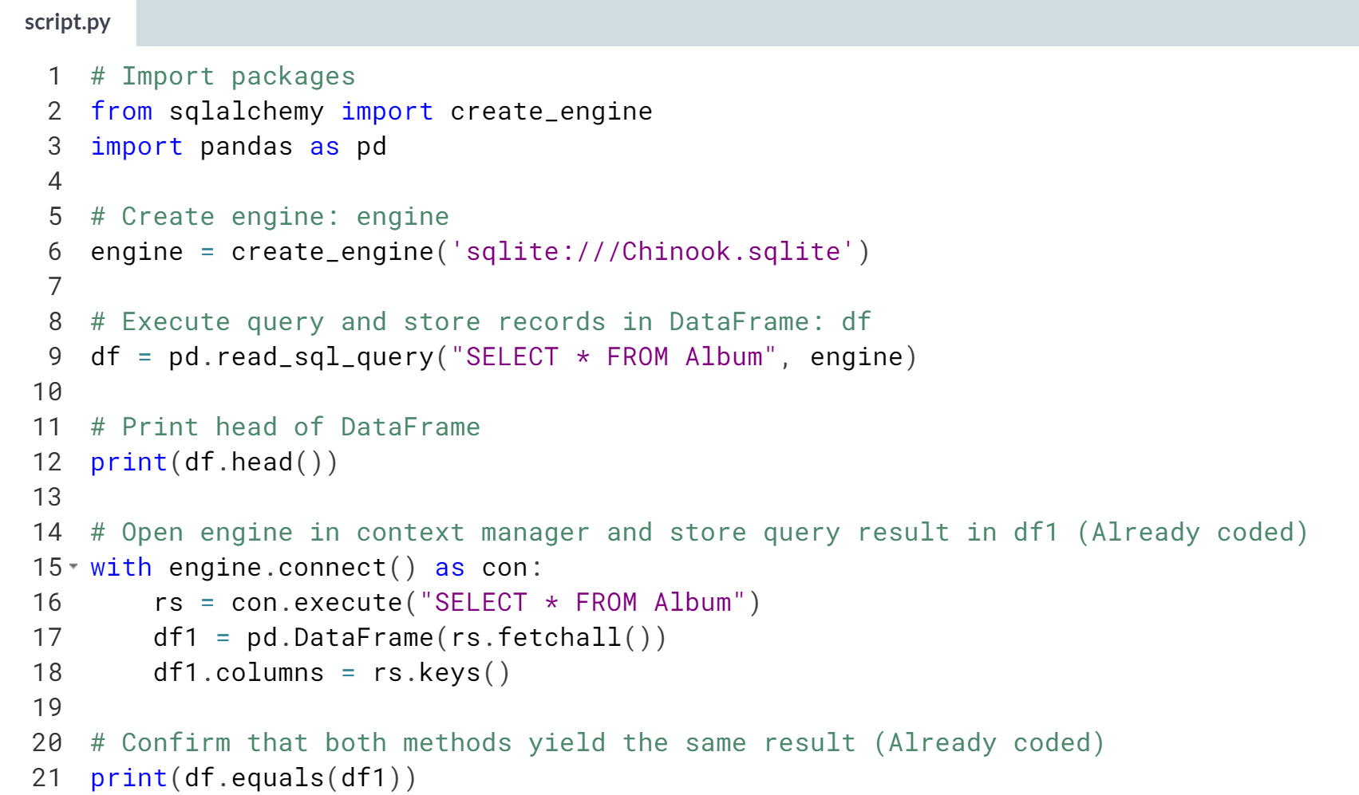

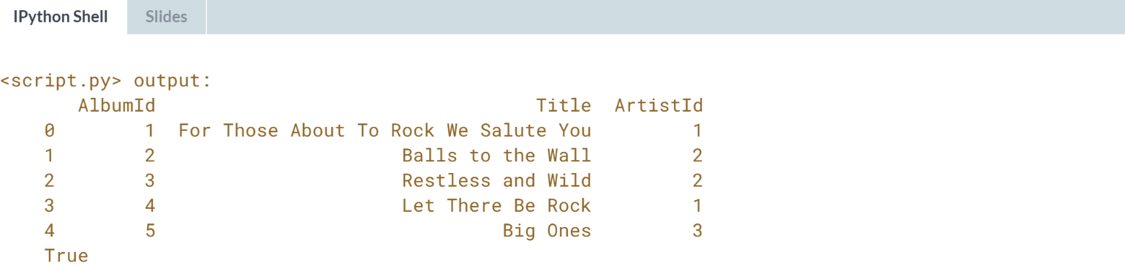

# Pandas for more complex querying

Here, you'll become more familiar with the pandas function read_sql_query() by using it to execute a more complex query: a SELECT statement followed by both a WHERE clause AND an ORDER BY clause.

You'll build a DataFrame that contains the rows of the Employee table for which the EmployeeId is greater than or equal to 6 and you'll order these entries by BirthDate.

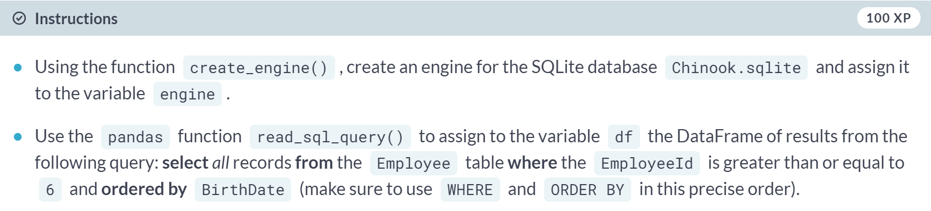

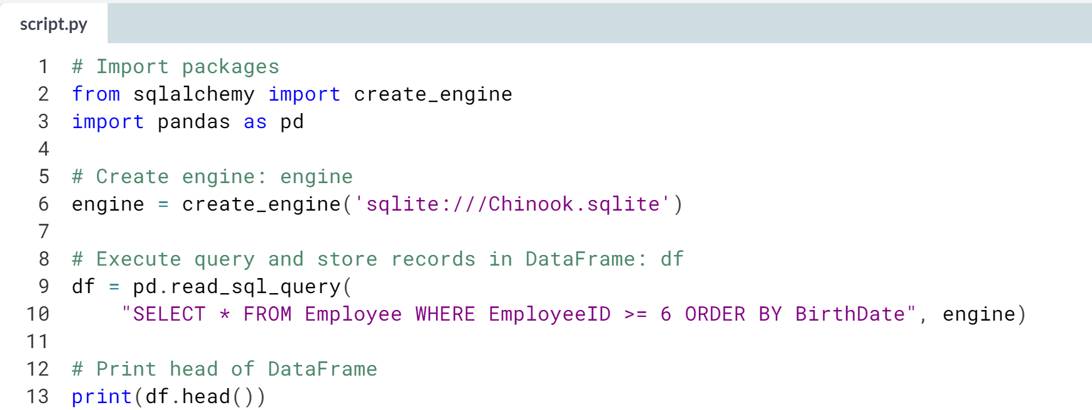

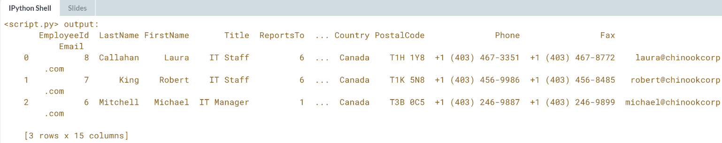



Much of the power of relational databases stems from the fact that they can capture relationships between tables: the tables are linked!

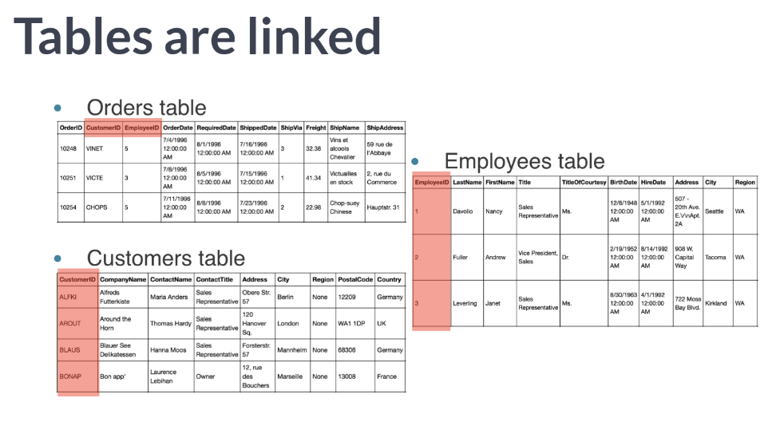  
For example, as we saw earlier, the 'Orders' table of the Northwind Traders database has both a column called 'CustomerID' and one called 'EmployeeID' columns, which correspond precisely to the primary keys in the 'Customers' and 'Employees' tables, respectively.

This means that given an order, we can immediately look at the details of the relevant Customer or Employee in the appropriate table.

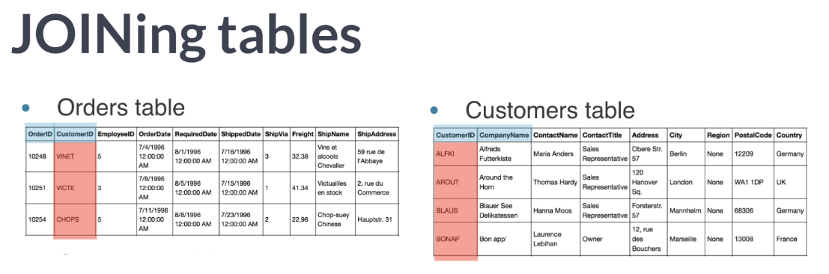  
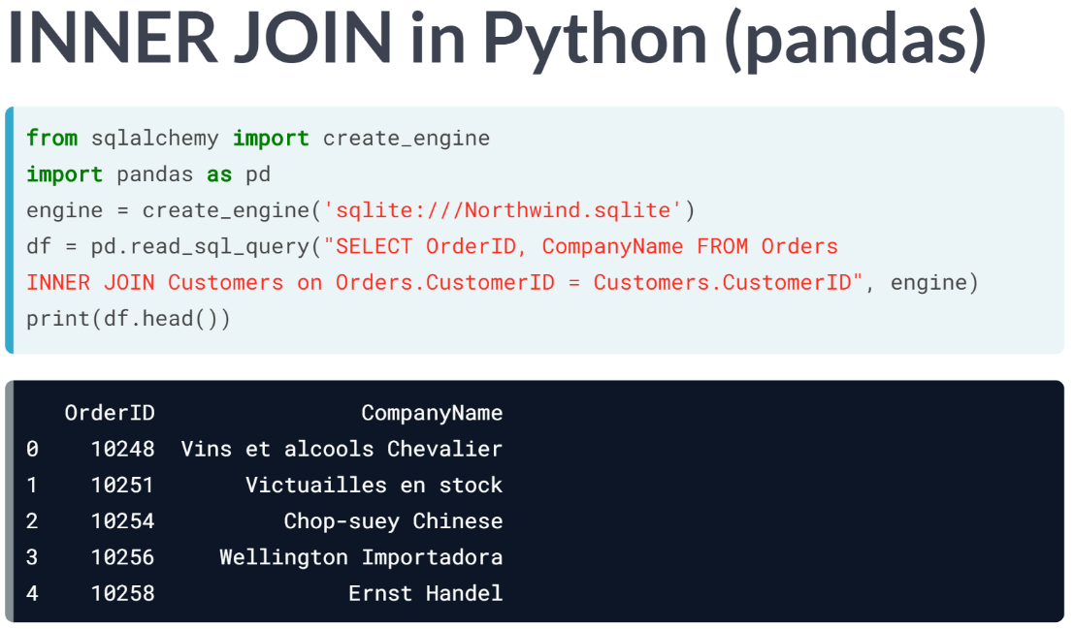

# The power of SQL lies in relationships between tables: INNER JOIN

Here, you'll perform your first INNER JOIN! You'll be working with your favourite SQLite database, Chinook.sqlite. For each record in the Album table, you'll extract the Title along with the Name of the Artist. The latter will come from the Artist table and so you will need to INNER JOIN these two tables on the ArtistID column of both.

Recall that to INNER JOIN the Orders and Customers tables from the Northwind database, Hugo executed the following SQL query:

"SELECT OrderID, CompanyName FROM Orders INNER JOIN Customers on Orders.CustomerID = Customers.CustomerID"

The following code has already been executed to import the necessary packages and to create the engine:

import pandas as pd

from sqlalchemy import create_engine

engine = create_engine('sqlite:///Chinook.sqlite')

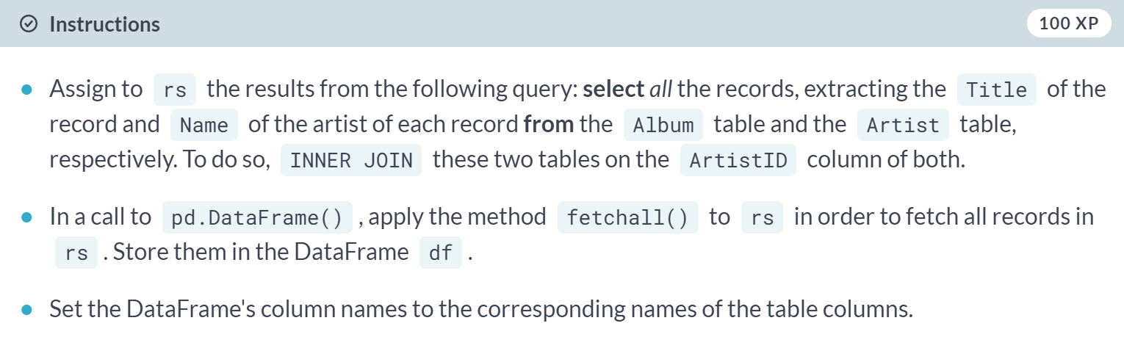

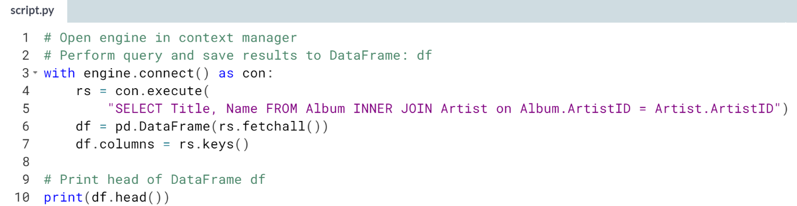  
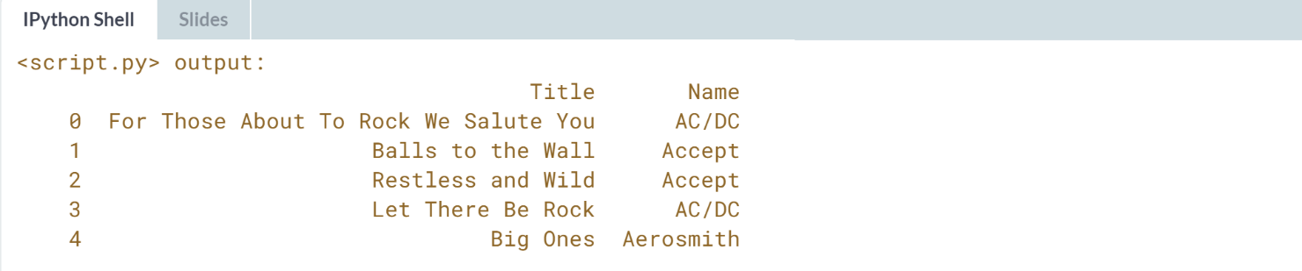

# Filtering your INNER JOIN

Congrats on performing your first INNER JOIN! You're now going to finish this chapter with one final exercise in which you perform an INNER JOIN and filter the result using a WHERE clause.

Recall that to INNER JOIN the Orders and Customers tables from the Northwind database, Hugo executed the following SQL query:

"SELECT OrderID, CompanyName FROM Orders INNER JOIN Customers on Orders.CustomerID = Customers.CustomerID"

The following code has already been executed to import the necessary packages and to create the engine:

import pandas as pd

from sqlalchemy import create_engine

engine = create_engine('sqlite:///Chinook.sqlite')

